Supplemental Materials for

##### A Course-Based Undergraduate Research Experience on the Evolution of Antibiotic Resistance and its Molecular Basis

Katie Dickinson1, Joya Mukerji1, 2, Stuart Graham1, Liz Warfield1, Ben Kerr1

1Department of Biology, Box 355320, University of Washington, Seattle WA 98195

2Present affiliation: Department of Biological Sciences, 6000 J Street, California State University – Sacramento, Sacramento CA 95819

**#Placeholder Table of Contents (Total pages 340)**



Part I.

Appendix 1: Student Lab Manual

Appendix 2: Student In-Class Worksheets

Part II.

Appendix 3: Instructor Lab Manual

Appendix 4: Prelab Quizzes

Appendix 5: Sample Clicker and Exam Questions

Appendix 6: Table of Learning Objectives: Vision and Change

Part III.

Appendix 7: Lab recipes and preparations

# to be removed/replaced upon submission

Table of Contents

APPENDIX 1: Student Lab Manual 4

Lab Safety 4

BIO1 5

BIO1 | Evolution of Antibiotic Resistance: Full Experiment Overview 5

BIO1 | CURE Lab 1 Evolution of Antibiotic Resistance 9

BIO1 | CURE Lab 2 Evolution of Antibiotic Resistance 20

BIO1 | CURE Evolution of Antibiotic Resistance, Transfer Protocol. 29

BIO1 | CURE Lab 3 Evolution of Antibiotic Resistance 35

BIO1 | CURE Lab 4 Evolution of Antibiotic Resistance 46

BIO1 | CURE Lab 5 Evolution of Antibiotic Resistance 58

MIC Tracking Sheet 71

Competition Drop-In Steps 72

BIO1 | CURE Lab 6 Evolution of Antibiotic Resistance 73

BIO1 | CURE Lab 7 Evolution of Antibiotic Resistance 78

BIO2 83

BIO2 | CURE Lab 8 Evolution of Antibiotic Resistance 83

BIO2 | CURE Lab 9 Evolution of Antibiotic Resistance 89

BIO2 | CURE Lab 10 Evolution of Antibiotic Resistance 94

BIO2 | CURE Lab 11 Evolution of Antibiotic Resistance 99

BIO2 | CURE Lab 12 Evolution of Antibiotic Resistance 105

Student Lab Manual 107

Evolution of Antibiotic Resistance 107

Student Lab Manual Appendices 107

Appendix I: Glossary 108

Appendix II: Using RStudio to do Statistical Tests and Make Graphs 114

Appendix III: Guide on How to Analyze Sequence Trace Files (a.k.a, Chromatograms) 118

APPENDIX 2: Student In-Class Worksheets 120

BIO1 | CURE Lab 1 Worksheet 121

BIO1 | CURE Lab 2 Worksheet 123

BIO1 | CURE Lab 3 Daily Transfers Worksheet 126

BIO1 | CURE Lab 3 Worksheet 127

BIO1 | CURE Lab 4 Worksheet 130

BIO1 | CURE Lab 5 Worksheet 132

BIO1 | CURE Lab 6 Worksheet 134

BIO1 | CURE Lab 7 Worksheet 137

BIO2 | CURE Lab 8 Worksheet 139

BIO2 | CURE Lab 9 Worksheet 143

BIO2 | CURE Lab 10 Worksheet 145

Sample Poster template 146

BIO2 | CURE Lab 11 Worksheet 146

BIO2 | CURE Lab 12 Worksheet 147

# APPENDIX 1: Student Lab Manual

## Lab Safety

In this experiment you will be working with a non-pathogenic strain of *Escherichia coli*.

It is critical to follow all proper safety procedures that your instructor will review with you.

- All waste must be disposed of properly; your instructor will review the procedures in class

- Wear gloves anytime you are working with bacteria

- Do not open the agar plates unless instructed

- Wear goggles while handling microtiter plates during lab 6.

- Report any spillages or accidents immediately to a member of staff.

- DO NOT eat, drink, chew a gum, smoke or use a mobile phone in the lab.

- Long hair must be tied back.

- Wash your hands with soap and water when entering and leaving the lab

- Do not place anything in your mouth or near your eyes while in lab (pens, fingers, etc)

Your instructor will also review the location of:

* Sharps container
* Eyewash
* Emergency shower
* Exits
* First Aid kit
* Fire Extinguisher

# BIO1

## BIO1 | Evolution of Antibiotic Resistance: Full Experiment Overview

**Road map for your experiment**

*\*\*This document should give you a brief overview of the experiment you will be running this quarter. Each week, you will receive a more detailed description of: the experiment’s steps for that week, the motivation behind the steps, and important concepts.*

*Although step-by-step protocols have been written for you each week, the actual results you will get are unknown.*\*\*

**Full Experimental Overview**

Since the 1940’s, the use of **antibiotics** has profoundly changed medicine and saved lives. But because bacteria multiply rapidly, they evolve **resistance** to antibiotics quickly. Antibiotic resistance is now one of the biggest threats to health worldwide. How can physicians and public health officials better-manage the evolution of antibiotic resistance?

One possibility is to use an approach called **drug cycling**, where patients are prescribed one antibiotic for an interval and then switched to a different antibiotic. Cycling is a promising approach because cells that have evolved resistance to the first antibiotic may be susceptible to the second one. In addition, research has shown that cells that are resistant to an antibiotic often grow more slowly than non-resistant (**sensitive**) cells if the drug is absent. If so, then the level of resistance to the first drug should decline after the patient switches to the second drug. Eventually, the bacterial population may again be dominated by cells that are sensitive to the first drug. As they recover, patients would be less likely to transmit cells that are already resistant to the first drug to other people.

A second possibility is to use an approach called **drug cocktails**, where patients are prescribed more than one antibiotic at a time. The logic behind cocktails is that it should be more difficult for bacterial populations to evolve resistance to multiple drugs versus only one.

In practice, however, the use of cycling and cocktails is complex. Researchers have discovered cases where removing the first drug does *not* result in a decline in the level of resistance to that drug. This makes cycling less effective. Managing drug cocktails can also be difficult because of increased costs, side effects, and the evolution of multi-drug resistance. In addition, the evolution of resistance to one antibiotic can lead to increased resistance to *other* antibiotics. This is called **collateral resistance**. When this occurs, the use of cycling or cocktails may actually lead to worse outcomes. It would be better to prescribe cocktails and cycling approaches based on **collateral sensitivity**—combinations where research has shown that the evolution of resistance to one drug can increase the sensitivity to another drug.

**The big question motivating our research:** Can a better understanding of the evolution of antibiotic resistance lead to improved drug use by exploiting collateral sensitivity and avoiding collateral resistance? We also want to know much more about the molecular mechanisms responsible for drug resistance or sensitivity.

Your experiment will start on in the first lab of this class and continue for several weeks.

In **Lab 1** you will get comfortable working with bacterial cells, cultures, and colonies by using **sterile technique**. You will also receive a **liquid culture** of an ***Escherichia coli*** (*E. coli*) **strain** that is sensitive to both of the antibiotics we’re studying this quarter. You will spread a sample from this culture onto a series of 6 **Petri dishes**. Four of the dishes will contain an antibiotic. The remaining two dishes will be antibiotic-free.

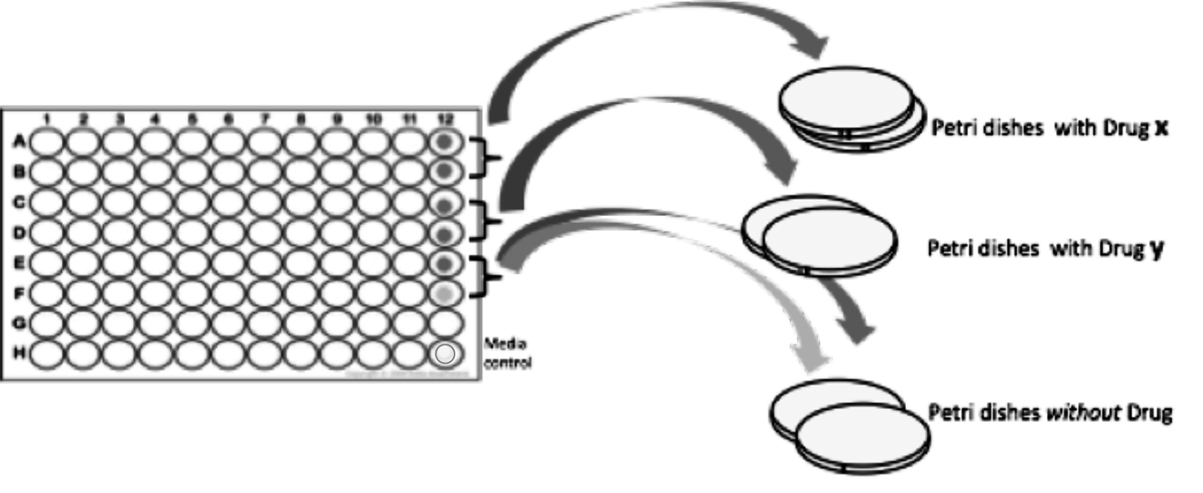

(Quick note: the plastic plate on the left of this figure is called a **microtiter plate**. It holds small volumes of up to 96 liquid cultures, each in a separate **well**. The 8 rows of wells are labeled A-H; the 12 columns of wells are labeled 1-12.)

In the Petri dishes with an antibiotic, we expect that the drug will kill most or all of the population. If a small number of cells grow, they probably contain a novel trait, or **mutation,** that confers resistance to the drug. A resistant cell will grow into a **colony**: a cluster of cells that is visible to the naked eye, growing on the surface of a solid medium. The cells in a colony are genetically identical, except for additional mutations that occurred during colony growth.

You will also have two Petri dishes *without* an antibiotic. On one of these dishes, you will plate a sample of bacteria. Since there is no drug present, almost all of the cells will grow. They will form colonies that grow into each other and form a **lawn**, where individual colonies can’t be distinguished. You will also grow a diluted sample of the ancestor on a second plate without antibiotics. Because this culture has been diluted, you should see single colonies of your sensitive ancestor.

In **Lab 2**, you will select one **colony** of bacteria resistant to Drug *x*, one colony resistant to your Drug *y*, and your TA will select a single colony of the sensitive strain for the class. (We refer to drugs *x* and *y* here because the antibiotics we analyze change from quarter to quarter.) Cells from each colony will be added to a liquid growth medium called **LB**.

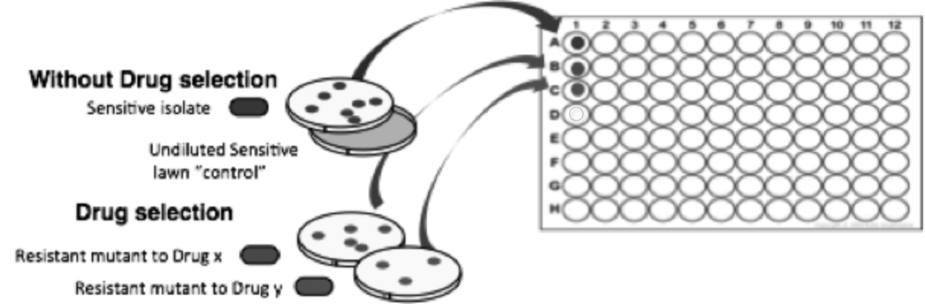

After a day of growth, your group will freeze a sample of each of your strains to use in a future lab. We call these cells the **progenitors**. They will give rise to future generations as you start **daily transfers** of your bacteria.

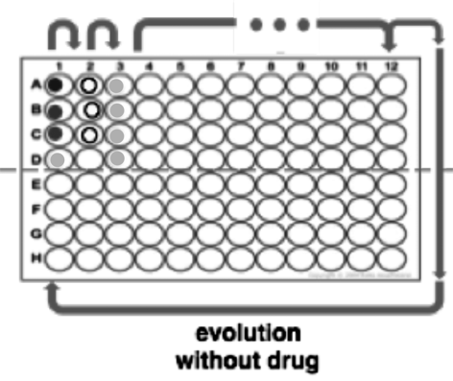To do the daily transfers, a member of your group will come to the lab every weekday to dilute your evolving populations and transfer a small sample to fresh liquid media. The transferred cells now have space and nutrients to grow. In this way, your population will evolve over time.

During **Lab 3** and **Lab 4**, you will learn more about collateral sensitivity and collateral resistance, make predictions about expected results, discuss how to analyze the data you’ll be collecting, and learn how to use a software package to visualize and analyze your results.

After completing the transfers, you will have evolutionary descendants of your Drug *x* resistant progenitor, Drug *y* resistant progenitor, and the Sensitive progenitor.



Progenitors

In **Lab 5** , you will thaw some of your frozen progenitor cells so they can grow again, and measure 1) thelevel of drug resistance in both progenitors and descendants, and 2) their relative **fitness**—meaning, their ability to grow in the absence of the drug.

In **Lab 6** you will gather your results and finally, in **Lab 7**, you will use data visualization software and basic statistical analysis to understand your data, interpret them, and discuss potential future directions.

**Putting it together**

By the end of this experiment you will have observed evolution in real time and gained a better understanding of mutation and natural selection. In addition, you will have contributed to research on a major global health crisis—the widespread evolution of antibiotic resistance—and gained valuable lab skills and knowledge that will transfer to future classes and/or industry. We also hope that your results inspire future research by you or your classmates.

**Looking ahead**

In Bio2, you will thaw your frozen isolates and collect data on the molecular and cellular mechanisms of resistance. You will gain experience with:

* Using Gel Electrophoresis to analyze PCR products
* Analyzing DNA sequence data
* Modeling protein structure
* Integrating the connections between genotype, phenotype, and fitness.

## BIO1 | CURE Lab 1 Evolution of Antibiotic Resistance

**I. Background information: Bacteria and antibiotic resistance**

Bacteria are everywhere! Most species are helpful or harmless but some cause infections that can be deadly.

**The problem:**

**Antibiotics** are molecules that kill or inhibit bacteria. They work by disrupting the molecular machinery inside bacterial cells without disrupting the cellular machinery in humans. Since their discovery, these drugs have transformed our ability to treat bacterial infections.

During an infection, bacteria reproduce by dividing into two daughter cells. Before this can happen, all of the hereditary material, or **genome**, in the bacterium must be copied. Genes are made of a molecule called DNA, so the copying process is called DNA replication.

DNA replication is not error-free. As a result, random changes occur in the DNA sequence of the newly-replicated daughter cells. These random, spontaneous changes are called **mutations**, and are the source of variation that makes evolution by natural selection possible. Although the probability that a mutation occurs during any single bout of DNA replication is small, bacteria have short generation times and have large populations. As a result, there are many opportunities for mutations to occur.

Most mutations have no impact on the trait we call antibiotic resistance, but a few do. These rare mutations may make the daughter cell with the mutation more **resistant** to an antibiotic. As Figure 1.1 shows, the frequency of drug-resistant cells increases quickly in the presence of an antibiotic. As the frequency of antibiotic resistance in bacterial cell populations increases, successful treatment of infections becomes more difficult.

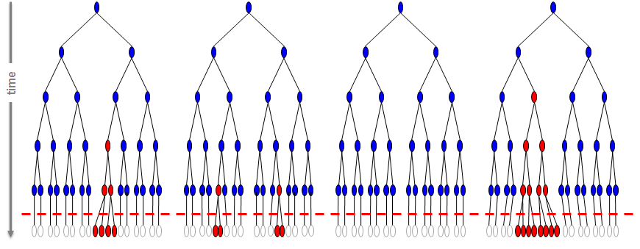

**Figure 1.1** Each “inverted tree” represents a separate population founded by a single bacterial cell (top) that gives rise to many descendants through cellular division (the branches in the tree). The red dashed line represents the application of an antibiotic. Cells that are **sensitive** to the antibiotic are shown as blue ovals; resistant cell are red and dead cells are empty. Note that mutations conferring drug resistance occur in the absence of the drug but increase in frequency quickly in the presence of the drug, as sensitive cells die off.

**Bacteria as a model organism for evolution experiments**

When conditions are favorable, bacteria multiply rapidly. For example, cells of the species called ***Escherichia coli***, often abbreviated to ***E. coli***, can divide every 20 minutes under optimal growth conditions. In a single day, a handful of cells in 1mL of growth medium can grow to a population of 1010 (10,000,000,000)—more than the entire human population. And because the cells are small, we can track large populations over many generations in a short period of time in a small volume of growth medium.

In this week’s lab you will expose a population of *E. coli* to two different drugs, so you can explore the evolution of antibiotic resistance.

1. Cells from a harmless strain of *E. coli* will function as the progenitor of your study population. You will expose cells from this strain to different antibiotics by taking a sample and putting it on a petri dish with drugs. You will also place a sample of this bacterial population on a petri dish lacking drugs. This will allow you to isolate a drug-sensitive strain.

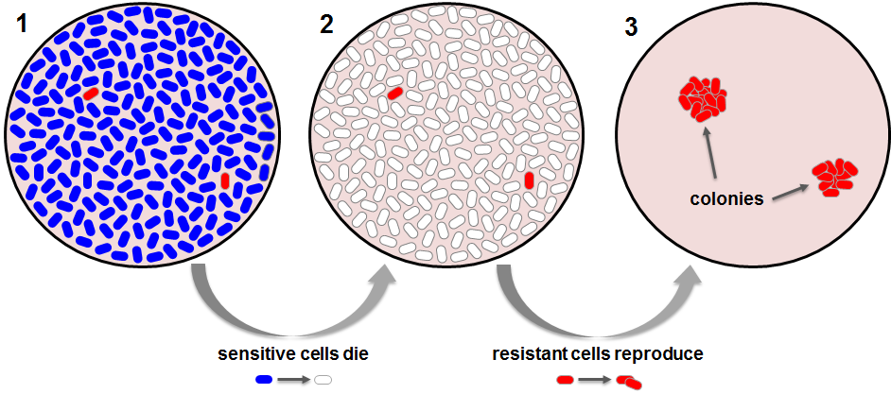

**Fig 1.2.** Step 1 shows cells spread on a petri dish containing drug (the cells are not actually visible to the naked eye). Step 2: The antibiotic kills any sensitive bacteria (blue). Step 3: After 24 hours of incubation, resistant cells (red) have reproduced enough to form visible colonies on the petri dish. A **colony** is a cluster of cells on the surface of a solid medium, usually descended from a single parent cell.

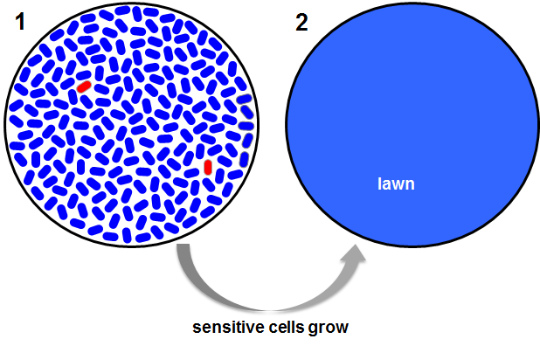

**Fig 1.3.** Step 1 shows cells spread on a petri dish without drug. Step 2: After 24 hours of incubation, sensitive bacteria have reproduced enough to form a **lawn**—a continuous cover of cells on the surface of a Petri dish, where individual colonies cannot be observed. In the absence of drug, the sensitive bacteria greatly outnumber the resistant bacteria (red).

1. Of the millions of cells placed on the petri dish with an antibiotic, most will die. However, by chance a few cells may have mutations that make them resistant to the antibiotic (we will refer to these bacteria as **mutants**). Individual bacteria cells are too small to see without a microscope, but you will let the resistant cell(s) divide many times overnight on the petri dish so a visible **colony**, consisting of scores of bacteria, forms. Resistance is vital to survival on a petri dish with an antibiotic. But resistance is usually accompanied by a **fitness cost**—meaning that the resistant calls don’t grow as well as the sensitive cells in the absence of the antibiotic.
2. Next week you will select a sample of these resistant mutants for your experiment, along with a sensitive progenitor.

**II. Sterile Technique: Guidelines and Skills Practice**

Sterile technique is crucial when working with bacteria. You need to be confident that what you see growing on your Petri dishes and in your tubes are the cells that you placed there, and only those cells. Contamination with other bacteria or with fungi can result in a devastating loss of irreplaceable material, and waste time and money. Lack of proper technique increases the likelihood for contamination. Implementing good sterile technique requires careful thought about how contamination happens. Bacteria and fungi are everywhere—on your fingertips, bench tops, in the air—so it is important to stay focused and aware.

**How to keep things sterile:**

1. **Barriers**
   1. Wear gloves
   2. Keep containers closed or covered when you are not directly using them
2. **Prepare Equipment**

Use an autoclave to sterilize media, pipette tips, microtiter plates, and other equipment and supplies. This will be done for you, by other members of the research team.

1. **Sterile technique and environment control**

Wipe your bench, your gloved hands, and your pipettes with ethanol to kill bacteria and fungi on these surfaces.

ALWAYS: Work carefully but efficiently**.**

**Lab Safety**

Although the strain of *E. coli* that you will use for your experiments does not cause disease in humans, safety is still extremely important.

There is absolutely no eating or drinking anything in the lab. NO EXCEPTIONS.

Make sure you know where the emergency eyewash and shower are located.

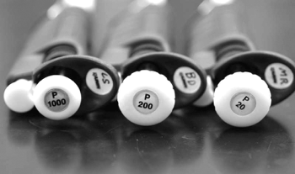**III. Pipetting**  
  
The micropipette, or **pipette**, is a common, easy-to-use laboratory tool that you will use to dispense small volumes of liquids with precision. Different pipettes are made to handle different volume ranges. The most common ones used for small volumes are the P-20, P-200, and P-1000 pipettes. The number after the “P” refers to the MAXIMUM volume in microliters (µl; one-millionth of a liter) that can be dispensed by the pipette:

P-20 2 µl-20 µl range  
P-200 20 µl-200 µl range  
P-1000 100 µl-1000 µl range

**Fig 1.4** The tops of the P-1000, P-200, and P-20 micropipettes. Image used with permission; Marcia Bhide, Edu-graphics.com.  
  
The volume on a pipette is set by turning a knob near the top of the handle and watching the dial change to the correct setting. Important: **Never turn the dial past the range of the pipette**. These pipettes are accurate in the ranges they are designed for. However, they will break or lose their calibration if you attempt to set them to a volume outside of their operating range.

A pipette has a plunger with a flat knob at the top for withdrawing and dispensing liquids. When you press this knob down, you will notice that it has two stops; the second stop is felt after you push down harder after hitting the first stop. The second stop adds an extra puff of air to remove all the liquid out of the pipette tip. Whether or not you use this second stop depends on your purpose. In this class you will only push down to the first stop!

A pipette is a precisely-tuned instrument. It is useful to note that the volume distributed may change slightly if the pipette is not straight up and down while in use, and if the dial has been twisted past its normal range.

Never:

1. Hold or place the micropipette upside-down. If you do, fluid can flow up the barrel and be inadvertently dispensed later. This will mess up your and subsequent users’ experiments.
2. Touch the end of the un-tipped barrel to any surface, as it can become contaminated or bent.
3. Forcibly jam a tip onto the barrel. Be firm but gentle.

**Pipetting basics:**

1. Set the volume on the pipette.
2. Spray ethanol on a Kimwipe and wipe down the pipette to sterilize.
3. Put on a pipette tip
4. Depress the plunger.
5. Immerse the tip and gently let the plunger go to its resting position.
6. Put the pipette—held at 10–45 degrees—against the wall of the receiving chamber, and smoothly depress the plunger to the first stop.
7. Slide the tip up the vessel wall to remove the pipette.
8. Allow the plunger to return to its rest position.

**Lab 1: In Lab Protocol**

In lab, you will:

**I**. Learn about lab safety and sterile technique, and practice laboratory skills that are essential for the success of your research.

**II.** Start your evolution of antibiotic resistance experiment

**Learning Objectives**

After completing today’s lab, you will be able to:

* Explain why the evolution of antibiotic resistance is a health concern.
* Instruct another student on proper sterile technique.
* Make a flow chart showing the experiment steps you performed, and add annotations explaining the rationale for each step.
* Diagram the week-to-week plan for this experiment over the course of the quarter.

**Today**:

You will be given a population of a bacterium called ***Escherichia coli*** (***E. coli***; strain MG1655). You will add them to Petri dishes that contain an antibiotic, so that natural selection can occur. Next week you will see if any of the cells in the population are resistant to the antibiotic being used. Your TA will also place a sample of this bacterial population on a Petri dish that lacks drugs, so you be able to isolate a drug-sensitive strain.

**I. Sterile Technique Guidelines and Skills Practice**

We, and the world around us, are covered with microorganisms. Sterile technique is crucial when working with bacteria because you have to keep your samples and experiments free of contamination with species other than the one you are studying. When you are using sterile technique, exposure to the air is kept to a minimum and sterile surfaces only touch other sterile surfaces.

**To keep things sterile:**

1. Media, pipette tips, microtiter plates, tubes and other supplies are already sterilized. Be sure that these items remain sterile by covering or closing them immediately after use. Close pipette tip boxes; put lids back on microtiter plates and Eppendorf tubes.
2. Set up your workspace before you begin. Clear off the lab bench, disinfect it with 70% ethanol, and arrange all of the materials you need so they are within easy reach.
3. Work carefully, but quickly and efficiently**.** Do not talk or cough or sneeze over your experiment while you are working.

**Practicing skills for effective sterile technique**

Divide your group into Pair A and Pair B, so each partner in the pair can practice.

The 1st person practicing in the pair will:

* Fill 4 wells in Column 2 of the microtiter plate with **saline**—water with salts added in concentrations that are appropriate for bacterial cells to stay alive.
* Fill 4 wells in Column 3 of the microtiter plate with a nutrient-rich growth medium called **LB** (for lysogeny broth, or Luria-Bertani medium).
* Transfer the liquid from Column 1 into saline, and then from Column 2 into the LB in Column 3.

After this, the second person in the pair will practice the same steps mentioned above, using the same microtiter plate.

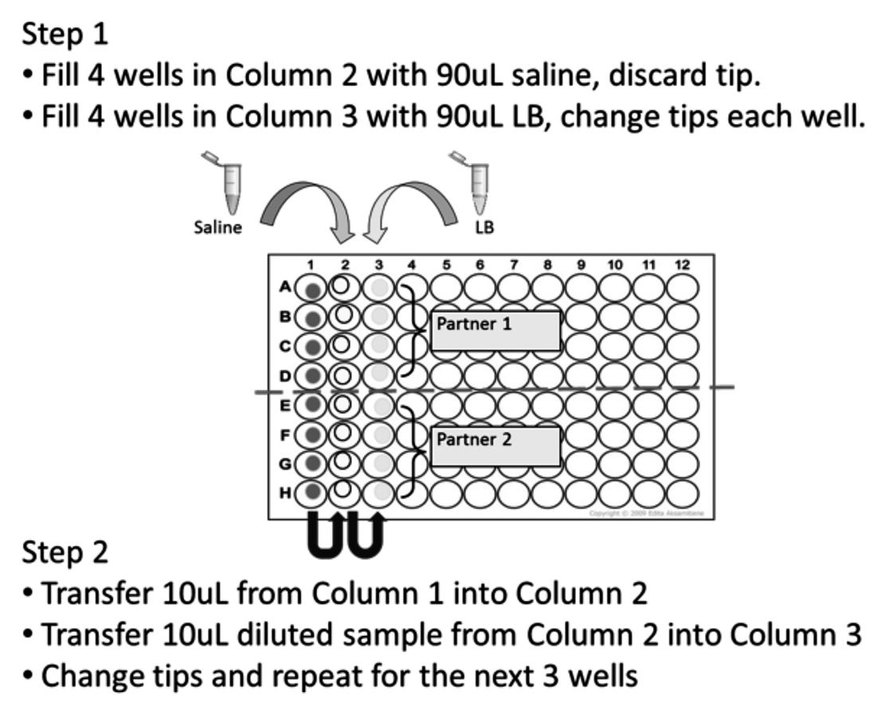

**Step-by-Step Protocol for sterile technique practice:**

1. Set up your workstation.
2. Set your P200 pipette to **90uL**.
3. Use the pipette to transfer **90uL** of the saline solution from the eppi to a well in Column 2 of the microtiter plate.

TIP:

* + 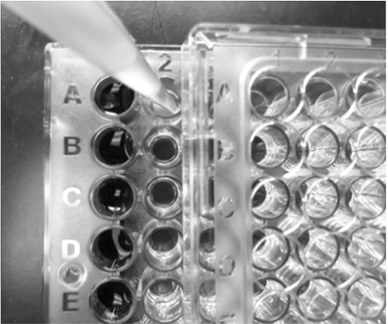 Open the lid on your microtiter plate *just enough to expose the column you want.* In this case column 1 and 2 should be exposed, with the lid resting over columns3 - 12 (see photo).

1. Once you are done, eject the tip into the tip-waste beaker. Make sure to replace the lid on your microtiter plate.

Now you will add LB from an eppi into the first 4 empty wells in Column 3.

1. Move your microtiter plate lid to the right by one column, exposing Column 3.
2. Add **90uL** from the LB eppi and dispense to each the next three empty wells in the Column 3.

Now practice diluting the “bacteria,” initially into the wells containing saline. Then you will transfer the diluted “bacteria” into the wells containing LB. IMPORTANT: You do not want the “bacteria” from different wells to mix. To avoid this, use a new tip as you move from one row to the next. To do a 10-fold dilution, you will add 10uL of “bacteria” to the 90uL of saline you pipetted.

1. Set your P20 pipette to **10uL**. Load a fresh tip.
   1. Open your microtiter plate just enough to expose the first three columns.
   2. Draw up **10uL** of “bacteria” from row A, column 1. Dispense this volume into the well directly to its right.

Keep the tip fully submerged to avoid creating bubbles. **Mix** the diluted culture by slowly and gently pipetting up and down—just to the first point of resistance on the pipette.

* 1. Using the same tip, draw up **10uL** of the now-diluted “bacteria” from column 2 into LB in column 3. Again, gently mix by slowly pipetting up and down.
  2. Discard the tip.

1. Repeat steps 7 for row B and then again for row C.
2. Replace the lid on your microtiter plate.

Once the first partner has finished practicing, switch so the second partner can practice.

**Make notes here—things to remember about sterile technique**

**II. Evolution of Antibiotic Resistance Experiment Day 1**

**Overview**

Using sterile technique, you will spread small samples from a liquid culture of bacteria on each of six Petri dishes. The nutrient-rich solid media in the first four dishes will contain an antibiotic, but the remaining two dishes will not contain an antibiotic.

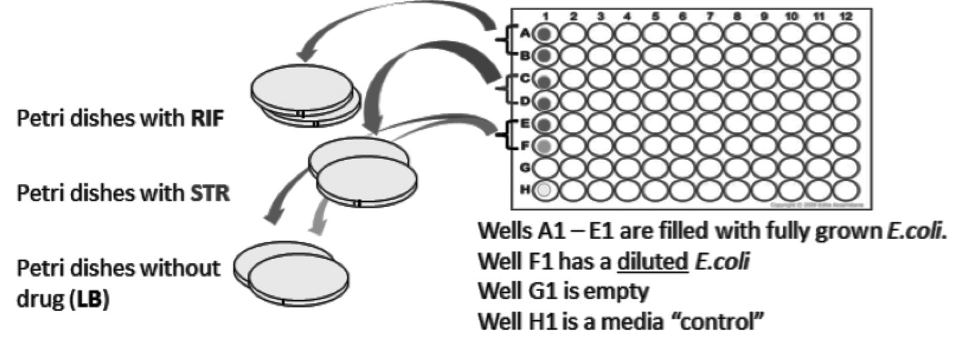

**Materials**

* 1 microtiter plate containing 5 wells of fully grown culture of mostly drug-sensitive *E. coli* bacteria and 1 well of *diluted* culture of mostly drug-sensitive *E. coli* bacteria
* 2 LB Petri dishes containing the antibiotic **rifampicin** (**RIF)**
* 2 LB Petri dishes containing the antibiotic **streptomycin** (**STR)**
* 2 LB Petri dishes *without* antibiotics

*Before you begin:*

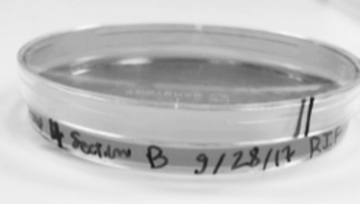Petri dishes are identified with different-colored stripes marked on the side. Check the labels on the edge/side of the dish’s base so you know which Petri dish is which.

* + Label your Petri dishes with your group’s #, section #, date, and drug. (For ease, rifampicin is abbreviated as **RIF** and streptomycin as **STR.** Label drug-free Petri dishes **LB**.
  + Other members of the research team have “beaded” the Petri dishes for you. Sterilized glass beads are used to spread the bacteria around the surface of the Petri dish.

1. Put on latex gloves. Spray ethanol on your bench and wipe it with a Kimwipe. Spray ethanol on a Kimwipe and wipe down your P200 pipette.
2. Set your P200 pipette to **200uL**.   
     
   Note: You will be drawing up the entire volume of liquid present in the microtiter wells. Due to evaporation there might be slightly less than 200uL of culture in your microtiter wells. As a result, when you are picking up your *E. coli* from the well you will likely get bubbles as you draw up the last of the culture in the well. **This is OK!** For this step in the experimental protocol, the exact volume is not important.
3. While practicing good sterile technique, load a sterile tip and transfer **200uL** of your fully-grown bacterial culture from well A1 into the center of the Petri dish containing RIF.   
   Eject your tip.
4. Shake the Petri dish so the glass beads spread out the bacteria, as demonstrated by your TA or PF. Make sure the beads are moving across the midpoint of the dish—not just running in a circle along the edges of the dish—and rotate the dish as you are shaking so that beads contact all parts of the media in the dish.
5. When the beads begin to move more slowly across the dish, it means that most of the culture has been absorbed into the agar. Flip the Petri dish over to collect the glass beads on the lid, and set the dish aside.
6. Load a fresh tip and repeat Steps 3 through 5 with the second RIF Petri dish, transferring **200uL** from well B1.
7. Eject the tip and spread the bacteria by shaking your Petri dish so the glass beads cross the plate, as above.
8. Repeat these steps, but this time pipet from wells C1 and D1 and plate onto the two Petri dishes labeled STR and pipetting from well E1 and F1 onto the Petri dishes labeled LB (no antibiotic). Notice the *diluted* bacterial culture from well F1 is less cloudy than the other wells.

Well G12 is empty. Well H1 contains the **media control** that was created when your TA set up the microtiter plate. Inspect well H1 carefully. It should be clear and not cloudy. If it is clear, it means that the media is not contaminated and growth in the other wells should be from the bacteria placed in them.

1. To remove the glass beads from your Petri dishes (Your TA or PF will demonstrate before you do this step.)
2. Place your Petri dishes agar-side up (lid-side down) in the tray. Your TA or PF will take them to the 37°C incubator, so the bacteria can start growing.

*IMPORTANT! Before leaving the lab*…

* Wipe down your bench with ethanol
* Empty your tip-waste beaker and non-tip-waste beakers into the appropriate collection containers.
* Dispose of your gloves in non-tip-waste.
* Wash your hands *thoroughly*.

**Make notes here—things to remember about the experimental treatments you’ve created**

## BIO1 | CURE Lab 2 Evolution of Antibiotic Resistance

**I. Background information: Mutations that confer resistance**

In Lab 1 you learned that **mutations** are random events that can change the sequence of an organism's DNA (its genotype). Different mutations affect cell function differently, and their impact on the organism’s fitness depends on the environment that the cell is experiencing.

Think about the bacteria that you placed on Petri dishes in the last lab. Mutations that result in drug resistance have a huge advantage in an environment with the drug present: the mutant cells grow and reproduce much better than their sensitive progenitors. It is important to note, though, that drug-resistant cells usually have lower **fitness** in an antibiotic-free environment, meaning that they grow and reproduce more slowly or die more often than their sensitive progenitors. This is called the **fitness cost** of resistance.

Given this information, it should make sense to you that mutations for resistance will be rare in your progenitor population, because the cells had been growing in the absence of antibiotics. It should also make sense that, because mutations are random changes in genes caused by copying errors, there is always genetic variation in every population in every generation. Thus, drug-resistant cells occur in the progenitor population in every generation just by chance—they don’t arise because the cells were exposed to an antibiotic. Mutations are rare, though, so these mutants will be at very low frequency. You plated out a large population of cells to increase the probability of finding at least one resistant cell to each antibiotic.

**II. Predictions about your Petri dishes**

For each of the Petri dishes with an antibiotic, cells that have mutations conferring drug resistance will grow into visible colonies overnight. When you examine your plates, each of the small spots that you see contains the descendants of a single cell that landed there and was able to continue dividing in the presence of the antibiotic.

For the LB Petri dish, which was drug-free, you would predict that a **lawn** of bacteria will grow because so many cells survive and grow. When this happens, the colonies are so close together that you cannot distinguish the individual clumps of cells. Remember that you also plated a diluted sample of the progenitor onto a second plate without antibiotics. Because this culture went through seven 10-fold dilutions, you should be able to see separate, distinct colonies. If so, you can use this plate to isolate cells from the same drug-sensitive colony.

This week you will make observations about the colonies or lack of colonies on your Petri dishes. Then you will isolate the cells that you will be studying during the rest of the experiment. You will pick one colony of bacteria resistant to the drug rifampicin (RIF) and one colony resistant to the drug streptomycin (STR). Your TA will select one colony of the sensitive isolate, for the entire lab to study. Each colony will be initiated into a liquid growth medium (LB). These cells will act as the **progenitors** for your experiment (see Figure 2.1)

**III. Experimental evolution**

The Kerr Lab is collecting data on what happens to drug-sensitive and drug-resistant strains of bacteria over time. To provide these data, you will perform **experimental evolution**: setting up an environment, letting a study organism evolve, and then comparing the traits of the progenitors and the descendants. This quarter, the environment that your cells will evolve in *lacks* antibiotics. The drug-free environment simulates what happens in a patient where resistance to a particular antibiotic has evolved, and the physician prescribes changing the antibiotic. What happens to the cells that were resistant to the first antibiotic? Is resistance maintained even in the absence of selection pressure? If so, it would be unwise for the physician to prescribe the same antibiotic later. Or is resistance lost over time? If so, the first antibiotic could be effective again later, if the infection persists.

To help the Kerr lab answer these questions, you will do two things with the cells you isolate this week:

1. You will remove a sample of each strain to be frozen. Freezing stops cell growth but does not kill the cells. Later you will thaw these progenitors and study them.
2. A sample of each drug-resistant strain will be allowed to grow and evolve for many generations.

Later this quarter you will compare the descendants that result from experimental evolution with their progenitors. The data that you generate will document whether the progenitors and descendants differ in terms of their fitness and their level of drug resistance.

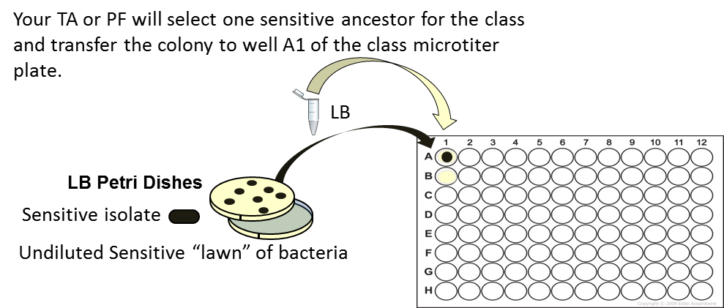In addition, it is important to study a baseline strain when you do experimental evolution, as a control. In your experiment, the baseline will be the drug-sensitive progenitor. But because we want you to focus on the drug-resistant strains that you isolate this week, your TA or peer facilitator will be working with the sensitive strain. They will freeze a drug-sensitive progenitor and allow its descendants to evolve under precisely same conditions as your drug-resistant strains.

**IV. Daily bacterial transfers.**

After 24 hours of growth, a member of your group will come into lab to start daily transfers of your bacteria. In addition, a member of the research team will freeze a sample of each of your progenitors, so you can study them later in the quarter.

For the next two weeks, a member of your group will come to the lab every day, except for weekends and university holidays, to transfer your evolving cultures. A different person from your group can come in each day, to make scheduling easier.

To understand what is happening during the daily transfers, think back to **Figure 1.1** from the Lab 1 protocol (shown again here). Recall that the red cells contain a mutation that confers resistance, and that bacteria divide by binary fission. As a result, they can grow exponentially: one cell becomes two, two cells become four, four cells become eight, and so on. During exponential growth, *E. coli* divide about once every 20 minutes. So after 24 hours of growth, you will have a lot of cells in your microtiter wells.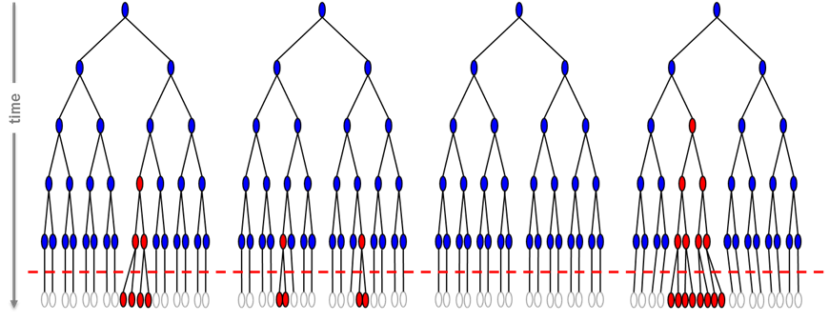 Growth will stop at this point, however, because the cells run out of space and nutrients. The cells will just sit there.

To keep evolution going, the person who is signed up to do the transfer will start by diluting the culture that grew the previous night. The dilution will be 100-fold: an initial 10-fold dilution in saline, followed by a 10-fold dilution into fresh growth media.

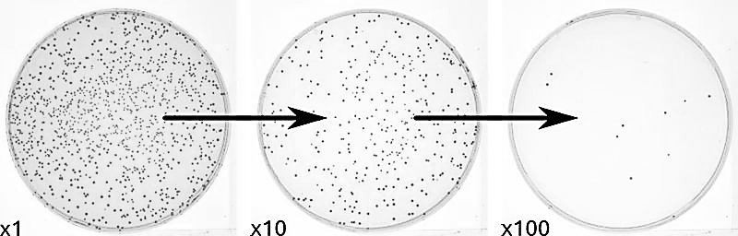The image to the left shows the effect of dilutions. (NOTE: the Petri dish on the far left is *much less* dense than what we would expect a full culture of bacteria to look like on the plate. This image is simply to show how dilutions work).

Remember that as your cells continue to grow every day, error-prone DNA replication continues to generate genetic variation via random mutations. Many of these mutations will have no effect or a negative effect on fitness in the absence of the drug. However, a small proportion of these mutations may actually enhance fitness, in which case the new mutations will increase in frequency over time.

The Kerr Lab is particularly interested in **compensatory mutations**. When these occur, the cost of resistance goes down and high levels of antibiotic resistance can be maintained over time, *even in the absence of the drug*. Compensatory mutations make drug cocktails and drug cycling less effective. They increase the threat to human health posed by the evolution of antibiotic resistance.

The cycles of dilution and growth that occur as you transfer your cells daily for several weeks will allow opportunities for mutations — including compensatory mutations — to occur and be passed on to the next generation.

Question to think about. You are transferring your cultures in drug-free media. Would you expect your sensitive isolate or the resistant mutants to be more fit in this environment? How might this change (or not change) over time?

**Lab 2: In-lab protocol**

In lab you will:

**I**. Make observations of your Petri dishes.

**II**. Using sterile technique, isolate antibiotic-resistant mutants (1 isolate per drug).

**III.** Learn the Daily Transfer protocol.

**Learning Objectives**

After completing today’s lab, you will be able to:

* Using the terms heritable variation and differential reproductive success, explain why the evolution of resistance is a predictable consequence of natural selection in environments that contain antibiotics.
* Define mutation, and using the term allele, explain why changes in a genotype can alter a phenotype in terms of antibiotic resistance.
* Define the term fitness trade-off, and explain the prediction that resistance to RIF or STR will have a fitness cost.
* Instruct another student on how to do the transfer protocol, and predict what evolutionary changes are likely to occur in *E. coli* populations being transferred in different environments.

**I. Make observations of your Petri dishes.**

You should have 6 Petri dishes from Lab 1. Do *not* remove the lid of any of the Petri dishes unless instructed to do so.

1. Examine each plate.
   1. Did cells grow in the absence of a drug? Does the undiluted plate have a lawn and the diluted plate have individual colonies? Note: these cells are almost undoubtedly sensitive to antibiotics.
   2. Do the RIF-containing dishes have colonies? Do the STR-containing dishes have colonies?
   3. Count how many colonies you have on each dish. You can use a felt-tipped marker to mark a colony the top of the dish with a dot, once you have counted it.
   4. Share your observations with the class. Compare your dishes with other groups.
2. Set aside your LB Petri dishes, and any dish that has zero colonies. **If your RIF (or STR) Petri dishes *both* have colonies, choose one dish to work with. Set the other plate aside.**
3. On each dish, identify one colony (at random) that you will transfer to your microtiter plate.
   1. 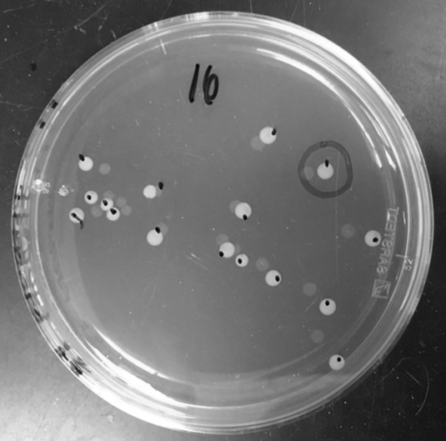Pick only one colony from one dish for each drug.
   2. Some of the colonies may be small. Use a felt-tipped marker to circle the colony (see photo) so it is easier to find when you are using a pipette to transfer the colony into media to grow.
4. Review the pipetting tips below.

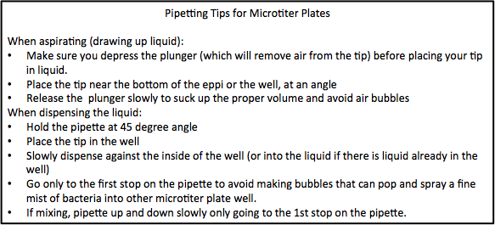

**II. Isolate antibiotic-resistant mutants**

You will use a sterile pipette tip to pick one RIF-resistant colony and one STR-resistant colony and initiate them into liquid media to grow overnight. Your TA or Peer Facilitator will also initiate one colony of the sensitive strain, which will evolve alongside the resistant strains as a control.

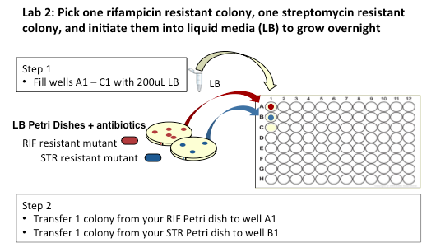

**Figure 2.1 Initiating liquid cultures of each of your two resistant strains from single colonies. Using a sterile pipette tip, you will transfer a bit of each colony into 200uL of media to grow overnight.**

**Materials**

* 2 Petri dishes with RIF-resistant *E. coli* colonies
* 2 Petri dishes with STR-resistant *E. coli* colonies
* 1 LB Petri dish with sensitive *E. coli* colonies
* 1 LB Petri dish with a sensitive lawn of *E. coli*
* 1 eppi containing LB media
* Sterile pipette tips
* 1 sterile 96-well microtiter plate

Step-by-Step Protocol

1. 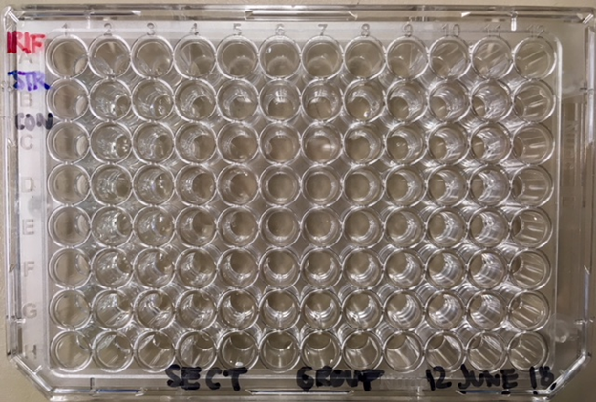On the left edge of your microtiter plate, label wells for your mutants and sensitive isolate.ByColumn 1:

* Label Well A1 **RIF**, for your rifampicin-resistant colony.
* Label Well B1 **STR**, for your streptomycin-resistant colony.
* Label Well C1 “**C**” or “CON”, for your media control well. This is your check for contamination.

1. Across the bottom of your plate, write your section, group name/number, and the date.
2. Put on gloves. Spray ethanol on your bench. Spread it across your work area with a Kimwipe or paper towel to sterilize your work area.
3. Wipe your P200 pipette with ethanol and set it to 200uL. Practicing good sterile technique, take up 200uL of LB media from the eppi tube of sterile LB, labeled “L,” that the research team prepared for you. Transfer the media into Well A1.
4. Repeat step 4 for wells B1 and C1, using a fresh tip for each well.

Next you will use a sterile pipette tip to pick cells from a colony and transfer them to liquid media. IMPORTANT: Don’t dig. *Try not to pick up any agar when you scrape up your colony.*

1. Open your Petri dish with the RIF-resistant colonies. Hold the lid to cover the rest of the dish.
2. With a sterile pipette tip, gently scrape the top of the agar where the colony is, to get cells on the tip. Do **not** stab the agar with your tip.
3. Carefully dip the tip (with cells on it) into well A1. Gently swirl the tip and drag it across the bottom of the well, to make sure that some cells come off and into the well. Discard the tip.
4. 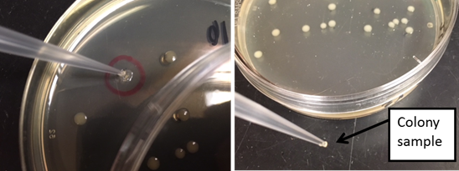With a new tip, select a single STR-resistant colony. Gently swirl this colony into well B1.
5. *No bacteria* will go into well C1. This is your media control, labeled “**C** or **CON**.” This well will tell you if your media have been contaminated.
6. Take your microtiter plate to the designated tray. A member of the research team will move the plates to the 37oC incubator for overnight growth. *Remember to keep the plate level—that is, parallel with the ground—when you are walking. This will prevent liquid from spilling*.

**III. Practice the transfer protocol**

Review the transfer protocol. Your TA will then walk you through the steps of the protocol and give you time to practice. Don’t forget to clean up your lab bench once you are done!

*IMPORTANT STEPS before leaving the lab*…

* Wipe down your bench with ethanol.
* Empty your tip-waste and non-tip-waste beakers into the appropriate collection containers.
* Dispose of your gloves in non-tip-waste.
* Wash your hands *thoroughly*.

**Next steps**

Tomorrow, a member of your group will come in to freeze a sample of your bacteria and will start daily transfers. Talk with your group to decide who will be coming into lab.

**Make protocol notes here**

### BIO1 | CURE Evolution of Antibiotic Resistance, Transfer Protocol.

**Page 1-3**, Instructions for the *first* transfer

**Pages 4-6** Instructions for the *daily* transfers

**Transfer Overview**

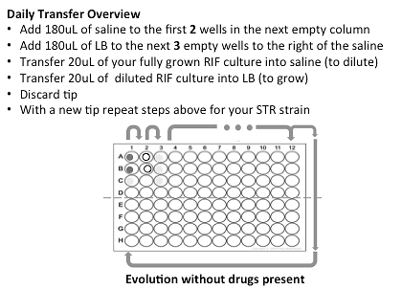You will dilute your cultures in saline, to reduce the number of cells present. Then you will transfer a small amount of diluted culture into fresh media, so that your populations of *E. coli* can continue to grow and evolve. On day 1, a member of the research team will freeze down a sample of each of your populations to use in future assays*.*

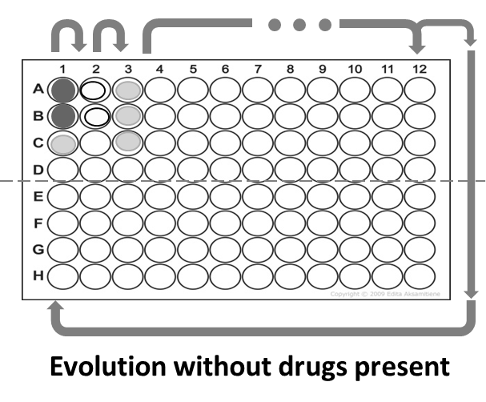

**Day 1 Transfer**

**Materials**

* 1 Microtiter plate with your growing strains
* 1 eppi tube containing 1mL of LB media (this liquid will have a yellow tint)
* 1 eppi tube containing 1mL of saline (this liquid will be clear)

**Step-by-Step Protocol**

1. If it hasn’t already been done for you, see a member of the research team about retrieving your microtiter plate [***Remember to* *keep the plate level when walking, so liquid does not spill and set it down gently on your lab bench*.**] Check your media control to make sure that it is not cloudy.

Remember that after you picked your mutants, you swirled them into wells in Column 1 to grow. When you remove it from the incubator, wells A1 and B1 should now be turbid/cloudy. Well C1 should not be cloudy: this is your media control well. If it is cloudy, contact your TA or peer facilitator.

1. Put on gloves; ethanol your bench and pipette to sterilize them.
2. Set up your workspace with the required supplies.
3. Set your P200 pipette to **180uL** and fill wells A2 – B2 (Column 2) with **180uL** of **saline**. Saline will only be used to dilute your bacteria—it is not a good growth medium. If you maintain proper sterile technique, you should not need to change tips between wells. However, if you have any reason to doubt the sterility of your tip, change to a fresh tip.
4. Load a new tip onto your P200 pipette and fill Column 3, wells A – C with **180uL** of **LB** media per well. This time, change tips with each well.
5. Set your P20 pipette to **20uL**.
6. Dilute your bacteria 10-fold by drawing up **20uL** of culture from well A1 and dispensing this volume into the well directly to its right: well A2. Mix the diluted culture by pipetting up and down—just to the first point of resistance on the pipette—inside well A2. Do this *slowly and gently—*pipetting with too much speed and force will create a fine mist of bacterial cells (aerosolization) that can contaminate your experiment and ruin it. Also, remember to keep the tip fully submerged to avoid creating bubbles.
7. Using the same tip, draw up **20uL** of the now-diluted bacteria and transfer it into the well to the right. This is well A3, and contains LB. Mix gently, as above.
8. Dispose of tip.
9. Using a fresh tip, repeat the steps above for the STR-resistant bacteria in row B.
   1. Draw up **20uL** of culture from well B1. Dispense this volume into the saline in the well directly to its right: well B2.
   2. Mix the diluted culture by *slowly and gently* pipetting up and down (just to the first point of resistance on the pipette) inside well B2.
   3. Using the same tip, draw up **20uL** of the now-diluted bacteria and dispense it into well B3, containing LB.
   4. Mix gently.
   5. Dispose of tip.
10. **Remember:** No culture goes into row C. This is your new media control—a treatment that indicates whether the media you used today is contaminated.
11. When you are done with all rows (A through C) of the transfer, contact your TA. They will use a multichannel pipette to pick up the remaining culture from Column 1 to freeze down. These frozen cultures are your progenitors. They will be reanimated (thawed out, so they can begin growing again) for your competition assays and minimum inhibitory concentration (MIC) assays in a future lab.
12. Take your microtiter plate to the designated tray. ***Remember to keep the plate level when walking so liquid does not spill***. Your TA will move the class tray to the 37oC incubator for overnight growth.
13. Clean up your lab bench.

*IMPORTANT STEPS before leaving the lab*…

* Wipe down your bench with ethanol.
* Empty your tip-waste beaker and non-tip-waste beakers into the appropriate collection containers.
* Dispose of your gloves in non-tip-waste.
* Wash your hands thoroughly.

**Daily Transfers**

*Over the next ~2 weeks, you will make serial transfers daily. At least one group member will come in each weekday (excluding University holidays) and repeat the procedure described below. You will dilute your cultures in saline and then transfer them into fresh media so that they can continue to grow, with transfers progressing from left to right across the microtiter plate. We anticipate that this protocol will take less than 15 minutes per day to complete.*

* Each time you complete a transfer, contact the rest of your group members to let them know, using a method you agree upon, such as an email or text message.

**\*\*NOTE: During drop-in sessions, you are functioning as an independent researcher. This means that *you* are responsible for your safety, the integrity of the lab space, and the quality your experiment. Peer facilitators will be present in case of emergency; they can also make sure that you are clear on proper technique during your first transfer. \*\***

**Materials**

* 1 microtiter plate with your growing strains
* 1 eppi tube containing LB media
* 1 eppi tube containing saline

**Step-by-Step Protocol**

1. If it hasn’t already been done for you, see a member of the research team about retrieving your supplies, listed above. ***Always keep the microtiter plate level when walking so liquid does not spill***.
2. 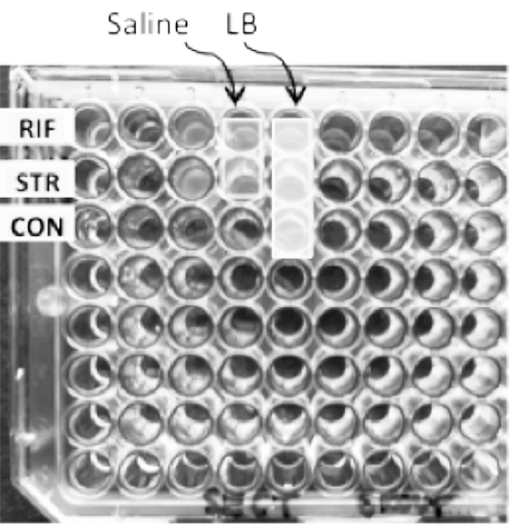Check your wells for growth and your media control well for contamination. If the control well is cloudy or if your bacteria wells are *not* cloudy, contact your peer facilitator.

**After 24hrs of growth, your microtiter plate will look similar to this photo when you prepare to do the second transfer. Remember, Column 1 was used to select your mutants. After growth, each sample was first diluted in saline in column 2 and then transferred into media, in column 3, to grow. (Note: Column 1 now looks mostly empty since sample was frozen down to use in a future lab).**

1. Put on gloves; ethanol your bench and pipette to sterilize.
2. Set up your workspace.
3. Add **saline** to the empty column that is directly to the right of the most recent fully-grown culture.To do this, set your P200 pipette to **180uL** and fill the next empty column, wells A – B with **180uL** of saline. Recall that you are using saline to dilute your bacteria; it is not a good growth medium.

If you maintain proper sterile technique, you should not need to change tips when dispensing saline. (However, if you have a momentary lapse in proper sterile technique, then change your tip.) Generally, for all other steps, besides when pipetting saline, you will want to change tips each step.

1. Load a new tip onto your P200 pipette and fill the empty column directly to the right of the saline, wells A – C, with **180uL** of LB media per well. Change tips for each well.
2. Set your P20 pipette to **20uL**.
3. Dilute your bacteria 10-fold by taking up **20uL** of culture from the well with the most recent fully-grown culture in row A. Dispense this volume into the well of fresh saline directly to the right in row A. Mix the diluted culture by pipetting up and down—just to the first point of resistance on the pipette. Keep the tip fully submerged as you do this and pipet slowly and gently, to avoid creating bubbles and causing contamination.
4. Using the same tip, take up **20uL** of the now-diluted bacteria into the well to the right containing LB. Again, gently mix by pipetting up and down.
5. Discard the tip.
6. Using a new tip, pipette **20uL** of bacteria from the well with the most recent fully-grown culture in row B. Dispense this volume into the well of fresh saline directly to the right in row B. Gently pipette up and down to mix.
7. Using the same tip, take up **20uL** of the now-diluted bacteria into the well to the right containing LB. Again, gently mix by pipetting up and down.
8. Discard the tip.
9. Row C is for your new media control. Do not transfer media from one day to the next day! (Why not?)
10. Take your microtiter plate to the designated tray, ***remembering to keep the plate level when walking so liquid does not spill***. You TA will move the class tray to the 37oC incubator for overnight growth.
11. Clean up your lab bench.

*IMPORTANT STEPS Before leaving the lab*…

* Wipe down your bench with ethanol.
* Empty your tip-waste beaker and non-tip-waste beakers into the appropriate collection containers.
* Dispose of your gloves in non-tip-waste.
* Wash your hands thoroughly.

NOTE: When you reach the end of a row, you will move to using the bottom half of the microtiter plate and follow the same steps that you did for the top half of the plate. See image below.

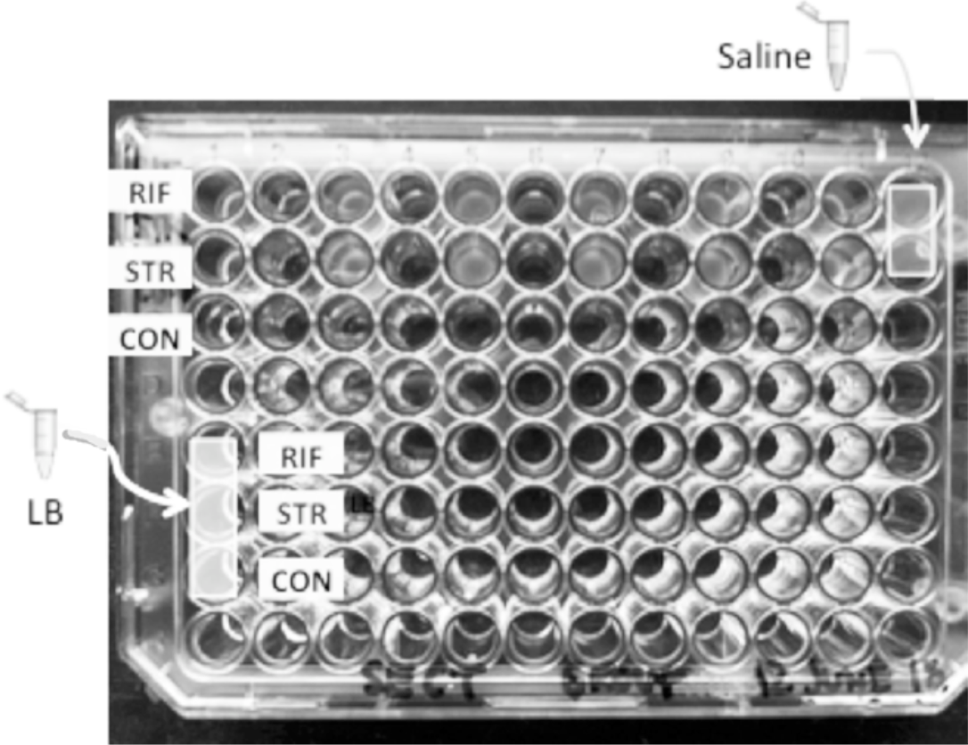

**Around Transfer 6, your microtiter plate will look similar to this photo. You will place saline in Column 12, Wells A & B, and LB in Column 1, Wells E-G, so that you can continue your transfers using the bottom half of the microtiter plate.**

**Wrap up**

At the end of the transfers, you will have the isolates that were frozen at the start and their descendants. You will be able to compare the progenitors and descendants and evaluate whether evolution with respect to drug resistance took place.

## BIO1 | CURE Lab 3 Evolution of Antibiotic Resistance

1. **Where you’ve been and where you’re going**

In Lab 1, you took a sample of bacteria and plated it onto Petri dishes with and without drugs. In Lab 2, you selected isolates that could grow on these dishes.

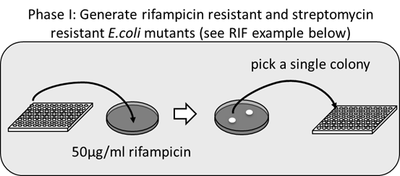

Currently, you are transferring your bacteria daily in the absence of a drug, allowing your bacterial strains to divide and grow. They are evolving, over time.

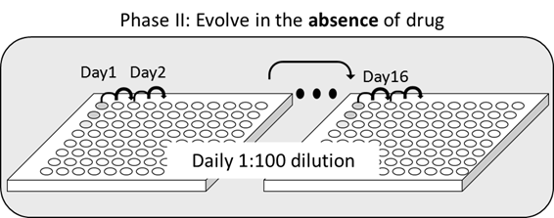

By the end of your serial transfers, your bacterial populations will have gone through many generations. To better understand the dynamics of adaptation, you will need to compare the progenitors (isolates frozen at the start of the daily transfers) to their descendants (strains from the end of the transfers). Later this quarter you will measure the relative fitness of your strains to determine if:

1. there was a fitness cost associated with drug resistance, and

2. fitness changed over time.

You will also measure levels of resistance to both rifampicin and streptomycin, to see if the levels are related and if they changed over time. These data will help you and the Kerr Lab answer a number of questions, including whether your strains have evolved collateral resistance or sensitivity.

1. **The molecular basis of resistance**

Different types of mutations arise over time in a population. Most of these mutations are neutral or detrimental with respect to fitness, but some can be beneficial. For example, the mutations that allowed your drug-resistant strains to grow on Petri dishes with antibiotics occurred at random but happened to be beneficial in that environment.

Different mutations can result in similar **phenotypes**. The mutation that enabled your strain to grow on a Petri dish containing RIF may differ from the mutation that allowed a cell to grow on a different group’s Petri dish containing RIF. These mutations produce similar phenotypes—resistance to RIF—but there may also be important differences. Why? The answer lies in the molecular basis of sensitivity and resistance to rifampicin.

Rifampicin binds to a molecular machine found in bacteria: an enzyme called **RNA polymerase**. RNA polymerase is a protein that makes an RNA copy of the genetic information encoded in DNA. This process is called **transcription**. When RIF sticks to the machine, it stops working efficiently. When transcription slows or stops, the cell can’t make proteins efficiently and dies.

Resistance to RIF occurs when mutations in the gene for RNA polymerase make RIF less likely to bind to the machine and disrupt its normal function. Based on this information, two key points should make sense to you:

1. Mutations that make RIF a little less likely to bind confer low resistance. Mutations that make RIF much less likely to bind confer high resistance. Mutations that prevent RIF from binding at all mean that the drug has no impact. Thus, the trait we call resistance is not all-or-none. It varies among cells, forming a gradient from 0 to very high.
2. In many cases, mutations that confer resistance affect how well the machine does its normal job. Specifically, resistance mutations tend make the enzyme work less efficiently when the drug is absent. When this happens, researchers say that there is a **fitness cost of resistance**. To measure this cost, you have to a) measure the growth rate of a drug-resistant strain in an environment that lacks the drug, and b) compare it to the growth rate of a drug-sensitive strain in the same environment.

To summarize, many different mutations can confer resistance. As a result, there is variation in the level of resistance and in the fitness cost of resistance. Part of your task in this week’s lab is to learn how to quantify the cost of resistance.

**III. Measuring the cost of resistance**

How will you measure fitness cost? Fitness is relative—meaning that it is only meaningful in a comparative context. Researchers can measure the fitness cost of drug resistance as a slower growth rate, reduced competitive ability, or lower survival rate in resistant cells versus sensitive cells when the drug is absent. You will be measuring relative fitness as a growth rate over a 24-hour period—specifically, the ratio of the growth rate of one strain over the growth rate of another strain.

In the image below, the growth rate of Strain A (in purple) is shown relative to the growth rate of Strains B, C, D, and E (in green). Time is plotted on the *x*-axis. The first hashmark indicates the start of growth (Day 0) and the second hashmark the end of growth (Day 1); the green and purple lines start at different points at Day 0 just so you can see them clearly. Each of the letters on the graphs (a, b, c, d, and e) refers to the slope of the line for the corresponding strain. The slope of the line, in turn, represents the strain’s growth rate.

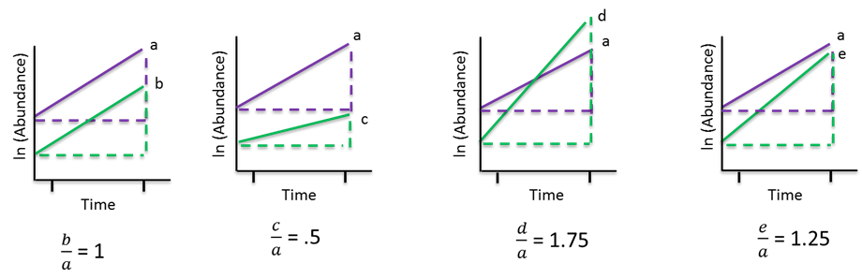

If Strain B grows as fast as Strain A, its relative fitness is 1. If Strain C grows more slowly than Strain A, its relative fitness is less than 1—meaning that Strain A has higher fitness than Strain C. In contrast, if Strain D grows faster, its relative fitness is greater than 1 and you conclude that Strain A is less fit than Strain D.

Is Strain E more fit or less fit than Strain A?

Is Strain E more fit or less fit than Strain D?

**IV. Visualizing Data**

Understanding basic data analysis and statistical inference is fundamental for all science, and an important skill for you to have in your professional toolkit. For example, it is almost always helpful to graph data so you can visualize it. Deciding how to represent a dataset graphically is important—it can influence the story that the data tell and either mislead or inform you and your readers. Specifically:

* 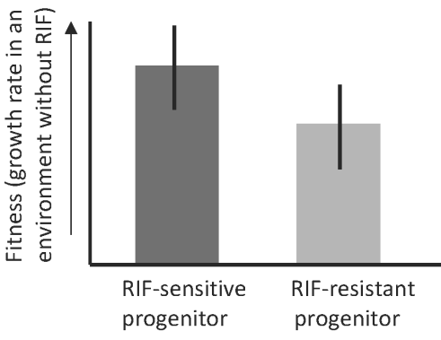Choose the right type of graph for your data;
* Think carefully about the range and the scale for the axes on the graph;
* Always make sure that your graphs are labeled properly.

A **bar graph** (also called a bar chart) plots the arithmetic average, or **mean**, from two or more groups. The mean is represented by a bar and is calculated as the sum of all the observations divided by the number of observations. The bar is almost always accompanied by a vertical line indicating the standard error of the mean—a measure of how uncertain the estimate of the mean is.

A bar chart, accompanied by an appropriate statistical test, answers a simple question: Are the two groups that you are analyzing different? Answering this question is harder than it sounds, because when you sample individuals from two groups and measure a variable like fitness in a drug-free environment, you will almost see differences in their means just by chance—even if there is actually no difference in the fitness of the two groups. The purpose of a statistical test is to quantify the probability that the differences you observe in your experimental groups are indeed due to chance, and *not* due to differences in the treatment conditions in the experiment. The results of the test tell you whether the data support the null hypothesis—of no difference between groups or no relationship between variables—or allow you to reject the null.

In Lab 3 you will use a powerful data analysis program called RStudio to:

1. Make bar graphs, and
2. Do a ***t*-test**.

The *t*-test allows you to ask whether an observed difference between two means is “significant.” The quotes are there to alert you that in statistics, significance does not mean important, as it does in everyday English. Statistical significance simply means that the probability of observing the differences that you measured, just by chance, is less than 5%. Statistical tests produce a quantity called a ***p*-value**. A *p*-value quantifies how likely your results are to be due to chance, under the null hypothesis of no difference between treatments.

In this lab you will be analyzing some data from previous work on the fitness values of RIF-resistant progenitors and the sensitive-isolate progenitor. The null hypothesis here is that the mean fitness is the same in both groups. In analyzing these data, you’ll be practicing so you can analyze the data that you’ll be generating later in the course.

**Lab 3: In Lab Protocol**

In lab, you will:

I. Complete your daily transfer;

II. Learn how to use the software program Rstudio.

III. Use Rstudio to make a bar chart and do a t-test.

**Learning Objectives**

After completing today’s lab, you will be able to:

* Explain why resistance is not all-or-none but a phenotype with continuous variation, and predict the consequences of experiments that change antibiotic concentrations over time.
* Explain why resistance can be costly in the absence of an antibiotic, and analyze methods for measuring the cost of resistance.
* Explain why researchers perform statistical analyses, in terms that a 4th grader can understand.
* Navigate the interface of RStudio, load a practice data set, and run practice analyses.

**Fitness**

In Lab 5 you will run a fitness competition assay. The data from that assay will tell you how the resistance mutation found in your bacterial cells impacts their ability to compete for resources in an environment that lacks the drug. You’ll use growth rate as an index of fitness.

Your task today is to think about how to calculate fitness and interpret the results of the fitness assay that you will do in Lab 5. Your data will help you and other members of the Kerr lab understand how resistance mutations might impact the ability of the bacteria to grow in patients who are cycling off certain drugs or switching cocktails.

When you start the assay, each lab section will start with the sensitive progenitor that your TA picked from the drug-free LB plate. This strain will be grown in the same plate as a “Common Competitor.” This common competitor consists of cells from the same strain that are marked in a different way, so you can tell the two populations apart by color. The competition environment will be drug-free, so you can measure any changes in how well the sensitive strain competes over time. The fitness (growth rate) of the sensitive strain will serve as a baseline that you can compare to the fitness of your resistant mutants.

**Comparing sensitive and resistant strains**

To measure the fitness of your resistant mutants, you will set up competitions between each of your Focal strains and the Common Competitor. The focal strains are your RIF-resistant progenitor and descendant and your STR-resistant progenitor and descendant.

Here are the steps in this assay:

* 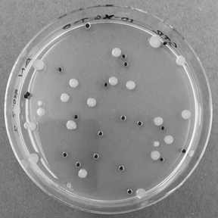You will grow a Focal strain and the Common Competitor together in a microtiter well for   
  1 day—a 24-hour growth cycle—in the absence of drug.
* At the start of each competition, you will spread samples from each well onto Petri dishes to grow.
* After growth on the Petri dish, you will count the colonies to measure the *initial* numbers of cells for your Focal strains and for the Common competitor.

NOTE: All of the Focal strains will form BLUE colonies on an indicator petri dish. The Common Competitor will form WHITE colonies.

* At the end of the competition cycle, you will again spread samples of bacteria on Petri dishes to determine the *final* number of cells of each type.
* You will enter colony counts, which indicate the number of cells of each strain present, into a database and calculate fitness.

If the two strains start the competition experiment with equal numbers of cells, then the strain with more cells at the end of the growth period must have a higher growth rate, meaning that it is better-adapted to the experimental environment.

With the data from these assays, you will be able to:

1. Assess how fit the resistant mutants are compared to the sensitive isolate.   
   This will allow you to determine whether there is a cost to resistance in your strains.
2. See how the average fitness changes over time by comparing the progenitors to their descendants.

**Make notes on fitness here:**

**Using RStudio**

RStudio is an interface for analyzing data in R—a popular and free programming language for data analysis and statistics. Most professional scientists and engineers use R (or another language called Python) to graph, interpret and analyze their data. Today you will harness the power of R by working with a pre-written **script**—a set of instructions that tells R how you want to analyze your data.

You will download files and place them into a folder on the Desktop of your computer. Step-by-Step Instructions for the rest of the lab are given in the Source Code frame of Rstudio (or in the appendix). Follow them carefully; make sure to check with your TA or PF or a neighboring group if you get confused momentarily. The appendix “Using RStudio to do Statistical Tests and Make Graphs” has some helpful information on using Rstudio.

At the end of the lab, congratulate yourself! You now know how to do everything you will need to do to analyze the fitness data you’ll be collecting from your experiment. Just as important, you have begun learning how to use one of the most important and powerful software tools available for analyzing biological and biomedical data. Go Dawgs!

**Make notes on statistics and Rstudio here:**

**Lab 3: RStudio protocol**

**Introduction to Statistics**

Welcome to RStudio! This may be one of your first experiences with coding, and you may be feeling a little apprehensive. However, with the instructions in this R script, and your TA and peer facilitator on hand, we are confident you will quickly realize how simple and powerful coding is. This is important because the number of careers that require coding skills is growing rapidly, and if you can gain some coding skills now, you will be highly competitive candidates for these types of jobs when you graduate from UW!

In today’s lab you will get to practice using *t*-tests and interpreting the results. This will be useful for your next exam and for when you analyze your lab data later this quarter. By the end of this lab, you will be able to: 1) Recognize data that can be analyzed with a *t*-test, 2) run a *t*-test in RStudio, 3) interpret the results of a *t*-test, and 4) explain why statistics are important in Biology.

**Part 1: Loading and exploring data**

To get started, you will need to tell R to use some commands that the BIO 180 teaching staff have edited. These edited versions will more useful for your needs. To load them, run the following line of code

source("AdditionalFunctions.R")

To start practicing *t*-tests, you are going to need some data. The file you will use today contains fitness data collected by students in previous quarters of BIO 180. It is the same type of data you will be collecting in Lab 6. Load these data into RStudio and save the file under the name “classData” by running the following line of code

classData <- read.csv("ClassData.csv")

Whenever you are analyzing data, your first task should be to look at it. Do this by clicking on the name “classData” in your Environment (see top-right panel of the screen). Each row in the data represents a single strain of *E. coli*. As you move across the columns, you will see that for each strain you have information on: whether it is a progenitor (PRO = frozen at the end of lab 1) or a descendent (DES = underwent serial transfer), the drug that was used at its isolation (NONE = sensitive strain), and its fitness measured through the competition assay. The final column “PROBLEM.IDENTIFIED” contains 0 or 1, with 1s indicating that there is an issue with the data and therefore the strain should not be included in the analyses.

Use the code below to remove these problem strains from your data so you don’t accidentally include them in your analysis

classData <- subset(classData, classData$PROBLEM.IDENTIFIED == 0)

Great work! Your data are now ready for statistical analysis! Before moving on to the next section, be sure to complete Part 1 of your worksheet.

**Part 2: *t*-test**

Recall that *t*-tests are used to ask questions of the form “Is A different from B?” To use a *t*-test, you need an independent/explanatory variable that is categorical and a dependent/response variable that is continuous. To practice the *t*-test, you are going to ask whether there is a fitness cost to RIF resistance. To do this you will compare fitness between RIF-resistant progenitors and RIF-sensitive progenitors.

Before continuing, work with your lab group to complete questions 4-6 on your worksheet. You will write out your hypothesis and corresponding null hypothesis for this *t*-test, and draw a graph of your expected results under both your hypothesis and the null hypothesis.

Next, restrict your dataset to only the RIF-resistant progenitors and RIF-sensitive progenitors (the only strains you need to test your hypothesis), and call this new dataset “RIFvsSENFitness:”

RIFvsSENFitness <- subset(classData, classData$PRO.OR.DES == "P" &   
 classData$DRUG.AT.ISOLATION %in% c("RIF", "NONE"))

Now you can do a *t*-test by running the next line of code. When you do this, the output of your *t*-test will appear below. Make sure you can find the *p*-value in this output.

t.test(FITNESS ~ DRUG.AT.ISOLATION, data = RIFvsSENFitness)

##   
## Welch Two Sample t-test  
##   
## data: FITNESS by DRUG.AT.ISOLATION  
## t = 11.373, df = 39.066, p-value = 5.786e-14  
## alternative hypothesis: true difference in means is not equal to 0  
## 95 percent confidence interval:  
## 0.1802701 0.2582579  
## sample estimates:  
## mean in group NONE mean in group RIF   
## 1.022792 0.803528

Now plot your data by running the next line of code:

barGraph(dependent <- RIFvsSENFitness$FITNESS,  
 independent <- RIFvsSENFitness$DRUG.AT.ISOLATION,  
 ylab <- "Fitness",  
 xlab <- "Drug at isolation",  
 main <- "Fitness cost of RIF resistance")

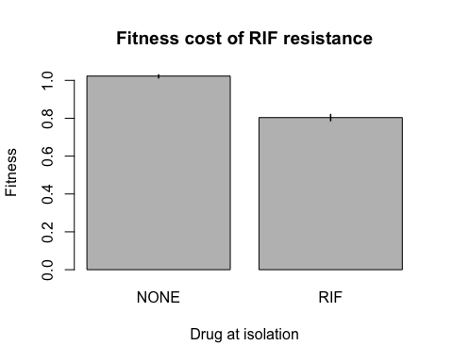

Now that you have done a *t*-test and plotted the means and SEs, return to your worksheet to describe and interpret your results (do questions 7 and 8).

**Part 3: *t*-test with paired data**

In this section you will practice using a special kind of *t*-test called a paired *t*-test. When is a paired *t*-test appropriate? Consider an example: Imagine you are asking whether a new medicine decreases blood pressure. You get a group of volunteers and measure each volunteer’s blood pressure before taking the medicine, and then measure their blood pressure again after they have been taking the medicine for 5 weeks. To determine whether the medicine works, you could use a regular *t*-test (like the one you used earlier) to determine whether blood pressure differs between the “before medicine” group and the “after medicine” group. However, this test could return a significant result even if most volunteers’ blood pressure did not change, but a few volunteers’ blood pressure decreased A LOT. A better way to test whether the medicine works is to calculate the change in blood pressure for each volunteer and then test if the of all the changes was a decrease. This is what a paired *t*-test does.

In your experiment this quarter, you will be generating your own before-and-after data. Specifically, you will have progenitor (= before serial transfer) and descendent (= after serial transfer) strains of *E. coli*. You will want to test whether serial transfer changed the fitness of your RIF strains. Does fitness differ between the RIF progenitors and the RIF descendants?

Before continuing, work with your lab group to complete questions 9-11 of your worksheet: Write out your hypothesis and corresponding null hypothesis for this paired *t*-test, then draw a graph of your expected results under both your hypothesis and null hypothesis.

Now make a dataset that contains only the RIF strains (progenitor and descendants), and call it “RIFStrains:”

RIFStrains <- subset(classData, classData$DRUG.AT.ISOLATION == "RIF")

Remove from your dataset any strains for which there isn’t both an progenitor and a descendent. These strains are not paired, so they can’t be used in the paired *t*-test.

RIFStrains <- removeUnpaired(data = RIFStrains, pairID = RIFStrains$GROUP)

Now create another new dataset where the progenitor and descendent fitness data are in separate columns and where each row contains a pair (one progenitor and its descendent). Call it “RIFPaired.” After running this code, be sure to look at the new dataset by clicking on its name in your Environment (top-right panel of RStudio).

RIFPaired <- RIFStrains[RIFStrains$PRO.OR.DES == "P", c("GROUP", "FITNESS")]  
RIFPaired$DES.FIT <- RIFStrains[RIFStrains$PRO.OR.DES == "D", "FITNESS"]  
colnames(RIFPaired)[2] <- "PRO.FIT"

Great! Now your data are ready for the paired *t*-test. Go ahead and run it! Be sure to find the *p*-value in the output that will appear below

t.test(RIFPaired$PRO.FIT, RIFPaired$DES.FIT, paired = T)

##   
## Paired t-test  
##   
## data: RIFPaired$PRO.FIT and RIFPaired$DES.FIT  
## t = -8.9771, df = 24, p-value = 3.871e-09  
## alternative hypothesis: true difference in means is not equal to 0  
## 95 percent confidence interval:  
## -0.203658 -0.127518  
## sample estimates:  
## mean of the differences   
## -0.165588

Plot your data using the next section of code. Note that the lines on the plot connect the paired progenitors and descendents (from the same lab group)

pairedPlot(before = RIFPaired$PRO.FIT, after = RIFPaired$DES.FIT, ylab = "Fitness",  
 main = "Change in RIF fitness over time")

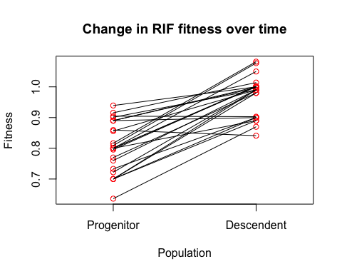

Congratulations! You have loaded data into RStudio, reorganized your data, and conducted both a *t*-test and a paired *t*-test! To finish off lab 3, get back together with your lab group and interpret the results of your paired *t*-test, so you can answer the final questions (12-14) on your worksheet. If you want to keep a copy of your analysis in RStudio, you can create an html file from this script (hit the “Knit” button at the top) and email it to yourself.

## BIO1 | CURE Lab 4 Evolution of Antibiotic Resistance

**I. Background Information**

Currently you are transferring your bacteria daily, allowing your bacterial strains to divide and grow. By the end of your serial transfers, your bacteria will have grown for almost 100 generations! To better understand the dynamics of adaptation, we can compare the progenitors (which were frozen in Lab 2) to their descendants (from the end of the transfers). This comparison will tell you whether resistance levels and/or average fitness of your strains changed over time.

In our discussion last week, you started to explore the complexities of resistance more deeply. We discussed that there are a variety of potential mutations that could confer resistance to the same drug, and that different mutations may have different effects on the level of resistance and on growth rate.

In Lab 5 next week, you will be conducting two assays designed to answer some of the key questions motivating this research. Data from those assays will help us answer a series of questions:

* Is there a fitness cost of resistance?
  + If there is a cost, is it consistent across strains that are resistant to the same drug? Or is there variation in the cost associated with different mutations?
  + Will the fitness cost of resistance decrease or disappear, due to compensatory mutations that arise when the bacteria are transferred daily? Recall that compensatory mutations diminish the cost of resistance—meaning that resistant cells grow more efficiently when the drug is absent.
  + Will the level of drug resistance change when the bacteria are transferred daily in the absence of drug? Specifically, will your resistant cells evolve in a way that makes them revert back to sensitivity?
* Does resistance to one drug correlate with resistance or sensitivity to second drug?

This week’s lab focuses on the possibility of bacteria evolving collateral sensitivity or resistance to other drugs. In addition, you will continue using RStudio to make graphs and learn statistical analyses that will help you interpret the data you’ll be collecting in the Lab 5 assays.

**II. Collateral Effects**

Last week’s lab introduced the idea that antibiotic resistance is not binary—cells are not either completely sensitive or completely resistant. Resistance is a continuous phenotype that ranges from sensitive to slightly resistant to highly-resistant and everything in between. This is because mutations that confer resistance to a given drug may affect components of the essential cellular growth machinery in different ways. In addition, you analyzed why resistance can have a fitness cost, meaning that resistant cells may not grow as well as sensitive cells in an environment that lacks the drug.

Research has also shown that mutations conferring resistance to one antibiotic can increase or decrease a bacterial strain’s resistance to another antibiotic. When an organism that has evolved resistance to one antibiotic (“Drug x”) displays increased sensitivity or increased resistance to another antibiotic (“Drug y”), the effect of Drug x resistance on Drug y resistance is called a **collateral effect**.

In many or most cases, researchers still do not know the molecular mechanism responsible for collateral effects. One possibility is a phenomenon known as genetic hitchhiking. To understand how this works, imagine a population of gumballs where small gumballs *just happen* to be yellow and large gumballs tend to be other colors.

If the population of gumballs is in a gumball machine and the spout-size selects for smaller gumballs, what kind of gumballs come out most often? The answer is small gumballs, which coincidentally are yellow. 

Essentially, traits that are *not* the direct target of selection may co-occur (coincide) with traits that *are* directly selected. In our gumball example, yellowness was co-occurring with the selected property of smallness. Collateral effects with respect to drug resistance may be a function of the evolutionary response to a *single* antibiotic (spout-size), with resistance to a second antibiotic hitchhiking along like yellowness on small gumballs.

Another possibility is **pleiotropy**: when a single gene affects more than one trait. For example, it is possible that changes in the gene for RNA polymerase that confer resistance to RIF also impact the cellular machine that is targeted by STR.

Three outcomes are possible when you investigate whether the evolution of resistance to the antibiotic rifampicin (RIF) increases or decreases levels of resistance to the antibiotic streptomycin (STR):

* **No collateral effect:** If cells that are resistant or sensitive to RIF exhibit the same level of resistance to STR, then there is no evidence of a collateral effect for this pair of drugs.
* **Collateral resistance**: If RIF-resistant cells are more resistant to STR than RIF-sensitive cells, they show collateral resistance to STR.
* **Collateral sensitivity**: If RIF-resistant cells are more sensitive to STR than RIF-sensitive cells, they show collateral sensitivity to STR.

Research has shown that the evolution of resistance to a single antibiotic frequently results in increased resistance to another antibiotic. Much less is known about the frequency and mechanism of collateral sensitivity.

Recall that collateral effects are important in clinical settings—especially when patients are receiving multiple drugs concurrently (a **drug cocktail**) or sequentially. Sequential use is called **drug cycling**, and works by prescribing one drug and then switching to another after a period of time. Cocktails and cycling are two approaches that clinicians are using to cope with the crisis of widespread antibiotic resistance.

The drugs that you are investigating this quarter target different aspects of the cellular machinery. Rifampicin binds to RNA polymerase and interferes with transcription; streptomycin binds to ribosomes—the machines where proteins are synthesized—and interferes with the process called **translation**. The two drugs are sometimes prescribed together when physicians are treating patients with tuberculosis (TB). Because TB is one of the three most important infectious diseases in the world today—the other two are AIDS and malaria—the work that you are doing really matters.

When we complete our MIC assay, we will place our RIF-resistant progenitors and descendants and our STR-resistant progenitors and descendants into two microtiter plates. One microtiter plate will be filled with a drug gradient of rifampicin and the other will contain a drug gradient of streptomycin. We can start to investigate collateral effects by looking at how well a strain that is resistant to one drug grows in the presence of a second drug, and vice versa.

**III. Determining MIC**

To analyze whether collateral effects occur in your cells, you will need to measure how resistant they are to both RIF and STR. You will do this by measuring the **Minimum Inhibitory Concentration (MIC)**, which is the lowest concentration of an antibiotic that inhibits cell growth during an overnight incubation. You will estimate MIC using the same **assay**—an analysis that detects the presence or amount of substance—that professional researchers and clinicians use. Doing the MIC assay will also help you to visualize and understand the continuous nature of resistance.

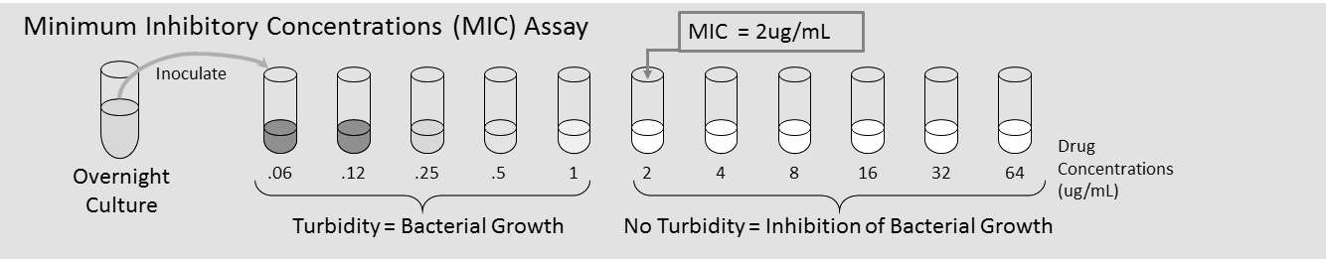

This figure shows a set of test tubes containing growth media plus a drug of interest. The tube on the left contains the lowest concentration of drug; each tube to the right contains a progressively higher drug concentration, from 0.06 to 64 𝛍g/mL. Once this gradient is set up, a fully-grown overnight culture of bacteria is inoculated into each of the tubes at the same time (“t= 0”). After 24 hours of incubation, you can observe which test tubes contain bacterial growth: Media in tubes with growth will appear to be cloudy, or turbid, but the media in tubes with no growth will look clear. As you scan from left to right, up the increasing series of drug concentrations, the first test tube in which there is *no* bacterial growth contains the drug concentration that is referred to as the MIC. This is the lowest (minimum) concentration of drug that prevented (inhibited) bacterial growth. In the example shown, the MIC is 2𝛍g/mL. Stated another way, once the drug concentration is at (or above) 2𝛍g/mL, we expect this strain of bacteria to be inhibited.

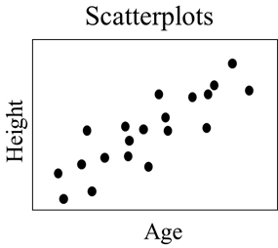**IV. Statistics Part 2: using linear regression**

A **scatterplot** shows the relationship between two continuous variables, with one graphed on the horizontal axis and the other graphed on the vertical axis. In this week’s lab you will be learning how to make scatterplots in Rstudio and how to analyze the relationship between two variables (MIC and Fitness) using **linear regression**.

Recall that linear regression:

1. Fits a line that best-describes the relationship between a predictor (or independent) variable on the *x*-axis and a response (or dependent) variable on the *y*-axis; and
2. Tests whether the slope of that line is significantly different from zero. Zero is the slope that is consistent with the null hypothesis of no relationship between the variables. The *p*-value reported from the analysis tells you how often you would get a slope as large or larger, by chance, when the null hypothesis is correct.

**Lab 4: In-Lab protocol**

In lab, you will:

I. Analyze the logic of an MIC assay;

II. Begin to explore the concept of collateral effects;

III. Continue practicing the methods you will use to analyze and interpret your data in RStudio.

**Learning Objectives**

After completing today’s lab, you will be able to:

* Identify examples of possible collateral sensitivity and collateral resistance, given MIC data for five different antibiotics in an *E. coli* population selected for resistance to RIF.
* Design a treatment plan that would cure patients and slow the evolution of antibiotic resistance, given data on collateral sensitivity and collateral resistance in a suite of antibiotics,.
* Use RStudio to graph, interpret, and analyze data.

**Part I: Determining “MIC” using a Plate Diagram**

MIC stands for “Minimum Inhibitory Concentration.” The aim of an MIC assay is to determine the lowest drug concentration that inhibits the growth of the bacterium being investigated. Variations of this assay are done routinely in both research labs and clinical settings.

This week you’ll be learning how to do MIC assays. Next week you’ll be doing them. Specifically, you will test both RIF and STR on your *E. coli* progenitors and descendants from the sensitive, RIF-resistant, and STR-resistant strains. (Recall that your progenitors and descendants come from the beginning and end of your serial transfers.) So, you’ll test 6 strains x 2 drugs = 12 assays total. In addition, you’ll do two replicates of each assay.

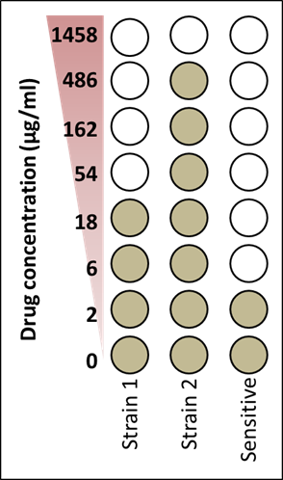

As the figure on the right shows, MICs work by testing the ability of cells from the same population to grow in increasing concentrations of the drug you’re investigating. In our experimental setup, the wells in the bottom row (Row H) will be drug-free. Wells in the next row up will contain the lowest drug concentration, and each row of the plate moving upwards will contain a higher concentration of the drug until we reach the highest drug concentration (Row A). Each of the wells in a given column of the microtiter plate will be inoculated with the same strain.

After incubation, you will examine the wells to see if the media is cloudy or clear. This will indicate growth or no growth. In the image above, Strain 1 has an MIC value of 54 g/mL, Strain 2 has an MIC of 1458 g/mL, and the Sensitive strain has an MIC of 6g/mL. Which is most drug resistant?

Step-by-step details of the MIC assay will be described in the next lab. For now, you will practice using MIC data summarized in MIC Plate Diagrams provided by your TA.

**Reading a plate diagram**

* Drug concentrations *decrease* as you go down the rows, from the highest concentration in Rows A at the top to the lowest concentration in Row G at the bottom of the plate.
* The MIC is designated as the lowest drug concentration at which your strain failed to grow.

1. We call a strain “resistant” when its MIC exceeds that of a reference sensitive strain. In our case, the reference strain—the cells that were never exposed to drugs—is called SEN for progenitors and SEN.D for descendants.
2. Different resistant strains can differ in the degree of their resistance. The greater the MIC, the greater the strain’s level of resistance to the drug.

* In each microtiter plate, each strain has been inoculated in two neighboring columns, giving us two replicates to determine MIC for each strain. Consistency among replicates gives us more confidence in the results.
* In the diagrams that you’ll be working with, darker shades of gray represent greater well turbidity; lighter shades of gray represent lower turbidity; lightest gray means there was no growth in that well. Turbidity is cloudiness due to bacterial growth.

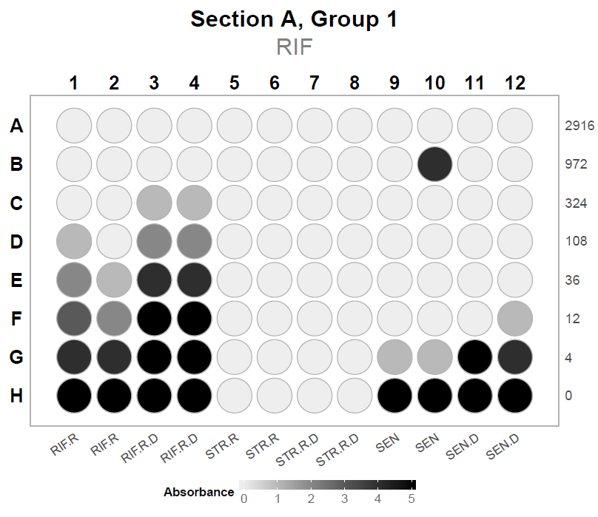**MIC practice**

1. Your TA will give your group an MIC Plate Diagram to analyze. You’ll use sample data for a strain isolated off a rifampicin plate (RIF.R) and its descendant (RIF.R.D), and compare their MICs to the sensitive (SEN) strain.

Drug concentrations are labeled at the end of each row. Strain identities are labeled below each column.

1. Look at the diagram and compare the 2 replicates for each of the 4 strains: RIF.R, RIF.R.D, SEN, and SEN.D. Determine which drug concentration inhibits growth.

**NOTE**: The MIC value is the smallest drug concentration where *at least one* of the two replicates has no growth. For example, if one replicate shows no growth above a drug concentration of 36𝛍g/mL and the other replicate shows no growth above 12𝛍g/mL, the MIC value for this strain will be the lower of the two values: 12𝛍g/mL.

1. Be sure to diagnose any problems on your Plate Diagram. Is there a gap in the turbidity/grayness of a culture? Are there inconsistencies between your replicates? There might be no growth where we expect growth, or growth in wells where it is not expected (e.g. see column 10 in the image above). Your group should discuss why these issues might arise. We will revisit these proposed explanations when you receive your actual MIC data.

**Make notes on the MIC assays here:**

**Part II: Collateral Effects**

Physicians often switch a patient from one antibiotic to another antibiotic when the bacteria that are causing an infection evolve resistance to the first antibiotic. In some cases—enough to cause problems in treating patients—the health care providers find that the cells that are causing the infection don’t respond to the second antibiotic. Stated another way, there seems to be collateral resistance. Collateral resistance has not been studied thoroughly yet, and the Kerr lab is interested in understanding it better. How common is collateral resistance? Why does it happen? Does collateral sensitivity occur?

Your TA will lead a discussion on how you can use MIC data to document whether your RIF-resistant and STR-resistant cells show collateral effects.

**Make notes on collateral effects here:**

**Part III: RStudio and Statistics Part 2: Using a linear regression**

Last week you got introduced to RStudio—a software environment used to write and execute programs in the R programming language. (Remember that the appendix “Using RStudio to do Statistical Tests and Make Graphs” has some helpful information on using Rstudio.) Today we will use RStudio again to analyze whether there is a relationship between MIC and Fitness, using linear regression. A working understanding of statistics is essential for almost any field related to biology. Let’s collaborate on building our statistical skills!

A simple linear regression is the appropriate statistical test to use when you are analyzing two variables that represent continuous data, and when you want to determine whether or not the two variables are related. In this lab, you will investigate whether there is a relationship between MIC and fitness.

As you learned in Lab 3, resistance is not all-or-none; it varies among cells. In addition, you learned that mutations that confer resistance often affect how well the machine that is targeted by a drug does its normal job. The consequence of these two observations is that some mutations have a higher fitness cost than other mutations. For example, mutations that confer extremely high resistance can also have a high fitness cost, because individuals with the “mutant machines” can’t grow as well as cells with “normal machines” when no drug is present.

Can a strain’s MIC predict its fitness in the absence of the drug? If so, what does such a relationship mean?

To answer these questions, you will use a **linear regression** model.

First, you’ll need to generate a scatterplot with one point graphed per strain. The *x*-axis should be the MIC relative to SEN); the y-axis should be relative fitness (from the competition assay).

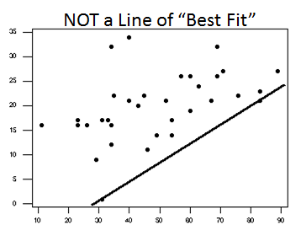When you do a regression analysis on the data, R will calculate the **line of best-fit**. A line of best-fit is a mathematical function that minimizes the distance that each point is away from the line. Here it will tell us whether we can use our knowledge of a strain’s MIC to predict its fitness level.

* If the slope of the line is 0, then there is no relationship between MIC and Fitness. A 0 slope is consistent with the null hypothesis.
* If the slope is positive, it means that Fitness increases as MIC increases
* If the slope is negative, it means that Fitness decreases as MIC increases

Most of the functions that you will encounter in Biology 180 are linear, meaning that they have the form *y* = *ax* + *b*, where *a* is the slope of the line and *b* is the *y*-intercept.

Once you’ve used RStudio to run a regression, locate the *p*-value and the R2 value. R2 is a percentage that tells you how much of the variation in the *y*-variable (here, fitness) is explained by the *x*-variable (here, MIC).

Congratulations! Now you know more about statistical tests and how to manipulate a pre-written R-script to analyze data. The teaching team will provide you with a more complicated script, along with careful guidance, that will help you analyze your own data later this quarter, using the skills you built this week.

**Make notes on linear regression and Rstudio here:**

**Wrap Up**

Next week you will be setting up two assays: one to estimate minimum inhibitory concentration (MIC) and one to estimate fitness.

The MIC assay will measure the RIF- and STR-resistance levels of your team’s strains of the:

* Sensitive isolate (to use as a baseline for comparisons);
* RIF progenitors and descendants; and
* STR progenitors and descendants.

The fitness assay data, from the progenitors and descendants of your team’s strains, will enable you to:

* + - Draw conclusions about whether resistance-conferring mutations in progenitors had a fitness cost; and
* Generate hypotheses about the types of mutations that changed the cost of resistance over time. You’ll do this by comparing descendants to progenitors, using both the fitness and MIC data.

**Lab 4: RStudio protocol**

**MIC and Collateral Effects**

Welcome back, experienced RStudio users! Let’s get straight to it with today’s learning goals. By the end of this lab, you will be able to: 1) Recognize data that can be analyzed with a linear regression, 2) Deploy a linear regression in RStudio, 3) Interpret the results of a linear regression, and 4) Explain why we expect to see a relationship between MIC and fitness.

**Part 1: Loading and exploring data**

To practice using linear regression, you will be using fitness and MIC data collected by students in previous quarters of BIO 180 (the same data you will be collecting in lab 6). Load this dataset into RStudio and save it under the name “classData” by running the following line of code

classData <- read.csv("ClassData.csv")

Remember to look at these data again to remind yourself how the file is organized (hint: look at the data by clicking on the filename in the Environment panel). When looking at the data, you will see that the last column is called “PROBLEM.IDENTIFIED” and contains 0s and 1s. Recall that the 1s indicate that there was a problem with the data in that row. Remove those rows from your data by running the following line of code

classData <- subset(classData, classData$PROBLEM.IDENTIFIED == 0)

**Part 2: Linear regression**

Recall that linear regression is used to answer questions of the form “is there a relationship between A and B?” To use linear regression we need both our dependent and independent variables to be continuous. To practice linear regression, you will be testing whether there is a relationship between MIC and fitness. The theory behind why there might be a relationship between MIC and fitness is a little tricky, so let’s work through it together.

Antibiotics kill bacteria by interfering with essential machinery in the bacterial cell. When this machinery doesn’t work properly, the bacterium cannot survive. The antibiotic can only mess up the machinery if it binds to it, and it can only bind to it if the machine is a particular shape. If a bacterial cell is resistant to an antibiotic, it is usually because its version of the machine has a slightly different shape, due to a mutation in the gene for that machine, so that the antibiotic can no longer bind to it as well. Unfortunately for the resistant bacterium, this new shape usually means that the machine can’t do its job as well as it did before a mutation changed its shape. This produces the cost of resistance that you learned about in previous labs.

In today’s lab, you went one step further and learned that bacteria can have different levels of resistance, and that you can measure these levels by MIC). In most cases, bacteria with weak resistance have only slight changes in the shape of their machine, so the antibiotic is still able to bind to it off and on. However, this small change in shape also means that the machine can still do its normal job, so these bacteria experience a low cost of resistance. Bacteria with high resistance have machinery with a very different shape, so the antibiotic almost never binds and interferes with its operation. But it also can’t do its job very well, which means that the cells experience a high cost of resistance.

Using this information, you should be able to make a prediction about the relationship between MIC and fitness. Be sure to ask your TA and/or peer facilitator about this if you are unsure—this is a tricky concept!

Now that you have a prediction, you can create a new dataset for analysis that only contains the RIF progenitors. Call it “FitVsMIC”:

FitVsMIC <- subset(classData, classData$PRO.OR.DES == "P" &   
 classData$DRUG.AT.ISOLATION == "RIF")

Now run your linear regression and save the output under the name “FitVsMICModel”:

FitVsMICModel <- lm(FITNESS ~ MIC1, data = FitVsMIC)

The next line of code will print a summary of your linear regression. Make sure you can find your *p*-value (fourth column, second row of the coefficients table) and R-squared value (Multiple R-squared - second row from the bottom of the output)

summary(FitVsMICModel)

##   
## Call:  
## lm(formula = FITNESS ~ MIC1, data = FitVsMIC)  
##   
## Residuals:  
## Min 1Q Median 3Q Max   
## -0.16871 -0.04481 -0.02027 0.06973 0.11377   
##   
## Coefficients:  
## Estimate Std. Error t value Pr(>|t|)   
## (Intercept) 8.280e-01 2.308e-02 35.879 <2e-16 ***  
## MIC1 -2.147e-05 1.445e-05 -1.487 0.151   
## ---  
## Signif. codes: 0 '***' 0.001 '**' 0.01 '*' 0.05 '.' 0.1 ' ' 1  
##   
## Residual standard error: 0.08086 on 23 degrees of freedom  
## Multiple R-squared: 0.08766, Adjusted R-squared: 0.048   
## F-statistic: 2.21 on 1 and 23 DF, p-value: 0.1507

Finally, make a scatterplot of your data

plot(FitVsMIC$FITNESS ~ FitVsMIC$MIC1, ylab = "Fitness", xlab = "MIC",  
 main = "Fitness vs. resistance to RIF")  
abline(FitVsMICModel)

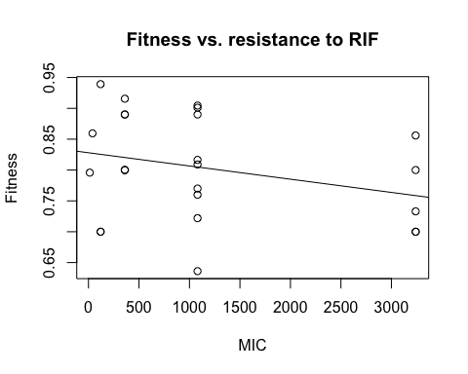

Nice work! You have now run a linear regression in RStudio! To finish off this lab, get back together with your lab group. Interpret the results of your linear regression and answer the final questions on your worksheet. And remember, if you want to keep a copy of your linear regression analysis, you can create an html file from this script by hitting the “Knit” button at the top and emailing it to yourself.

## BIO1 | CURE Lab 5 Evolution of Antibiotic Resistance

**Learning Objectives**

After completing today’s lab, you will be able to:

* Explain how data from your MIC assays will allow you to assess a) changes in antibiotic resistance over time, and b) whether collateral resistance or sensitivity occurs.
* Explain how data from your competition assays will allow you to assess the cost of resistance in progenitors and descendants of each of your strains.

**I. Background Information**

This week is the end of the experimental evolution phase of your research. Thanks to your serial transfers, your bacteria will have grown for almost 100 generations. Now you can compare the progenitors (which were frozen in Lab 2) to their descendants (from the end of the transfers) to determine whether resistance levels and/or average fitness changed over time.

This week you will be conducting two assays designed to answer some of the key questions motivating the investigation:

* Is there a fitness cost of resistance?
  + If there is a cost, is it consistent across strains that are resistant to the same drug? Or is there variation in the cost associated with different mutations?
  + Will the fitness cost of resistance decrease or disappear, due to compensatory mutations that arise when the bacteria are transferred daily?
  + Will the level of drug resistance change when the bacteria are transferred daily in the absence of drug? Specifically, will your resistant cells evolve in a way that makes them revert back to sensitivity?
* Does resistance to one drug correlate with resistance or sensitivity to second drug?

This week’s tasks:

1. Complete your final transfer
2. Re-animate your progenitors
3. Start up the common competitor strain for it to grow overnight

These steps will be done by the lab *prep team*, the day before your lab. During your lab, *you* will

1. Start the MIC assay and the Fitness competition assay
2. Freeze your descendants for future use by other collaborators

The day *after* your lab, a member of your lab group will come in to

1. Finish your Fitness competition

Next week’s tasks:

1. Count your *t* = 0 and *t* = 1 Petri dishes for the fitness competition assays
2. Analyze your MIC microtiter plates.

**II. MIC Assay: An overview**

Last week’s lab introduced you to the concepts of collateral resistance and collateral sensitivity to antibiotics. To investigate whether your strains show collateral effects with RIF and STR resistance occur, and to analyze whether the level of resistance changed during experimental evolution, you will be determining the **Minimum Inhibitory Concentration** (**MIC**) of your progenitors and descendants in both the RIF-resistant and STR-resistant strains. Recall that MIC gives you a quantitative measure of how resistant each bacterial strain is to each drug.

To complete the MIC assay, you will place your RIF-resistant progenitors and descendants and your STR-resistant progenitors and descendants into two microtiter plates. One microtiter plate will be filled with a drug gradient of rifampicin and the other will contain a drug gradient of streptomycin. This will allow you to investigate collateral effects by looking at how a strain that is resistant to one drug grows in the presence of a second drug, and vice versa.

To measure MIC, you will have microtiter plates that contain a gradient of **rifampicin** OR a gradient of **streptomycin**. Review the image below. On the left, the shading in the wells represents drug concentration. Row H lacks any drug, Row G has a low dose of the drug, and each row moving upwards has a 3-fold higher concentration of the drug. The highest drug concentration is located in Row A. The labels below each column indicate the strain that you will add to all 8 wells in that column; the designation “.d” indicates the strain is a descendant. Note that you will make 2 replicates for each strain.

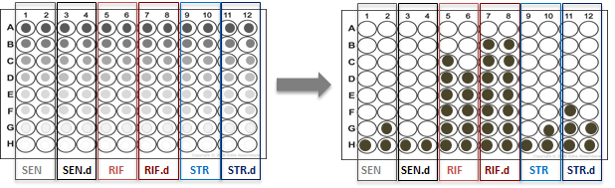

The plate on the rightshows what the plate might look like after 24 hours of bacteria growth, with filled circles indicating that bacteria were able to grow in that well.

**III. Competition Assay: An overview**

Several of the questions that motivate this research focus on the fitness cost of resistance. Although the cost of resistance is highly variable, it is typically observed as a reduced bacterial growth rate in the absence of the drug.

As you did daily transfers, your resistant strains evolved in the absence of antibiotics, to mimic what might happen in patients who stop taking a drug. In this environment, there should be intense selection favoring cells with a reduced cost of resistance. This could lead to

1) back-mutations that undo the original mutation, so descendants revert to drug-sensitivity; or

2) compensatory mutations that decrease the fitness costs of the original mutation.

This week your group will estimate the cost of resistance by measuring how well each of your strains grows in a head-to-head competition with a common competitor strain. You will measure the starting numbers of each strain (*t* = 0) and the ending numbers of each strain (*t* = 1), so you will be able to determine which strain grew faster.

At *t* = 0, cells of the focal strain and the common competitor will be present in roughly equal amounts. After allowing them to grow in liquid media, where the two strains will compete for food and space, you will count the cells to determine which grew faster. You will do this by placing them on an indicator petri dish. The focal strain will form BLUE colonies on this indicator dish, while the common competitor will form WHITE colonies.

You have 6 focal strains: your sensitive isolate and its descendant, your RIF-resistant strain and its descendant, and your STR-resistant strain and its descendant. But because all of the experiments this quarter started with the same sensitive progenitor, the lab will just do one set of competitions with the sensitive progenitor and descendent (the strain that your TA or Peer Facilitator has been transferring daily for your lab section). This is an efficient way for each group to be able to compare their resistant strains’ fitness to the sensitive progenitor’s fitness.

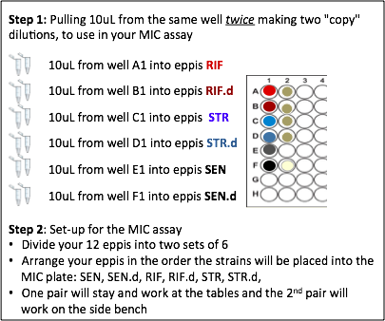

**IV. MIC Assay: Protocol**

Your group will begin by diluting each of your strains twice and then making a copy, so you have *two identical sets of eppi tubes containing diluted bacteria*. Be very careful when you do this pipetting, because you will be pipetting out of the same wells in Column 1 later to start your competition assay.

Next, one pair in your group can add strains to the RIF-gradient microtiter plate, while the other pair adds strains to the STR-gradient microtiter plate.

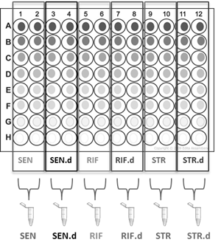You will inoculate every strain in **two** columns of each of the drug-gradient microtiter plates as shown in the figure below. (Remember that one plate will contain RIF and one will contain STR.) For example, the SEN progenitor will go into every well in Column 1 ***and*** Column 2 working from low concentration (drug-free Row H) up to the highest concentration in Row A. You can use the same tip for the 2 replicate columns, *changing tips between drug concentrations* (between rows). You will also want to *change tips between strains* (every time you switch to a new eppi of a different bacterial culture).

After adding the SEN progenitor to wells in Column 1 and Column 2, you will move to the next two columns for the SEN descendant. Again, use the same tip for Well H3 and H4 but change tips as you move up the column into each row of progressively more-concentrated drug.

Setting up your MIC assay will involve a good amount of pipetting—stretch your thumb muscles beforehand!

**Pro tips:**

* Divide your group of four into two pairs (Pair A and Pair B). In each pair, one person can be the “Caller” and the other the “Pipetter”. The Caller will hand eppis to their Pipetter partner andhelp keep trackof which wellthe Pipetter has added culture to. The Pipetter will add culture to the appropriate well from the eppis and relay that information to the Caller.
* Pair A can fill the RIF plate and the Pair B can fill the STR plate (or vice versa).
* Once each MIC plate is ½ full (i.e., just before loading diluted RIF.d culture into Columns 7 and 8), the Pipetter and the Caller can swap roles, if desired.

*Note: Change tips between each of the rows as you move upwards from Row H to Row A. This is important to maintain the different drug concentration in each well*. It will also help you keep track of which wells you have added bacteria to in your microtiter plate.

**MIC Step-by-Step**

Wash your hands with soap and put on gloves. Clean your bench and gloves with ethanol.

1. 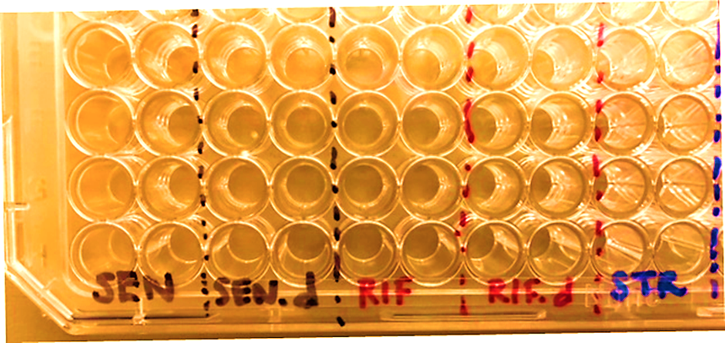While keeping the plate level, c*arefully* label the gradient microtiter plates (a.k.a. MIC plates) on the edge of each lid. Include your section, group number and the date. In addition, label across the bottom of the microtiter plate which strain is going in which column, as shown.

Set your MIC plates aside, for now. First, you will dilute your fully-grown cultures 100-fold into eppis containing saline. You will work down **Column** **1** in your microtiter plate.

1. Arrange your 2 sets of saline-filled eppis in the rack to match the order of the strains in your microtiter plate.
2. Set your P20 pipette to **10uL**.
3. Dilute your bacteria 100-fold by aspirating 10uL of culture from Well **A1** and dispensing this volume into the eppi labeled **RIF**.
4. Repeat, aspirating 10uL of **RIF** from Well A1 into the second eppi labeled RIF**.**
5. Get a fresh tip and repeat for your **RIF.d** strain, aspirating 10uL from Well **B1** into the eppi labeled **RIF.d**. Repeat aspirating 10uL of **RIF.d** from Well B1 into the second eppi labeled **RIF.d**.
6. Continue working down Column 1 of your microtiter plate—*using a fresh tip for each strain*—diluting first your progenitors and then descendants: each separate strain into its own 2 eppis.
7. Once you have diluted, all 6 of your strains (making two copies), set your microtiter plate aside. (You will use it later to prepare your competitions). ***For the rest of your MIC assay, you will pipette out of the eppis, adding diluted culture into the microtiter plate wells.***
8. Separate your 12 eppis into two groups of 6, so Pair A and Pair B each have a set of diluted samples of all 6 strains to add to their MIC plate.
9. Each pair should rearrange their 6 eppis within their eppi racks so that the tubes are now ordered in the same way as the strains will be added to the columns of your MIC microtiter plates (**SEN**, **SEN.d RIF**, **RIF.d**, **STR**, **STR.d,**).

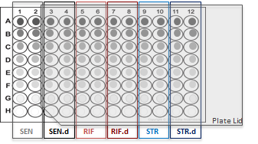Now you are ready to fill the microtiter plates containing the drug concentration gradients. Work *up* the plate from low concentration to high concentration (Row H - Row A), filling two columns at a time (to create 2 replicates). Pair A will fill each well in the RIF MIC plate and Pair B will fill the STR MIC plate. ***Regardless of which MIC plate you are filling (RIF or STR) the steps below are the same.***

1. Set your pipette to **20μL.**
2. Practicing good sterile technique, lift the microtiter plate lid and prop it open, as shown in the figure, so that only Column 1 and Column 2 are exposed.

*Leaving wells exposed increases the risk of contamination, but we will do it here to be efficient and to help keep track of which wells you have added bacteria to.*

1. Using a sterile tip, pipette 20µL of diluted culture from the eppi labeled “**SEN**” into Well **H1**.
2. Repeat, using the *same* tip as for Well **H1**: Draw up 20μL from your eppi of diluted **SEN** culture, and dispense it into the adjacent well, Well **H2**. Eject the tip.
3. Move one row higher in the plate. Using a *new* tip, draw up 20μL of SEN culture and dispense it into Well **G1**.
4. Using the *same* tip as for **G1**, repeat for Well **G2**.
5. Repeat the steps above for Wells **F1** and **F2**. Then keep moving up the column in this way, *changing tips between each row.* You will add 20μL of your **SEN** culture into each well in column 1 and 2.

Always make sure to *change tips* as you switch to a different eppi tube containing a different strain.

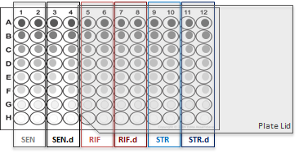

1. Next, carefully slide your microtiter plate lid to the right to expose **Columns 3 & 4.**  Change eppis: here you will add **SEN.d** to each well.
2. Using a new tip, draw up 20μL of **SEN.d** culture and dispense the culture into Well **H3** and 20μL into Well **H4**.
3. Using a new tip, draw up 20μL of **SEN.d** culture; dispense it into Well **G3**. Repeat for Well **G4**, using the same tip. Change tips and repeat for Well **F3** and **F4**, etc.: moving up the column, adding 20uL of your **SEN.d** culture to each pair of wells in Columns 3 and 4, and changing tips for each row.
4. Carefully slide your microtiter plate lid to the right to expose Columns 5 & 6.
5. Repeat the pattern moving up the column, adding 20μL of your **RIF** culture to each pair of wells in Columns 5 and 6, and changing tips for each row.

*You’re halfway there! You can switch “Pipetter” and “Caller” roles in your pair now, if you wish.*

1. Next, carefully slide your microtiter plate lid to expose Column 7 & 8.
2. Using a new tip, repeat the pattern, add 20μL of your **RIF.d** culture to each pair of wells in Columns 7 and 8. (Still changing tips for each row.)
3. Next, expose Column 9 & 10. Repeat the steps above, but this time adding **STR**- resistant strain to Wells H9 and H10 and every pair of wells in Column 9 and 10, changing tips between rows.
4. In the same manner, using a new tip for each row, you will add 20uL of **STR.d** to each well of Columns 11 and 12.

**SUMMARY**: You are adding 20μL of culture to each of the wells in your plate, row by row (**using a fresh tip for each row**), in pairs of 2 columns, sliding the lid of the microtiter plate over to expose the next two columns for the next strain that you will work with, following the pattern of strains noted below each column in the figure.

1. Now, re-cover your microtiter plate with its lid. Set your eppis that contain any leftover diluted culture aside.
2. Contact a teaching team member. He or she will take your MIC assay plates to the incubator and remove your eppis of diluted strains from your bench. Congratulations – you have finished loading your MIC plates!

**Competition Assay: Protocol**

Each group will create competitions between the progenitors and the common competitor or between the descendants and the common competitor in Column 5 of a microtiter plate that is set up as shown below. Yesterday, your prep team completed your final transfer, reanimated the progenitors in Column 1, and started up wells containing your Common Competitor in Column 2.

***\*\*NOTE: The competitions for the SEN strain and the SEN.d strain will be done at the class level. Each group can then compare their resistant mutants to the sensitive progenitor. \*\****

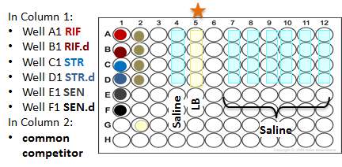

**Microtiter Plate Layout**

Column 1: Your focal strains

Column 2: Common Competitor

Column 3: will be empty

Column 4: will contain saline

Column 5: will contain LB, this will be your **Competition Column**

Columns 7 - 12: will contain saline

We want your competition assay mixture to start with approximately the same number of cells from both strains (focal strains and common competitor strain), so we will combine an equal volume of both strains’ fully-grown cultures into a single well in **Column 3**. Specifically, you will pipette 100uL of culture from Column 1 into Column 3, and then add 100uL of culture from Column 2 into Column 3. In this way, Column 5 will end up containing a 200ul mixture of ~50% focal strain cells and ~50% competitor strain cells. With the mixture in column 3 you will:

* Take an aliquot of each competition, perform a dilution series, and spread samples onto indicator Petri dishes to grow overnight. The next day we will count the colonies, giving us our initial (*t* = 0) counts for each strain.
* Dilute and transfer the mixture into LB to compete overnight. The next day these competitions will again be diluted and spread on indicator Petri dishes to get final (*t* = 1) competition counts.

**Competition Step-By-Step:**

***Phase 1. Set up the 50:50 mixture of each focal strain + the common competitor***

1. Set your P200 pipette to **100uL**.
2. Practicing good sterile technique, load a sterile tip on your pipette.
3. Pipette 100uL of the **RIF** strain from Well **A1** + 100uL of the Common Competitor from Well **A2** (using the same tip) into Well **A3**. Gently mix the **RIF** strain with the Competitor by slowly pipetting up and down in the well, going just to the first stop on the pipette.

Using a ***new* tip for each row**, you will work your way down Columns 1 and 2:

1. With a fresh tip, pipette 100uL of **RIF.d** from Well **B1** + 100uL of the Common Competitor from Well **B2** (using the same tip) into Well**B3**. Gently mix and discard your tip.

1. With a fresh tip, pipette 100uL of **STR** from Well **C1** + 100uL of the Common Competitor from Well **C2** into Well **C3**. Gently mix and discard tip.

1. With a fresh tip, pipette 100uL of **STR.d** from Well **D1** + 100uL of the Common Competitor from Well **D2** into Well **D3**. Gently mix and discard tip. You will use a new tip for each row. At the end you will have:

Well A3 = 100uL **RIF** + 100uL competitor

Well B3 = 100uL **RIF.d** + 100uL competitor

Well C3 = 100uL **STR** + 100uL competitor

Well D3 = 100uL **STR.d** + 100uL competitor

*Note: Check your end result: each well of Column 3 will have a* ***total volume of 200uL****.*

***Phase 2. Start your competitions by diluting the 50:50 mixtures in saline and then transferring the mixtures into LB to grow overnight.***

Note: Because you mixed *fully-grown* cultures in Phase I, the cells will not grow unless they are diluted and transferred to fresh media—just as you needed to do for the daily transfers.

1. Set your P20 pipette to **20uL**.

1. Dilute your bacteria 10-fold by aspirating **20uL** of the mixture from well **A3** and dispensing this volume into the well with saline directly to its right: well **A4**. Gently mix.
2. Using the same tip, aspirate **20uL** of the now-diluted bacteria into the competition well, well **A5**. Again, gently mix by pipetting up and down.
3. Using the same tip, aspirate **20uL** of the competition into well **A7** (skipping Column 6). Again, gently mix by pipetting up and down and eject your tip.

Repeat the process for Row B:

1. Load a *new* tip and aspirate 20uL from well **B3** and dispensing this volume into the well with saline directly to its right: well **B4**. Gently mix.
2. Using the same tip, transfer **20uL** of the now-diluted bacteria into the competition well, well **B5**.Gently mix.
3. Using the same tip, aspirate **20uL** of the competition into well **B7**. Again, gently mix by pipetting up and down and eject your tip.
4. Repeat for Row C: With a fresh tip, transfer **20uL** from well **C3**, dispensing this volume into the well of fresh saline directly to the right, well **C4**. Transferring your now-diluted culture into the competition well, **C5**. Transfer **20uL** from well **C5** into **C7** and discard tip.
5. Repeat for Row D

***Phase 3. Complete the dilution series on your competitions.***

Recall that a grown culture of bacteria can easily have 100,000,000 cells per mL of fluid. If you simply spread such a bacterial culture on a Petri dish with solid growth medium, the cells would grow into an uncountable lawn. To avoid this, you need to perform a dilution series on our samples before plating.

Each well in the dilution microtiter plate has been filled for you with 180µL of saline. In order to achieve a ten-fold dilution, 20µL of the fluid to be sampled will be drawn into a pipette tip and dispensed into a well (20µL into 180µL is a 1/10 dilution). This process is repeated several times; 20µL from the previous well into a fresh well, mixing each time you transfer liquid.

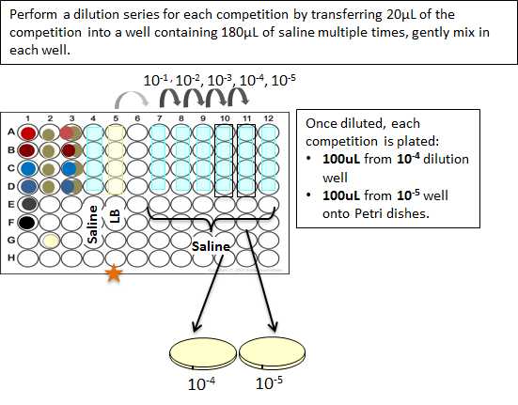

1. Set your pipette to **20uL**.
2. Draw up 20uL from well **A7** and transfer it into well **A8.** Gently mix by slowly pipetting up and down in the well, going just to the first stop on the pipette. Discard tip

1. With a new tip, draw up 20µL from well **A8** and transfer it into well **A9**, gently mix as above.

1. With the same tip, draw up 20uL from well **A9** and dispense into well **A10**, gently mix.

1. With the same tip, repeat, draw up 20uL from well **A10** and dispense into well **A11**, gently mix.

1. Using the same tip, draw up 20uL from well **A11** and dispense into well **A12**. Gently mix and discard tip.

**Always change tips between rows!

1. *Using a fresh tip for each competition* (each row), repeat the steps above—working your way down the column so 20µL of culture from well **B7** is transferred to **B8**, gently mixing and discarding the tip.

1. With a new tip, transfer 20µL from **B8** into well **B9** and mix, transfer 20uL from **B9** to **B10** and mix, transfer 20uL **B10** to **B11** and mix, transfer 20uL **B11** to **B12**. Discard tip.

1. Repeat steps above for your next competition. With a new tip transfer 20uL from well **C7** to **C8** and so forth. (Mixing after each dilution).

1. Repeat the steps above for the competition in row D.

***Phase 4. Spread samples onto Petri dishes to grow.***

After the sample has been sufficiently diluted, it needs to be spread onto a Petri dish. Similar to Lab 1, you will aspirate 100µL from the well of the appropriate dilution and dispense it onto the appropriate Petri dish. Shaking the Petri dish so that the glass beads roll across its surface ensures an even spreading of the sample. (The lab prep team will already have “beaded” your dishes for you.) After shaking, the beads are removed and placed in a beaker containing ethanol and the Petri dishes will be placed into the incubator to grow overnight.

1. Organize your Petri dishes. Your Petri dishes will be labeled with: Focal strain, Dilution (either 10-4 or 10-5), Date. 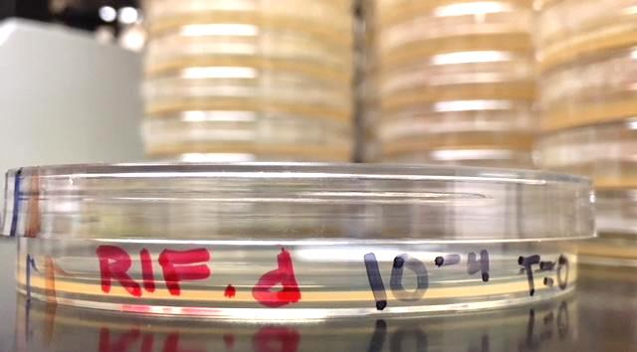

**Please add:**

* **Your group #**
* **Section**

Note: Samples of each competition will be spread twice so you will have 8 Petri dishes in total. You’ll spread two different dilutions to make sure you get countable colonies on a Petri dish—not too many and not too few.

1. Set your P200 pipette to **100µL**.
2. Using a sterile tip, pipette 100µL of the **10-5** dilution, found in well **A11** and dispense this aliquot onto the center of the appropriate **10-5** Petri dish. Dispose of tip.
3. Shake the Petri dish to spread out the bacteria, taking care not to swirl beads around the circumference of the Petri dish. (The beads should cross back and forth across the center of the dish while you gently turn the dish.) Shake the plate for 1-2 minutes, until the beads appear dry.
4. Tip the dish to one side so that all the beads collect together. Flip the dish so that the agar-filled half is on top and the beads drop into the lid. Set the plate aside agar side up.
5. With a new tip, repeat Steps 3-5, so that you plate the *same* competition but a different dilution (10-4), on the 10-4 Petri dish. Pipette 100µL from well **A10** and dispense onto the center of the 10-4 Petri dishes. Discard tip.
6. Shake to spread the beads. Once you are done, flip the dish over so the beads drop into the lid.
7. Repeat the plating steps above moving down Columns 11 and 10 for each of the 4 competitions. You will have 8 Petri dishes in all.
8. Locate the class beaker that will be used to collect the beads. Over the beaker, tilt the Petri dish so you can open the lid allowing the beads to fall down into the beaker.
9. A member of the research team will collect your petri dishes and move them to the incubator to grow overnight.
10. Clean up your lab bench. Dispose of your gloves and wash your hands.

Tomorrow, a member of your lab group will come in to dilute the competitions that grew overnight and plate them on Petri dishes to grow so we can get final (*t* = 1) counts for the competition assay.

### MIC Tracking Sheet

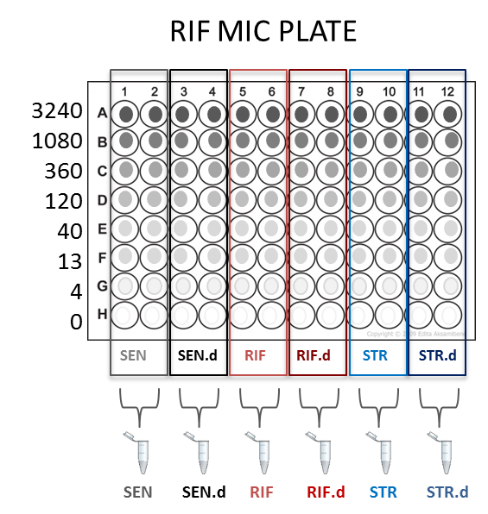

SECTION:

GROUP Name/#:

NAMES:

MIC assay notes/protocol deviations:

Rifampicin (ug/mL) concentration gradient plate

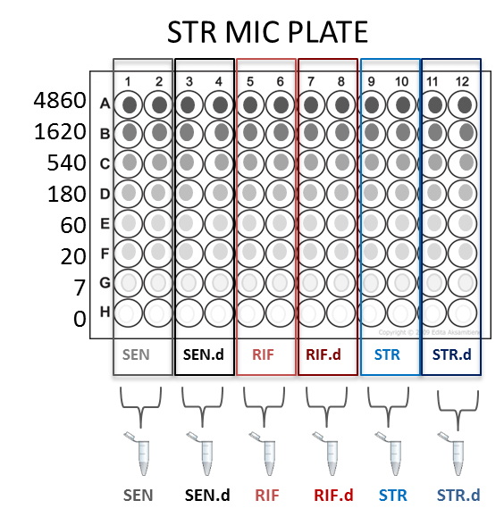

Streptomycin (ug/mL) concentration gradient plate

### Competition Drop-In Steps

## BIO1 | CURE Lab 6 Evolution of Antibiotic Resistance

**Learning Objectives**

After completing today’s lab, you will be able to:

* Predict which results from the fitness assays you performed would allow you to conclude that the cost of resistance was high, low, or 0.
* Explain how the MIC data you collected will allow you to address questions about variation in level of resistance, and changes in the level of resistance over time;
* Explain how the MIC data you collected will allow you to address questions about collateral resistance and collateral sensitivity.

**I. Background Information**

Last week you performed two assays, the MIC assay and Fitness assay. Today you will collect data on the results; next week you will analyze and interpret the data.

MIC assay:

You placed your 6 strains (**SEN**, **SEN.d RIF**, **RIF.d**, **STR**, **STR.d**) in microtiter plates containing a drug concentration gradient—either rifampicin or streptomycin. Strains were incubated overnight. After 24 hours of growth, the research team moved the plates into a refrigerator to store for your lab today.

Competition assay: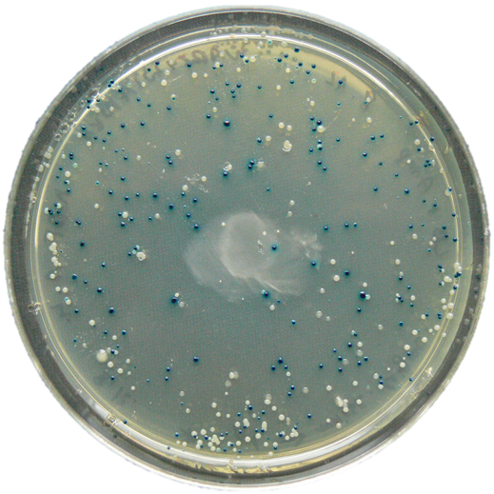

Recall that you made a 50:50 mixture of your focal strain (**RIF**, **RIF.d**, **STR**,or **STR.d**) and a common competitor, and that your peer facilitator set up the competitions for the **SEN** and **SEN.d** strains.These mixtures were diluted and transferred into liquid LB to compete and grow overnight. Before growth in the liquid LB began, a member of your group diluted a sample from each competition and spread the cells onto Petri dishes to grow. Counting colonies from these dishes will give you the initial densities of your competing strains (*t* = 0). You will be able to tell your competitors apart because your focal strains will have formed **blue** colonies and the competitor colonies will form **white** colonies.[1]

After your competitions have had 24 hours to grow, a member of your lab group came in to dilute a sample from each competition and spread the cells onto Petri dishes for growth. These dishes can be counted to estimate the final densities of the competing strains (*t* = 1). The following day, Petri dishes with colonies were removed from the incubator and stored. If the two strains start the competition with equal numbers of cells, then the strain with more numerous cells at the end of 24 hours must have a higher growth rate, meaning that this strain is better-adapted to the experimental environment.

The big picture

The data that you collect today and analyze next week will help the Kerr lab address important questions about the evolution of antibiotic resistance. In some cases, your data may also be relevant to questions about clinical practice.

Recall that at the start of this experiment, each lab group chose a RIF-resistant mutant and a STR-resistant mutant at random. As a result, it is possible or even likely that every lab group in the class is studying unique mutations in each of their strains. In effect, the class is exploring the universe of mutations that can occur in natural populations and confer resistance to these two widely prescribed antibiotics. It is also possible that at least some groups are studying mutations that are causing problems in clinical settings right now. Think about this as you quantify MIC in your progenitors and compare values among lab groups. You should also realize that if each resistant strain has a unique genotype, it may also have a unique phenotype. In Biology 200, you will be following up on the data you collect this quarter by analyzing genes and getting insight into the molecular basis of resistance in your strains. We hope to be able to understand *why* some strains are more resistant than others.

Using the MIC data you collect today, you’ll also be able to make some preliminary conclusions about the presence of collateral resistance or collateral sensitivity. Do your RIF-resistant and STR-resistant progenitors have higher or lower resistance to the other antibiotic than the sensitive progenitor? If the data from your group and many other groups indicate that collateral resistance is occurring, it may not be wise to pair RIF and STR in drug cocktails or drug-cycling regimens. But if collateral sensitivity is common, then the two antibiotics might be able to work well in conjunction.

The experimental evolution phase of the research, which you completed last week, added another layer of interest. The daily transfers allowed your resistant strains to evolve in an environment that lacked RIF or STR, to mimic what might happen to resistant strains in a patient that stopped taking the drug. Is MIC still high in your descendant strains compared to the progenitor, or did it drop? The answer can tell us whether antibiotic resistance is likely to become less frequent if we stop using certain drugs, or if resistance will tend to persist.

You’ll also be able to think about some interesting questions once you have your competition data. Your *t* = 0 and *t* = 1 counts will document how well each strain grew against a common competitor, so you can estimate the relative fitness of your sensitive and resistant progenitors and descendants. The comparisons you will do next week will let you draw preliminary conclusions about variation in the cost of resistance and changes in the cost of resistance over time.

**II. MIC assay results: Protocol**

Today you will ...

1. Examine your 2 MIC assay plates and make observations

2. Decide on the MIC values for your team’s 6 strains in each of the 2 drugs, and

3. Give your strain’s MIC values to your TA or PF to enter into a class datasheet.

**Materials**

* 1 microtiter plate containing your fully-grown strains in a gradient of RIF
* 1 microtiter plate containing your fully-grown strains in a gradient of STR
* Safety goggles

**SAFETY**

Wear safety goggles and gloves. RIF and STR are toxic at high concentrations, so it is imperative to avoid contact with skin. Also, remember to keep plates level, to avoid spilling. This is especially important if you raise the plate up to the light to view it from below.

**Step-by-step**

Two group members can analyze MICs in RIF-gradient plates, while your other 2 group members analyze MICs in STR-gradient plates.

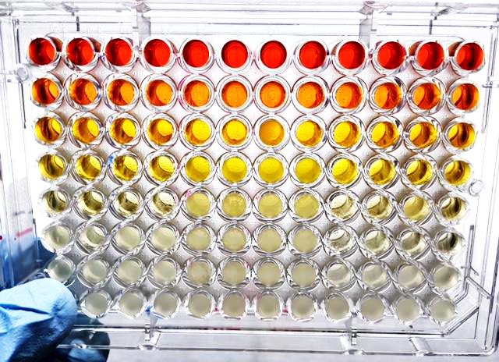Then exchange MIC plates and confirm your interpretations of the data.

1. Examine your MIC microtiter plates:

For each column, scan upward from Row H to Row A until you reach the first well with clear media / no bacterial growth. Note the letter of this row.

This was the well that contained the lowest concentration of drug that was sufficient to prevent growth. This is the MIC—the minimum inhibitory concentration.

**Recall that each strain has 2 replicates, located in adjacent columns. *Call the lowest blank well in each pair of columns the MIC for that strain.***

2. Record the MIC on each plate by writing down which well has no growth in each column.

3. Repeat for the second MIC plate.

4. Enter your MIC values in the appropriate cells in your group’s worksheet.

5. Place you MIC plates in the designated tray. The research team will autoclave your MIC plates so they can be disposed of safely.

**III. Competition assay results: Protocol**

Today you will:

* + - * Count colonies from the start of the competition (*t* = 0) and from the end of the competition (*t* = 1), and
      * Calculate relative fitness

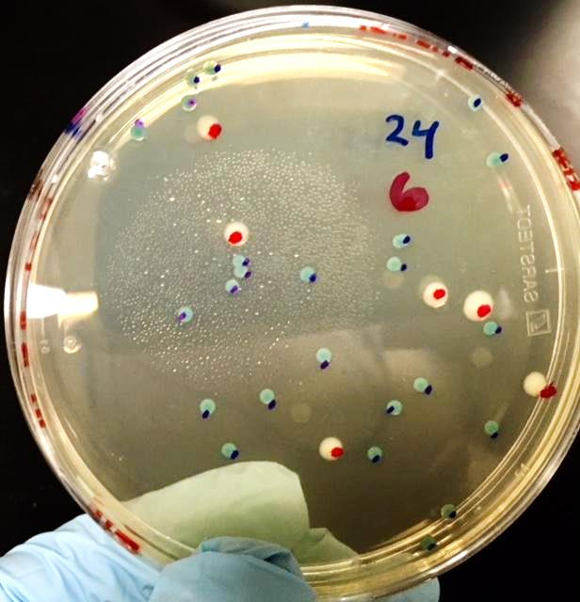**Step-by-step**

1. Use a clicker counter to count the number of **blue** focal strain colonies on the plate. Track which colonies you have already counted by using a sharpie to “dot” them. See the figure to the right.
2. Use a clicker counter to count the number of **white** common competitor strain colonies on the plate. Using a different color sharpie marker, again track which colonies you have already counted by “dotting” them.
3. Enter the *t* = 0 colony counts for your focal strains and for the common competitor strain.
4. Next enter the *t* = 1 colony counts for each strain.

|  |  |  |  |  |  |  |  |  |  |  |  |  |
| --- | --- | --- | --- | --- | --- | --- | --- | --- | --- | --- | --- | --- |
| **Focal Strain** | T = 0 | | | | | | T = 1 | | | | | |
| Focal (blue) | | | Competitor (white) | | | Focal (blue) | | | Competitor (white) | | |
| # of colonies | dilution | | # of colonies | dilution | | # of colonies | dilution | | # of colonies | dilution | |
| sample | 81 | | 7 | 59 | | 7 | 138 | | 8 | 95 | | 8 |
| RIF |  | |  |  | |  |  | |  |  | |  |
| RIF.d |  | |  |  | |  |  | |  |  | |  |
| STR |  | |  |  | |  |  | |  |  | |  |
| STR.d |  | |  |  | |  |  | |  |  | |  |

Once colonies, of each type (focal and competitor), have been counted we will need to calculate the *concentration* of each strain from the start and the end of the competitions. *Note: The common unit of concentration/density of bacteria is CFU (colony forming units) / mL*.

For example, imagine you diluted a bacterial culture through 6 rounds of 10-fold dilutions. Then you plated 100µL of that 10-6 diluted culture onto a Petri dish. After 24 hours of growth, you counted 43 colonies of your focal strain on the dish. 43 colonies = 43 bacterial cells. (For simplicity we will ignore the common competitor colonies for now.)

You want to know how many cells were in the microtiter plate well you sampled from.

You have 43 bacterial cells. The volume of the diluted culture that was placed on the Petri dish was 100uL. There are 1000µL in 1mL.  
You have: (43 bacterial cells / 100µL) × 1000µL = 430 CFU/mL.

If 4.3 × 102 CFU/mL cells were in the 10-6 dilution *well* that was plated, how many cells were in the full culture?

Once you have answered that question and can estimate the number of cells in each of the full cultures, you will have all the data you need to calculate growth rates for each strain. Specifically, what you want to know is how the growth rate of the Focal strain compares to the growth rate of the Competitor strain—that is, the relative fitness (ω) of your focal strain.

As a class you will calculate the relative Fitness of each Focal strain relative to the Competitor, or:

ω(F,C) = rF / rC

where r is the growth rate between *t* = 0 and *t*= 1.

And with that, you and your lab mates will have collected all of the data you need to do the analyses scheduled for next week.

**Make additional notes on your results here:**

## BIO1 | CURE Lab 7 Evolution of Antibiotic Resistance

**Learning Objectives**

After completing today’s lab, you will be able to:

* Use RStudio to graph, interpret, and analyze data.
* Choose appropriate statistical tests to analyze experimental results.
* Analyze MIC data and evaluate whether you are seeing evidence for collateral sensitivity, collateral resistance, or no collateral effects.
* Interpret any changes in fitness observed by your group or other groups.
* Suggest future experiments to follow up on your results.

This week you will:

1. Review the motivation for the experiment,
2. Analyze your data in RStudio and interpret your results, and
3. Discuss potential future directions for this research.

**I. Background Information**

You have been exploring evolution in real time to better understand the problem of antibiotic resistance. Recall that you started with a liquid culture of an *E. coli* strain called MG1655, which is sensitive to the antibiotics that we studied this quarter. But cells that happened to have a mutation that conferred resistance to RIF or STR survived on Petri dishes containing drug. Once you had isolated resistant strains, the research team froze a sample of the cells. These are your progenitors. You and your lab team then did daily transfers to allow the remaining bacteria to evolve in drug-free media for many (70-100) generations. The cells you had at the end are your descendants (see below).



Progenitors

In Lab 5, you set up and ran assays to estimate 1) the level of drug resistance to both RIF and STR in the sensitive progenitor, sensitive descendant, RIF-resistant progenitor, RIF-resistant descendant, STR-resistant progenitor, and STR-resistant descendant, and 2) the fitness of each of the 6 strains by quantifying how well they grow in the presence of a common competitor.

Last week you collected the data that resulted from these assays:

1. MIC ASSAY

You determined your visual MIC results by looking at your MIC microtiter plates and recording the level of drug resistance for your strains.

1. FITNESS ASSAY

You counted colonies so you can estimate relative fitness for your group’s strains.

Today you will analyze the data you collected. Over time, the Kerr lab is building a large data set that can shed light on interesting patterns to investigate with future research.

**II. What motivated this investigation?**

Science builds on previous research. Earlier work in the Kerr lab and elsewhere has shown that most antibiotic resistance mechanisms are associated with a fitness cost, usually observed as a reduced bacterial growth rate in the absence of the drug. A cost of resistance is logical, because antibiotics target essential biological functions in the cell, and resistance often involves alterations to the machinery carrying out these functions—alterations that should make the machines less efficient in a drug-free environment. Although resistance mutations have a major fitness advantage in the presence of the drug, evolution in a drug-free environment should lead to selection for reduced costs of resistance and thus a lower level of resistance.

The Kerr lab is particularly interested in the following questions:

1. Is there an initial cost of resistance?

* If so, is the cost consistent across strains that are resistant to the same drug? Or is there variation in the cost associated with different mutations?
* When drug-resistant bacteria evolve in a drug-free environment, does level of resistance decline, as predicted? Do drug-resistant strains revert back to drug sensitivity?
* When drug-resistant bacteria evolve in a drug-free environment, can compensatory mutations arise that reduce the cost of resistance while resistance levels are maintained?

1. Does resistance to one drug impact resistance or sensitivity to another drug? Are there collateral effects?

Answering these questions is important, not only because they are central to understanding how evolution works, but because they have a direct impact on clinical practice. Researchers and physicians need to come up with new ways of managing antibiotic therapies that reduce the level of resistance within bacteria strains and minimizes the spread of resistance among strains.

**III. Questions for this week**

**Come to lab prepared to discuss the questions below with your lab mates.**

1. Imagine that the relative fitness of your STR-resistant progenitor was very low but by the end of serial transfer, the relative fitness of the STR-resistant descendant was very high. Imagine, too, that your MIC assay showed that the STR-resistant descendant had the same MIC as the SEN strain.

How would you explain these results, in terms of natural selection?

Now imagine that the STR-resistant descendant had a much higher MIC than the SEN strain—as high as the STR-resistant progenitor. How would you explain these results?

1. In drug cycling programs, different antibiotics are prescribed in non-overlapping cycles. This means that one antibiotic (for example, RIF) will be prescribed for a certain period of time and then removed while a second drug is prescribed (for example, STR).

From the results of your experiment, what are some of the possible outcomes of a drug cycling program? For example, could cycling select for bacterial strains that are both drug resistant *and* superior in growth to their progenitors? If so, how likely is this to occur?

If you wanted to test the effects of drug cycling, how would you adjust the protocol that you did?

1. If you could repeat your experiment using the same protocol, is there anything that you would you do differently to make the work more efficient or the data more reliable?
2. What additional questions do your results raise? Are there any interesting patterns that you would like to investigate further? If so, what kind of experiments might you set up?
3. If you were to propose a future experiment, what kinds of questions might you want to investigate, and what variables would you manipulate? For example, how might your results change if you:

* continued the daily transfers for a longer time period?
* used a different strain of *E. coli* or an entirely different species of bacteria?
* had 2 or more strains of bacteria growing together for the duration of the experiment?
* used a different growth media than LB? Could the nutrient-rich media used in evolutionary studies impact evolutionary trajectories? Why or why not?
* changed the concentration of antibiotic (to be higher or lower) in the Petri dishes that we used as a selective pressure at the beginning of the experiment?
* used rifampicin and streptomycin together in a drug cocktail?

What other questions can you come up with?

**IV. Antibiotics in natural environments**

Most research on antibiotics is motivated by the need to treat infections effectively. But antibiotics have existed outside of the research and clinical setting for millions of years—they are a “natural product.” Where do they come from?

Most naturally occurring antibiotics are made by microorganisms such as bacteria and fungi. For example, streptomycin was isolated from a species of bacterium called *Streptomyces griseus* that is common in many types of soil, and rifampicin was isolated from a soil sample in an Italian pine forest. Antibiotics are molecules that microbes produce to kill other microbes.

* Why would bacteria synthesize substances to kill other microorganisms?
* Even if humans didn’t use antibiotics in hospitals, agriculture, and other settings, would antibiotic resistance still exist?

A key point here is that bacteria live in environments that are far more complex that our microtiter plate full of LB. For example, the “microbiota” in your gut consists of over 1000 species and over 100 trillion cells. The interactions that occur between cells of the same species and among species can be beneficial or detrimental—mutualistic or competitive.

Your gut flora is a complex community of microorganisms that exerts important effects on your physiology, metabolism, nutrition, and ability to fight disease. Researchers are finding that its composition can impact the tendency to develop health conditions ranging from gestational diabetes and obesity to anxiety and depression. Considering the far-reaching impacts of gut microbiome diversity on human health, it would be beneficial to deepen our understanding of how to balance and cultivate this diverse microbial ecosystem.

* What do you think happens to your gut microflora when you take an antibiotic? Specifically, how might the antibiotic change the composition of bacteria in your intestines?
* What “side effects” have you noticed in people who take antibiotics?

The above questions are not only relevant for your gut. Specialized, complex microbial communities inhabit every region and surface the human body. There is a skin microbiome, a vaginal microbiome, a nasal microbiome, and so on. Investigating how these microbial communities’ impact human health is an active research frontier.

**V. Antibiotic resistance: the big picture**

Most antibiotics sold in the United States today are used in the production of livestock animals raised for food. For reasons that aren’t completely understood, frequent or constant treatment with antibiotics helps cattle and other livestock grow faster. But as you now know, exposure to antibiotics also selects for resistant strains.

Humans aren’t just exposed to antibiotics when they are following a prescription. We can be also exposed to resistant bacteria through raising livestock (occupational exposure), food preparation, or meat consumption. In addition, antibiotics that are dispersed in animal waste often enter nearby aquatic and terrestrial ecosystems. There they select for resistant strains that can persist in the environment and affect the ecology and evolution of native microbial communities.

The general point here is that the spread of antibiotic resistance has ecological and environmental impacts as well as consequences for human health and clinical practice. Although antibiotics are a natural product and immensely important in medicine, their overuse can cause disturbances and can accelerate the evolution of resistant strains.

# BIO2

## BIO2 | CURE Lab 8 Evolution of Antibiotic Resistance

**Learning Objectives**

After completing today’s lab, you will be able to:

* Predict the most likely locations of mutations that confer resistance to rifampicin and explain your logic.
* Summarize the purpose of a PCR reaction.
* Make a labelled diagram showing how gel electrophoresis works.

**I. Background Information**

Your group has gathered information on level of drug resistance and fitness costs from your sensitive control and your drug-resistant progenitors and their descendants. Now we will focus on your rifampicin resistant strain to try and identify what changes, at the molecular level, enabled cells to be resistant. You will compare DNA sequences from the sensitive control (our reference strain) to your resistant mutants. The first step is to copy or amplify specific pieces of DNA where previous research has shown resistant mutations are likely to occur. For rifampicin resistance we are interested in two segments the *rpoB* gene (Cluster I and Cluster II). To do this we will run a **polymerase chain reaction** (PCR).

**II. PCR Sample Preparations**

PCR for this experiment takes approximately 5 hours. You will be starting a PCR reaction that will be used in the next lab period.

Each lab group will set up 4 PCR reactions:

Today you will be amplifying:

* RIF. Resistant Progenitor Cluster I (Sample ID: I-P)
* RIF. Resistant Progenitor Cluster II (Sample ID: II-P)
* RIF. Resistant Descendant Cluster I (Sample ID: I-D)
* RIF. Resistant Descendant Cluster II (Sample ID: II-D)

Course staff will amplify the sensitive reference strains.

**PCR Protocol**

Prepare PCR Tubes

1. Put on gloves. Wipe your gloves and bench with ethanol.

2. Ask TA to assign your group a bacterial sample – Record the Sample number:

My group will be using bacterial Sample: ________________________________________

3. Obtain a strip of 4 PCR tubes.

*Please note – Master mix, minus the enzyme TAQ polymerase**,** has already been added to all 4 PCR Tubes.

4. **Label PCR** – Using a sharpie marker write the **Tube label AND bacterial Sample ID** shown below on the lid AND side of each PCR Tube. (Use number you entered above instead of “#” shown below).

|  |  |  |  |  |
| --- | --- | --- | --- | --- |
| **Tube label** | **A** | **B** | **C** | **D** |
| **Sample ID** | #-I-P | #-I-D | #-II-P | #-II-D |

5. Set these labeled PCR tubes on ice and set aside.

Prepare bacterial sample

1. Using a sterile toothpick (or pipette tip) gently scrap across a single bacterial colony from agar plate – See TA demo.

a. one Rif-resistant progenitor (RP) colony and

b. with a new toothpick, one Rif-resistant descendant (RD).

Tip! Be sure not to dig into the agar that the colony grew on, you only need a small amount of colony so scrape across the colony instead of stabbing at the colony

2. Transfer RP colony into PCR tube A and C.

3. Transfer RD colony into PCR tube B and D.

In each PCR tube is something called “Master Mix” that contains purified water, a mixture of **dNTP**’s, and forward and reverse **primers**. To catalyzer the polymerase reaction, you must add a heat-stable enzyme called **TAQ Polymerase** to each tube.

4. Bring your labeled PCR tubes to your TA / Peer Facilitator. They will add the enzyme and will load tubes into the PCR machine.

**III. Gel Electrophoresis**

**Overview**

Next you will analyze DNA that was PCR-amplified by students in an earlier lab[2], using **agarose gel** **electrophoresis**. Electrophoresis uses a voltage to separate DNA fragments according to their relative sizes (number of base pairs (bp)). DNA has a negative charge, so it will move towards the positive end of the gel. Larger fragments of DNA will travel slower than smaller pieces of DNA. A “DNA Ladder” is run with your samples. This ladder contains DNA fragments of *known sizes* that also separate as the gel is run. Your goal is to separate your peer’s PCR products, compare samples to the ladder, and confirm PCR product approximate length (in base pairs). Depending on your experimental goals, there are different reasons for doing a PCR and gel-confirming the product. Here, visual bands provide evidence that our PCRs was successful at amplifying DNA and the sample should be sent out for **Sanger Sequencing.**

Name of Gene Sequenced: ___________________________________________

Cluster I: __________________________

Expected length of Cluster I:___________bp

Cluster II: __________________________

Expected length of Cluster II:___________bp

**Gel Electrophoresis Protocol**

**Prepare (a small part of) PCR samples to load on agarose gel–**

1. Put on gloves and wipe workstation and gloves with alcohol.
2. Obtain:
   1. 1 kb ladder
   2. loading dye
   3. four PCR tubes
      1. Label these 2, 3, 4, and 5
      2. These labels correspond to the lane of the gel that you will run them in
   4. PCR product samples (amplified by an earlier lab this week)
   5. Pre-made control sample
      1. This sample contains master mix only – no DNA
      2. Please note – loading dye has already been added
3. Using a P20 pipette: Please use a fresh pipette tip every time!
   1. Transfer 10 µL from PCR tube A into the tube labeled 2

*Be careful not to contaminate this sample: the remaining volume will be sent away to be sequenced!*

* 1. Transfer **10** **µL from PCR tube B into the tube labeled 3**
  2. Transfer **10 µL from PCR tube C into the tube labeled 4**
  3. Transfer **10 µL from PCR tube D into the tube labeled 5**
  4. Write down sample # (bacterial strain number) of PCR products here: ________

1. When finished with PCR products:
   1. Immediately return to TA
   2. Place on ice
   3. Based on your results, this sample will be sent to a lab for sequencing
2. Using a P20 pipette:
   1. Transfer 2 µL of loading dye to tubes 2, 3, 4, and 5, cap.
      1. Mix by flicking the tube with a finger.
      2. Set aside until ready to load samples into your agarose gel
   2. See TA for demo / review of how to load an agarose gel. Practice if needed.

**Load Agarose Gel**

Below is the schematic for loading your agarose gel.

|  |  |  |  |
| --- | --- | --- | --- |
| **LANE** | **SAMPLE** | **Loading dye to add to sample** | **Amount to load into the gel well** |
| 1 | DNA Ladder | NONE | 5 μl |
| 2 | Tube 2: RIF Res. Cluster I Progenitor | 2 μl | 12 μl |
| 3 | Tube 3: RIF Res. Cluster I Descendant | 2 μl | 12 μl |
| 4 | Tube 4: RIF Res. Cluster II Progenitor | 2 μl | 12 μl |
| 5 | Tube 5: RIF Res. Cluster II Descendant | 2 μl | 12 μl |
| 6 | Master mix – No DNA - Control | 2 μl | 12 μl |

1. Using a P20 pipette and a fresh tip for each sample, transfer:
   1. 5µl of DNA ladder into Lane 1 (the left-most lane) of the row of wells in your gel.
   2. 12µl from tube 2 into Lane 2,
   3. 12µl from tube 3 into Lane 3,
   4. 12µl from tube 4 into Lane 4,
   5. 12µl from tube 5 into Lane 5,
   6. 12µl of the control sample into Lane 6.

8. Secure the lid on the gel box, ensuring that the red wires on the lid match up with the red

tape on the gel box. Connect the electrical leads to the power supply.

9. Turn on the power supply and ensure it is set for ~100 V. Run the gel for 30-45 minutes. You want to run the gel far enough that you can see a difference between band sizes, but not so far that the DNA leaves the gel. If the blue part of the loading dye is about halfway down the gel, then you have probably run the gel long enough to see results.

Note: the blue marks are caused by the loading dye moving through the agar and do NOT represent where the DNA is. You will need to use a stain to visualize the DNA.

1. Staining: Without the addition of a stain, DNA is invisible. Course staff have already mixed a stain into the agarose gel for you, therefore there is no need to add a stain.
2. After running, turn off the power supply.

**Gel Electrophoresis: Visualizing PCR products**

Visualizing PCR products allows you to determine whether the PCR reaction worked – that is, whether DNA is present and whether its approximate size conforms to prediction. Each band viewed on the gel represents many copies of our desired target region from your strain’s DNA. If the gel confirms PCR was successful, we know we have PCR-products for sequencing.

Recall that we used PCR primers that amplify 2 regions of the *E. coli* genome where mutations conferring resistance to rifampicin typically occur (Cluster I and Cluster II) within the rpoBgene, which encodes part of the RNA polymerase enzyme (Reynolds, 2000).

1. Remove the lid from the gel box. Very carefully remove the tray from the gel box. The gel is slippery and can easily slide off! Nudge the gel off the gel tray with your gloved thumb and gently slide it into the plastic transfer tray.
2. Take the transfer tray holding the agar to the UV transilluminator. This view box will use ultraviolet radiation, causing the stain to be visible.

Our transilluminator has a UV protective screen, protecting you from the harmful UV radiation. This said, you should limit exposure whenever possible. CAUTION: Ultraviolet radiation can cause burns. Prolonged exposure is associated with an increased risk of skin cancer.

1. Close the lid and briefly observe the bands that you see when you turn on the view box. Then answer the following questions to interpret your data.

**Interpreting your gel electrophoresis results:**

1. On the diagram of the gel below:
   1. Label specifically what is in each lane
   2. Draw the results that you observed on your gel.

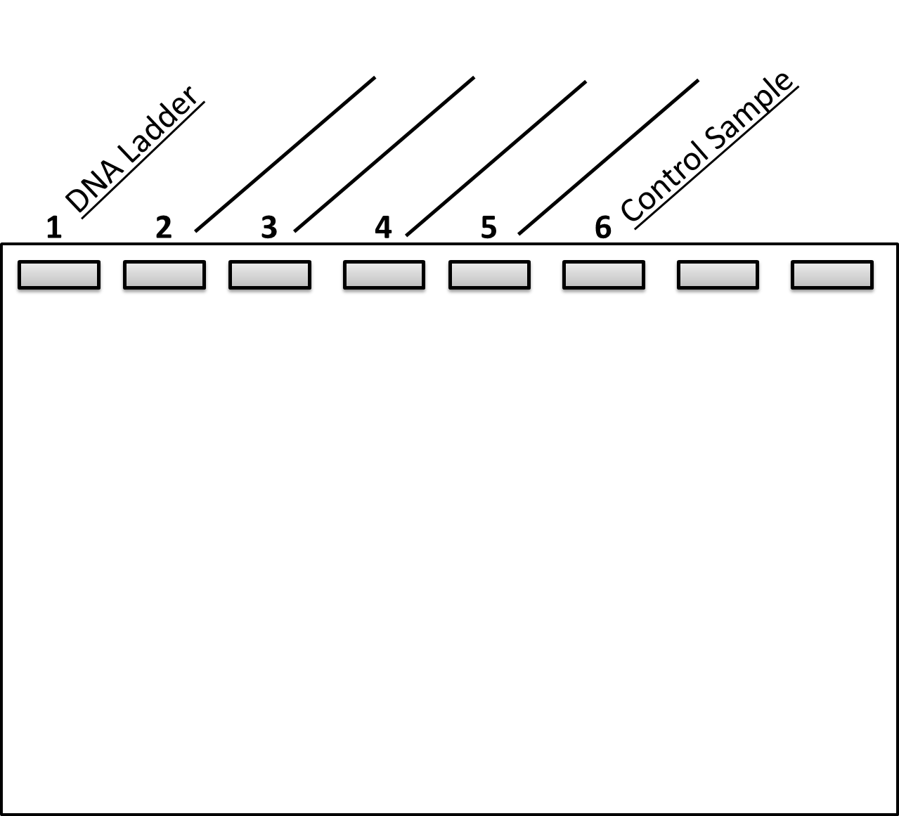

1. What size (how many base pairs) are the bands from:
   1. Lane 2 - Cluster I Progenitor: ___________________ bps
   2. Lane 3 - Cluster I Descendant: __________________ bps
   3. Lane 4 - Cluster II Progenitor: ___________________ bps
   4. Lane 5 - Cluster II Descendant: __________________ bps
   5. Lane 6 – Control Sample: ______________________ bps
2. Does the predicted PCR product length match what you observed? *(please explain in 1-2 sentences)*
3. Which samples should be sent out for Sanger Sequencing and why?

### BIO2 | CURE Lab 9 Evolution of Antibiotic Resistance

**Learning Objectives**

After completing today’s lab, you will be able to:

* Use Benchling software to create a sequence alignment and edit sequences as needed.
* Compare DNA sequences from progenitor and descendant strains and identify mutations.
* Analyze mutations and relate them to changes in the amino acid (primary) sequence of gene products.

**I. Background Information**

Rifampicin (RIF) is a common antibiotic used to treat a variety of bacterial infections, including tuberculosis. RIF binds to the β subunit of RNA Polymerase, blocking the elongation step of transcription. The gene for the β subunit of RNA polymerase is called *rpoB*. Last week we selected a region of the *rpoB* gene to sequence, used PCR (polymerase chain reaction) to make copies of two specific places in the *rpoB* gene—areas called Cluster I and Cluster II. After that we used gel electrophoresis to confirm that our PCR yielded products. Once we were confident that our PCR worked, course staff sent the amplified DNA out to a lab to have Sanger sequencing performed.

Because we only amplified two small regions in the middle of the *rpoB* gene we are missing important information at the beginning of the gene, like the promoter, +1 site, and the start codon (which will set the reading frame). Because this code is missing, we need to align our sequence to a reference sequence. This will allow a computer sequence to determine where the reading frame is and let us see where mutations have occurred.

**II. Sequencing Data Files**

For this next section, work in groups of two to create sequence alignments and compare results with your group mates. Your TA will tell you how to download your sequence files, which are labeled as follows.

Year-Quarter-Group # - D or P (Descendant or Progenitor) – I or II (Cluster I or Cluster II)

For example:

* 2018-Su-(Group number)-D-I-F-rpoB_CI.ab1

This is the sequence for Cluster I region of the descendant bacteria.

You will also have a file named: **rpoB_ref.gb**

* This is the reference strain (all groups will use these data)
* Benchling will automatically change the name of this file – don’t worry about it.

**Sequence Alignment Instructions**

* Open a web browser window and type in <https://benchling.com/>
  + Preferred browsers include Chrome, Firefox, and Safari
  + Click sign-in
    - Username: Bio200
    - Password: ----------
* Click on the brief case icon on the upper left-hand of the screen.
  + Next click “
  + The plus sign, “+”.
* Create Project
  + Name: Put in the name of your data set. For example, group 1 from section AF would be named “AF-1”
  + Add a description if needed. Leave ‘manage collaborators’ blank.
  + Click “Create project”
* Click on “Inventory” to highlight
  + 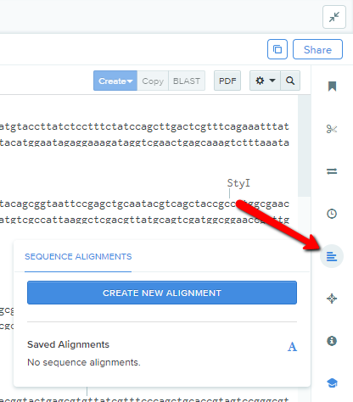Click “+”
* Click the add button, and then click “Import DNA sequence.”
  + Find the files downloaded from Canvas
  + Select and import Rpob_ref.gb, which is the reference strain file
  + Once done, click close
* Next click “Create New Alignment” button. (see image)
  + Click ‘Choose files’
  + Find sequence files downloaded from Canvas
  + Import one of the files from your group
* From the alignment window, under the heading “sequences”
  + Click on “rpoB_flanking_regions
    - This should cause a blue text buble to appear labeling it as ‘Template’
    - This sequence will act as the template that you will comapre our data to.
* From the alignment window, under algorithm, select MAFFT
* Click “Create Alignment.”

**III. Analyzing Sequencing Data**

**Task 1: Trim sequences**

One limitation of Sanger sequencing is that data from the 5’ and 3’ ends of the sequenced strand—typically, 40 - 60 base pairs—are not reliable and thus not useful. Your task is to identify the regions at the 5’ and 3’ ends that are unreliable and should be trimmed. Additionally, each sequenced base has had a quality value (QV) calculated. This value is logarithmically related to the base-calling error—the probability that the reported base is actually incorrect. If a specific base had a QV of 20, it has a 1% likelihood of being miss-called and therefore incorrect. When we trim a sequence, we look for the following:

* Frequently miss-called or “N” nucleotides
* High levels of ‘noise,’ meaning stretches with high QVs
* Location – specifically being within 40 – 60 base pairs of the 5’ or 3’ end.

**Cluster I of Progenitor**

At what location did you trim the 5’ end? Why?

At what location did you trim the 3’ end? Why?

Discuss your decisions with the rest of your lab group.

**Cluster I of Descendant**

At what location did you trim the 5’ end? Why?

At what location did you trim the 3’ end? Why?

Discuss your decisions with the rest of your lab group.

**Cluster II of Progenitor**

At what location did you trim the 5’ end? Why?

At what location did you trim the 3’ end? Why?

Discuss your decisions with the rest of your lab group.

**Cluster II of Descendant**

At what location did you trim the 5’ end? Why?

At what location did you trim the 3’ end? Why?

Discuss your decisions with the rest of your lab group.

**Task 2: Identify, Analyze, and Correct Miss-Called Nucleotides**

A miss-called nucleotide is when the computer reading the Sanger sequence cannot correctly identify a nucleotide. In this situation, a human brain is needed to look at the chromatogram and the quality value and “call” the nucleotide.

Where in the sequence do you see the highest instance of miss-called nucleotides?

Why do you think it happens in these specific locations? (Hint – look at peers’ data)

*After the TA’s demo*:

Did you find any miss-called nucleotides? ___________________________________

For each miss-call:

How did you call the nucleotide? _____

What was the location? ____

What was the quality value? ____

Is this a reliable call? _______

**Task 3: Scan for Mutations**

*See TA Demo.*

Did you find a mutation in your sequence?

**Take a screen shot of the mutation location and the annotation comment.**

If yes: Which sequence(s)?

* Progenitor or Descendant?
* Cluster I or Cluster II?

Location: _______ Reference Nucleotide: ________ Mutant Nucleotide: _______

Location: _______ Reference Nucleotide: ________ Mutant Nucleotide: _______

**Task 4: Create a translation for the template DNA**

*See TA Demo*

What is the first amino acid in this gene? _______________

What is the last amino acid in this gene? _______________

**Task 5: Create a translation for the aligned DNA**

*See TA Demo*

Does the primary sequence of the template’s protein match the primary sequence of your sequence?

Why might they be different?

**Discussion Questions**

Imagine that a group has evaluated data from Cluster I and II from both progenitor and descendant yet found no mutations.

1. Progenitor bacteria grew in an environment (on a Petri dish) that had rifampicin, and survived to make offspring. That said, we do not see evidence of a mutation. How can you explain this finding?
2. The progenitor was rifampicin resistant, but we do not see any mutations in the descendant bacteria. How can you explain this finding?
3. In this case, what would you suggest: **Pick one**
   1. Sequence a location elsewhere in this gene
   2. Sequence a different gene

Explain why this is the best option.

See your TA to enter your data on the Master Data Spreadsheet

## BIO2 | CURE Lab 10 Evolution of Antibiotic Resistance

**Learning Objectives**

After completing today’s lab, you will be able to:

* View and interpret the structure of RNA Polymerase.
* Identify the pocket where rifampicin binds to the β subunit of RNA Polymerase.
* Model and view rifampicin and how it binds to β subunit of RNA Polymerase.
* Edit *rpoB* DNA to produce a protein sequence that matches mutations identified in the previous lab.

**Part I: Prepare DNA for Modeling**

1. For this lab, we will work in pairs of two.
2. Similar to last week, open Benchling and create an alignment for only the DNA sequences that were known to have a mutation.

If neither Cluster I nor Cluster II had a mutation, create a single nucleotide replacement and continue with lab.

Important! If you create a mutation in a strain that does not currently have a mutation, please be sure to clearly state this in your lab report.

1. Create a translation for the *rpoB* template.
2. Isolate the region in the progenitor and/or descendant sequence that has a mutation.

Identify the reading frame (from the template’s translation) and create a translation for the mutation. This should include at least one amino acid before the mutation and one amino acid after the mutation.

1. Open a new tab in the web browser and open the class Canvas website.

Go to Files, Lab Files, CURE 3 Lab and open

* + 1. Codon Table
    2. Sidechain Chemistry
    3. Pymol Cheat Sheet

1. Once you have Benchling, the Codon Table PDF, Sidechain Chemistry PDF, and the Pymol Cheat Sheet open and easily viewable, continue to Part II.

**Part II: Model Quaternary Structure of RNA Polymerase using Pymol**

Today we will analyze and manipulate 3-dimensional (3-D) protein models to form hypotheses to explain why mutations in your strains conferred the ability to grow in the presence of rifampicin. Essentially, we will be using models of 3-D structure and our knowledge of chemical principles to connect our DNA sequence data (genotype from Lab 9) with protein structure data (phenotype from Lab 10) to make predictions about enzyme function. These predictions could explain your strains’ fitness data (from the BIO1 fitness competition assay).

**PyMol: Getting Started**

1. Open Finder (Face-shaped icon the right-hand icon bar)
   1. Click the Applications folder.
   2. Scroll down and select ‘Mac PyMol’

Note – Do **NOT** use PyMol 2.7

1. A 2-pane window will appear. Click on the white banner labeled Educational PyMOL.
2. The upper pane controls the general settings and functions of the program. We will not use this gray-and-white region, except for typing commands into the white box to the right of >PyMOL; we will call this your “command line.” (The upper pane is also a good place to see any error messages that display in the box above your command line.)

See the PyMol Cheat Sheet for tips and tricks.

1. Type: **fetch 5UAC** and hit return.

PyMOL will open the PDB file based on the crystal structure of the wild-type *Escherichia coli* RNA polymerase and rifampicin complex.

1. SAVE your session: File → Save Session As.
   1. Save your file somewhere that you can easily find it, like the desktop.
   2. **BEWARE!** This program does NOT have an un-do function. By saving frequently you can end and re-open your session if needed.

You are looking at the structure of *E. coli’s* RNA Polymerase, which was established using a technique called **X-Ray Crystallography.** This structure was published in the Protein Data Bank (PDB) format and made available to scientists across the world to download, view, and manipulate. A public repository now contains over 40,000 protein structures that can be downloaded, modeled, and viewed. You can search the PDB by organism name, molecule name, structure accession number (usually formatted as a single digit, followed by 3 letters) or even by sequence. You can access these at http://www.rcsb.org/pdb/home/home.do

1. Use the next few minutes to play with the model. Reference the cheat sheet for options.
   1. Click [S] and try viewing as a stick model—a complicated view. Click [H] when you want to hide stick view
   2. Next try bar view, cartoon view, and/or ribbon view.
   3. Once done, close PyMol – only save if you’d like to use this outside of class.

**Part III: Modeling the structure of the rpoB protein.**

Background: The previous view showed all protein chains in RNA Polymerase. Because we are interested in one protein out of the whole complex, we are going to make a copy of just the rpoB protein and hide all of the other protein chains. This will be useful for locating the residue to manipulate later.

1. Open PyMOL (MacPyMOL)
2. Type in command line: fetch 5UAC
3. In the right-sidebar next to “5UAC,” click "A" → preset → Publication.
4. Take a screen shot of the RNA Polymerase protein.

To take a screen shot:

1. Press “command” + “shift” + “4” keys
2. An X will appear; drag a box over the image of RNA Polymerase.

Save the image somewhere you can find it. Use a name like “RNA Pol Quat protein structure”.

1. From the Top Menu bar: Click Display → Sequence On
   1. The top of your model screen now shows amino acid abbreviations and their residue-number in the protein sequence.
   2. The numeric locations will correspond to the alignment made in Benchling. We’ll use this shortly.
2. Save Session – instructions given above.

**Copying the rpoB sequence**

Now you’ll isolate the β subunit of the rpoB protein from the RNA Polymerase sequence. This will allow you to view just this part of the enzyme.

1. In the top sequence display bar, scroll from left to right until you see a green RFP near “1341”. This is the authors’ abbreviation for RIF. This text will be written in neon green.
2. Click on “RFP” to select Rif.
3. Next scroll back to the right until you see a dark blue M under “/C/1” (if the numbers suddenly jump higher, you’ve gone too far.)
4. HOLD down SHIFT and click the M under C/1. This will select all of the amino acids in the *rpoB* gene.
5. In the right sidebar to the right of “sele”, click copy to object
6. “obj1” will appear in the right sidebar.
7. In the right sidebar to the right of “obj1”, click “A”→ rename → object
   1. Hit backspace to clear the name on the left of your window.
   2. Type rpoB and hit RETURN.
8. Now you have a set of menus (ASHLC, on the right sidebar) that will affect only the display of rpoB.
9. Click Display in the menu bar at the top of the screen.
   1. Click zoom
   2. Zoom out to show all
10. Save session.
11. Take a screen shot of the rpoB protein
    1. Remember that this is the β subunit of RNA Polymerase
    2. Save the image somewhere that you can find it.
    3. Use a name like “rpoB protein structure.”
12. In the right sidebar, Click on the light-gray “5UAC” so that it dims to dark gray, and most of the structure disappears – only rpoB and Rif remain.
13. Notice that the 5UAC sequence display also disappears, leaving only the rpoB sequence – useful for finding and selecting your mutated residue ….
14. To zoom back in, repeat:
15. In Right-sidebar next to: “5UAC_pol-conts”, Click "A" → center
16. Top Menu: Display → Zoom→ 20 Angstrom sphere

**Part IV: Model Rifampicin Binding Pocket**

Recent work has identified where Rif binds to the RpoB protein. This region is called the “Ligand binding site” or the “Rifampicin Pocket.” The shape and chemical characteristics of the amino acids in this region permit Rifampicin to bind. This is why Rif kills bacteria: It binds in this pocket and makes elongation of RNA during transcription impossible. To model the region:

1. Using the rpoB item in the right-hand window
   1. Click [A]
   2. →Preset
   3. →Ligand Binding Site
   4. → Mesh Surface
2. Take a screen shot of the rpoB protein with the Ligand Binding surface
   1. Save the image somewhere that you can find it.
   2. Use a name like “RIF binding pocket.”

**Part V: Model Rif**

In this next step you will be modeling and viewing how Rif interacts with the rpoB protein.

1. In the right-hand side menu, locate the menu for the rpoB protein.
2. Click "A" → preset→ Ligands.
3. This will create an object in the right sidebar called 5UAC_pol-conts
4. In Right-sidebar next to: “5UAC_pol-conts”, Click "A" → center
5. Top Menu: Display → Zoom→ 20 Angstrom sphere.
6. Save your work.

**Part VI: Mutagenesis: Modeling mutations**

Pymol allows you to view possible outcomes from a mutation that you specify. Using the numeric location of a mutation from Benchling, you can introducde this mutation into the 3-D model. Be sure that you have the sequence alignment prepped and ready in Benchling before you begin this step.

#### TOOL #3: Using the mutagenesis wizard

PURPOSE: To replace an amino acid sidechain at a specific site with a desired residue’s sidechain.

1. In the top sequence display bar at the top of the screen, click on the residue you wish to mutate.
2. Under the Wizard menu, select Mutagenesis
   1. At first the menu will say “No Mutation,” Click here.
   2. Next click the amino acid that you would like to see modeled instead

Use the Codon PDF and the Sidechain Chemistry PDF to help.

1. Select Apply
   1. This may take a few seconds to process.
   2. If nothing happens. Set the menu to ‘No Mutations’, click Apply, and try again.

#### **Steric clashes: Explanation of Mutagenesis Wizard color codes**

If the new amino acid produced by a mutation does not physically interact with any new other amino acid R-groups or backbones, it will appear as a simple substitution. No additional lines, disks, or colors will appear outside of the amino acid structure. But if Pymol predicts that a new amino acid will cause new physical interactions, they will be modeled as colored lines or disks. In highly structured molecules like proteins, it is common for interactions to cause overlap in the electron clouds of atoms, resulting in a repulsive force. These repulsive forces can push R-groups out of alignment and cause weak bonds and interactions to break. In Pymol, short green lines or small green disks are shown when the mutated R-group causes mild steric hindrance. Large red disks indicate significant steric hindrance.

* + - 1. Take a screen shot of the steric changes caused by your mutation.

1. Save the image somewhere you can find it.
2. Use a name like “AF 1 CII Mutation.”
   * + 1. Select Done.

The mutation disappear when you click Done, so only click it when you are finished using this tool.

## BIO2 | CURE Lab 11 Evolution of Antibiotic Resistance

**Learning Objectives**

After completing today’s lab, you will be able to:

* Connect changes in the molecular structure of RNA Polymerase to changes in MIC (level of drug resistance).
* Propose a hypothesis to explain the molecular basis of fitness trade-offs in RIF resistance.
* Connect changes in the molecular structure of RNA Polymerase to changes in relative fitness.
* Connect changes in the molecular structure of RNA Polymerase to data on collateral effects.

**Part 1: Lab review**

Your TA will lead the group through a brief activity. After the activity, work with your group members to answer the following questions.

1. How does the antibiotic rifampicin interact with RNA Polymerase, typically resulting in bacterial cell death? Be sure to specify where the interaction occurs. (answer in 1-2 sentences)
2. When rifampicin binds to RNA Polymerase, what happens to transcription? How does this change translation?
3. If the bacteria were resistant to rifampicin, in what environment would rifampicin resistance increase fitness?

Modify your answers from questions 1-4 to complete the “Background” portion of the poster template.

**Part 2: Establishing degree of Rifampicin resistance**

1. *Before you access your bacterial MIC data – think about the mutation that you found last week*. Based on the degree of steric hindrance and chemical difference in amino acids, predict what you think the MIC will be: (Circle one)

|  |  |  |
| --- | --- | --- |
| Low MIC (meaning that the cells will die when exposed to a low dose of drug) | MIC equal to the sensitive progenitor strain. | High MIC (meaning that the cells will only die when exposed to a high dose of drug) |

1. What was the MIC for the Rif-sensitive progenitor (control strain)? _____________
2. What were the MICs for your RIF-resistant bacteria?

Progenitor: _______________ Descendant: _______________

1. Has the degree of antibiotic resistance changed between the sensitive progenitor and your RIF-resistant progenitor? If so, how?
2. Has the degree of antibiotic resistance changed between the Rif-resistant progenitor and the Rif-resistant descendant? If so, how?
3. Are these data surprising, considering that the descendant was grown for generations in an environment *without* rifampicin? Why or why not?
4. Note there seems to be a large amount of diversity of MIC values among strains analyzed by the class as a whole. How would you explain this observation?

**Part 3: Relative Fitness in a growth competition**

Before you access your bacterial relative fitness data, remember that they were calculated as the ratio of the growth rate of one strain relative to that of another strain. Also, recall that to determine relative fitness, each strain was competed against a “common competitor” in an environment that lacked antibiotics.

1. Based on the degree of steric hindrance and chemical difference in amino acids, predict what you think the relative fitness of your resistant progenitor* strain will be compared to the drug sensitive progenitor: (Circle one)

|  |  |  |
| --- | --- | --- |
| **Relative fitness is less than one** (the Rif-resistant strain is less fit than the Rif-sensitive strain) | **Relative fitness is equal to zero:** meaning that both strains are equally fit | **Relative fitness is greater than one:** (the Rif-resistant strain is more fit than the Rif-sensitive strain) |

1. What is the relative fitness value for your RIF-resistant strains?
   1. Progenitor: _______________
   2. Descendant: _______________
2. After evolution in an environment that lacked Rif, how did the fitness of your Rif-resistant strain change relative to a) the sensitive progenitor, and b) the Rif-resistant progenitor?

**Looking at data from the class:**

1. Is there variation in the fitness values of the Rif-resistant progenitors? _____________

What sequence data, if any, do we have to explain the reasons for variation in fitness?

1. On average, does the fitness of Rif-resistant descendants differ from the fitness of Rif-resistant progenitors? If so, in what way?

What sequence data, if any, do we have to explain this observation?

1. Did your group find any additional mutations that arose from progenitor to descendant? Ask peers to assess what other groups found.
2. Do you note any relationship between the class fitness data and the frequency of new mutations that occurred between Rif-resistant progenitor and descendant strains?

**Part 4: Mutation to rifampicin resistance**

1. Thinking back to the mutation you analyzed, how did the rpoB protein change?
2. Based on the data you collected, did that mutation change the way that the rpoB protein interacted with rifampicin?
3. Think about transcription in the Rif-resistant strains. What do you think your mutation would do to bacterial transcription rates in these cells?
4. Producing less RNA is a serious problem in a cell and should cause fitness to decrease. Using your analysis of transcription rates in your sensitive and resistant strains, create a hypothesis to explain your fitness data.

**Part 5: Collateral Effects**

Recall that at the beginning of your experiment you also spread the sensitive ancestor onto petri dishes containing the antibiotic streptomycin, and selected a resistant colony to propagate. After daily transfers you completed the MIC assay and fitness competition assay with these strains, just as you did for your rifampicin-resistant strains.

Fill in the table below

Note: some of the information has already been recorded above in questions about rifampicin resistance. Please add that information to this table and complete the rest of the table.

|  |  |  |  |  |
| --- | --- | --- | --- | --- |
| **Strain** | | **MIC in rifampicin** | **MIC in streptomycin** | **Relative Fitness** |
| sensitive | Progenitor |  |  |  |
|  | Descendent |  |  |  |
| rif-resistant | Progenitor |  |  |  |
|  | Descendent |  |  |  |
| strep-resistant | Progenitor |  |  |  |
|  | Descendent |  |  |  |

12. What trends can you see in the table?

* 1. Did resistance levels change over time for any of your strains? If so, did resistance increase or decrease?
  2. Did relative fitness change over time for any of your strains? If so, how did fitness change?

13. In your data, are you seeing any indication of collateral resistance or collateral sensitivity? If so, be sure to alert your TA. Your TA will make a note of your strain information, because the Kerr lab (and others) are interested in collateral effects and may want to do some follow-up work with your strains.

14. Are any of these data surprising and/or interesting for future research?

**Part 6: Next Steps**

15. What surprised your most about the CURE lab this quarter?

16. With your group, brainstorm follow-up questions and generate hypotheses that could be used to continue your work.

17. How would you test the hypotheses you came up with?

18. Of the tools used in Bio 180 and 200 CURE labs, which techniques, assays, or tools would you use to test the hypotheses you proposed?

**Some of the techniques, assays, and tools used in Bio 180 and 200 CURE labs:**

|  |  |  |
| --- | --- | --- |
| Bacterial culturing | Minimum Inhibitory Concentration (MIC) | Relative Fitness |
| Statistics | R/RStudio | Data visualization |
| PCR | Gel Electrophoresis | Sanger sequencing |
| DNA alignment (Benchling) | Protein Modeling | Data analysis |

19. In these labs you used an array of techniques and tools. You also ran an evolution-in-action experiment in collaboration with your classmates, generated data that are of interest to the broader scientific community, and are presenting your results. What experience(s), from this set of labs, might you want to add to your CV or resume?

## BIO2 | CURE Lab 12 Evolution of Antibiotic Resistance

**Learning Objectives**

After completing today’s lab, you will be able to:

* Use evidence to make a scientific argument.
* Use oral, graphical, and writing skills to communicate effectively with both scientific and lay audiences.
* Evaluate data collected by your peers, recognizing excellence and contributing constructive feedback on how to strengthen ongoing studies.

**Background:**

The focus of today’s lab is practicing your scientific communication skills. The goal of this term’s poster session is for you to bring your entire project together, present it to the broader scientific community, consider new ideas, and contribute to your peer's ideas. Scientific poster sessions are a standard event at scientific conferences and symposia. You’ll also find them in the hallways of research buildings, so passersby get a glimpse of the work going on nearby.

Group work presents challenges and presenting in public requires extensive practice to build skills and gain confidence, but working with others and communicating effectively are important skills in almost any rewarding career. Science is extemely collaborative in nature. Poster sessions are an effective way of conveying information about your research and allow a high level of interaction and conversation. This is your chance to develop skills that are critical to becoming a professional.

Your TA will review logistics and guidelines for the poster session. In general, all members of presenting groups will be asked to stay with their posters, sharing their work and answering questions from their audience. When your group is not presenting, please mingle with your fellow scientists. Read their posters and ask questions!

Creating and sharing your poster will help you:

* Demonstrate your expertise
* Understand your own work even better
* Benefit from an opportunity to practice writing, graphic design, and public speaking
* Learn about the results from other groups in your class
* Create collaborations and discuss follow-on opportunities

Your TA will share a poster template with you, but feel free to be creative and to change the design and layout of your poster as your group sees fit.

**A few poster tips:**

* Be creative and have fun!
* Space is limited so carefully choose your words and graphics to be simple but informative.
* You can use borders, charts and graphs, photos, and text—anything that makes it easier for your audience to understand the information. For example, avoid backgrounds that can make your poster hard to read.
* Experiment with different layouts
* Have a good balance between text and graphics
* Make sure your fonts are large enough to be visible to people standing ~3 feet back from your poster
* Less is more. Leave white space—don’t overcrowd your poster or make it too text heavy
* Proofread for proper punctuation and spelling

**A few presentation tips:**

* What is the theme of your poster—its take-home message? How will you communicate it to your audience?
* Practice! Practice! Practice!
  + It can be helpful to present to friends or family members to make sure they can understand your work. They’ll ask great questions!
  + Tailor your talk to an educated but non-expert audience. Give people all the background information they need to track what you did and why, and understand what it means. Keep things simple and explain any jargon that you need to use.
  + It’s ok to be nervous—use that energy! Practice will also help calm jitters so you can think clearly on your feet.
* Stay close to your poster but just off to the side a bit, if possible, so people can see the figures.
* Try to engage everyone who wants to hear about your work—don’t get so engrossed in conversation with just one person that you inadvertently ignore others.

**Need more help?**

Ask your TA, your classmates, and look online (there are a ton of poster resources available).

## Student Lab Manual

## Evolution of Antibiotic Resistance

## Student Lab Manual Appendices

### Appendix I: Glossary

**Adaptation**: A heritable trait that increase fitness in a particular environment.

**Agarose gel:** Used for gel electrophoresis, a solid gel made of an agarose.

**Alignment:** A sequence alignment arranges DNA (or RNA) to identify regions of similarity (or differences) between the sequences that may have consequences to either function, structure, or evolution.

**Allele**: A version of a gene; for example, you have genes that influence eye color, but may have alleles that contribute to blue or brown or green eyes.

**Antibiotic**: a molecule that kills bacteria.

**Antibiotic resistance**: The ability of a bacterium to grow in the presence of an antibiotic. Antibiotic resistance is a trait with continuous variation; degree of resistance can vary from very low to very high.

**Assay**: An analysis that detects the presence or amount of a substance or attribute.

**Autoclave**: a machine that sterilizes lab supplies and equipment by exposing them to pressurized steam.

**Bar graph**: A type of plot where a categorical variable is plotted on the *x*-axis and a continuous variable is plotted on the *y*-axis. The continuous variable is represented by a bar whose height represents the mean and a vertical line that indicates the standard error of the mean.

**Chromatogram:** A graph that shows the order in which fragments of SNA exit the capillary tube in a DNA sequencer.DNA has been fluorescently dyed and the order of the chromatogram represents the sequence of nucleotides in the DNA molecule.

**Collateral resistance:** This occurs when the evolution of resistance to a particular antibiotic also increases resistance to another antibiotic.

**Collateral sensitivity:** This occurs when the evolution of resistance to a particular antibiotic also decreases resistance to another antibiotic.

**Colony**: a population of bacterial cells, usually descended from a single progenitor cell, that is growing on a surface and large enough to be visible to the naked eye.

**Compensatory mutations:** Genetic changes that lower the fitness cost of resistance, allowing drug-resistant cells to grow well even in the absence of the drug.

**Culture**: a population of bacterial cells growing in a nutrient medium, at an appropriate temperature.

**Daily transfers**: A standard technique in experimental evolution experiments, in which a small sample of cells from one population is placed in fresh nutrient medium. After transfer, the cells grow rapidly—meaning that many generations occur—until nutrients and space are used up. The next day, a small sample of cells from this population will again be transferred to fresh medium, so growth can resume.

**Dataframe**: a file containing data.

**Deoxynucleoside triphosphate (dNTP):** The nitrogenous bases (either A, T, G, or C) are attached to a ribose sugars and three high energy phosphate groups. During replication, these attach to the new strand of DNA.

**Descendants**: The direct genetic descendants of progenitor (an ancestor). In humans, grandchildren are the descendants of two sets of grandparents.

**DNA (Deoxyribonucleic acid):** DNA is the hereditary material in all living organisms, and contains the information required for a cell to live, grow, and reproduce.

**DNA Sequencing:** Technology used to determine the order of nucleotides in a segment of DNA

**Drug cycling**: The use of antibiotics or other drugs in a sequence, where one is replaced by another over time. Often used to cope with the rapid evolution of resistance to single drugs.

**Drug cocktail**: The use of multiple drugs at the same time to combat an infection. Often used to cope with the rapid evolution of resistance to single drugs.

**Enzyme:** A catalyst that changes the rate of a chemical reaction without being consumed in the reaction itself. Enzymes are proteins and are required for all living organisms.

**Eppi**: Slang for Eppendorf tube—a plastic tube with a hinged, pop-off cap suitable for holding small volumes.

***Escherichia coli*** (***E. coli***): A species of bacterium that is a common inhabitant of the human gut, and also widely used as a model organism in molecular and evolutionary biology. Most strains are harmless or beneficial to humans, but a few can cause food poisoning.

**Execute (code):** Activate or “run” commands in a computer language, so the computer performs the action specified.

**Experimental control**: In an experiment, a treatment or manipulation that serves as a contrast to the hypothesis being tested—often an “everything normal” or unmanipulated condition that will be compared to a group that is subjected to a new or experimental treatment.

**Experimental evolution**: Evolution that is managed in a laboratory setting. Although the environmental conditions are controlled, the outcome of evolution is unpredictable and may vary among replicates.

**Fitness**: The ability of an organism to produce offspring that go on to reproduce. An individual’s fitness is always measured relative to other individuals in a population.

* **Fitness cost**: Mutations that increase fitness in one environment often reduce fitness in a different environment. For example, mutations that confer resistance to antibiotics often have an adverse effect on other traits. They may lower the growth rate of the resistant cells in environments lacking antibiotics, or reduce the resistant cells’ ability to be transmitted to new hosts.
* **Fitness trade-off**: Although organisms can adapt to a particular environment, they cannot optimize fitness with respect to every trait. Instead, there are inevitable compromises. For example, an individual cannot maximize both egg size and egg number—increases in egg size are offset by decreases in egg number, resources devoted to maintaining health, or other issues.

**Gel Electrophoresis:** Used to separate DNA according to size. DNA is run through an agarose gel with an electric current, larger pieces of DNA will move slower through the agarose matrix than small pieces of DNA.

**Gene**: The fundamental unit of hereditary information (a segment of DNA that encodes a protein). The product of a gene may influence one or more than one trait.

**Genome**: All of the genetic material in an organism—specifically, the complete sequence of DNA.

**Genotype**: A listing of the alleles present in an individual.

**Incubation**: Keeping bacterial cells or other organisms at an appropriate temperature to support growth.

**Lawn (of bacteria)**: A continuous sheet of cells—where individual colonies are not visible—that has grown on a solid medium. Results when cells are plated at high concentration.

**Line of best fit**: In a simple linear regression, a straight line that minimizes the total distance between the line and the datapoints.

**Linear regression**: A statistical tool used to analyze the relationship between two (or more) continuous variables. A regression analysis finds the intercept and slope of the line of best fit, and calculates the probability of observing a slope this steep if the null hypothesis of no relationship is correct. (The null predicts a slope of 0.)

**Liquid culture**: Growing cells in suspension in a liquid nutrient medium inside a tube, as opposed to spreading them on the surface of a solid medium.

**LB (“lysogeny broth”):** The nutrient medium commonly used to grow bacteria in the lab; can be liquid or added to hot agar and cooled to form a solid.

**Mean** (of a sample): The arithmetic average.

**Media control:** An experimental treatment that tests for the integrity of the medium. The treatment contains growth medium, but no experimental cells. If the media controls stays clear, it means that the medium was sterilized and has not become contaminated. If it is cloudy, the medium is contaminated.

**Microbe:** Any microscopic organism (one that is too small to be seen with the unaided eye).

**Microtiter plate:** A plastic plate with wells deep enough to hold a small amount of liquid. The wells form rows and columns that are labeled by letter and number. Commonly used to grow small quantities of bacteria in a small amount of space, when an experiment requires many different treatments or replicates.

**Minimum Inhibitory Concentration** (**MIC**): the lowest concentration of an antibiotic that will inhibit cell growth during an overnight incubation. Commonly reported in mg/L.

**Mutation**: Any change in the hereditary material of an organism (DNA in most, RNA in some viruses). Many occur when genes are copied prior to cell division. All mutations are random with respect to fitness.

**Mutants:** Individuals with a novel trait caused by mutation.

**Nucleotide:** Made up of a phosphate group, a five-carbon sugar ring, and a nitrogenous base. Nucleotides are the building blocks of DNA (and RNA).

**Null hypothesis**: A statement of the “not” condition in a study—usually that the variable being manipulated has no impact on the outcome.

***p*-value**: The probability of observing the results of a study just by chance, if the null hypothesis is correct.

**PCR (Polymerase Chain Reaction):** A method of DNA replication that is used to make many copies (amplify) a segment of DNA *in vitro*.

**Petri dish (Petri plate):** A round, plastic dish with a lid. To “pour a plate,” growth medium (nutrients) are added to agar and sterile water, liquified by heating, poured into the bottom of the Petri dish, and allowed to cool and solidify.

**Phenotype**: The appearance of an organism—it’s morphology or form.

**Pipette:** A hand-held laboratory tool used to dispense small quantities of liquids precisely.

**Pleiotropy**: The ability of a single gene to affect more than one trait.

**Primer:** A short strand of DNA (or RNA) that binds to complementary DNA sequences and is used to initiate DNA replication

**Progenitor**: The individual or population that is the ancestor of a population that you are interested in.

**Protein:** Proteins are made up of amino acids, structure determines the function of a particular protein

**Resistance to antibiotics:** The ability to grow, at least a little, in the presence of a drug.

**RIF**: rifampicin

**Rifampicin**: An antibiotic that targets RNA synthesis machinery of bacteria. It is used to treat many bacterial infections including tuberculosis and leprosy. It is on the World Health Organization’s List of Essential Medicines.

**RNA polymerase**: The protein responsible for transcription. It catalyzes chemical reactions that produce an RNA molecule from a DNA template. In most cases the RNA product is called an messenger RNA, or mRNA. After it is produced, the information in an mRNA is used to form a protein product that performs a function in the cell.

**Sanger Sequencing:** A method for determining the nucleotide sequence of DNA.

**Saline**: An aqueous (water-based) solution that contains salts. Bacterial cells cannot grow in saline, but the concentration of salts is appropriate for keeping them alive and undamaged.

**Scatterplot**: A graph that shows the relationship between two continuous variables. A predictor or independent variable is plotted on the *x*-axis and a response or dependent variable is plotted on the *y*-axis.

**Script**: A series of instructions in a computer language that performs a specified task.

**Sensitivity to antibiotics:** The inability to grow in the presence of a drug.

**Sequencing:** The order in which nucleotides are assembled in a segment of DNA

**Source code**: Sets of commands in a computer language, like R, that tell a computer what you want it to do.

**Standard error of the mean**: A number that quantifies the level of uncertainty surrounding the estimate of a mean. The larger the sample used to estimate a mean, the lower the standard error.

**Sterile technique:** Procedures by which cultures may be manipulated without infecting or contaminating the cultures or the laboratory environment with unwanted organisms.

**Strain of bacteria:** A population with specific heritable characteristics.

**STR:** Streptomycin

**Streptomycin**: A widely used antibiotic that blocks the ability of ribosomal subunits to make proteins, resulting in bacterial death. It was the first antibiotic used to successfully treat tuberculosis, however it is now commonly used alongside rifampicin and other drugs in active TB treatments.

**TAQ Polymerase*:*** A heat-stable DNA polymerase isolated from the bacterium Therrnus aquaticus, used in PCR.

***t*-test**: A statistical test used to compare the means of two populations.

**Transcription**: A reaction catalyzed by RNA polymerase. It produces an RNA copy of the genetic information in DNA.

**Translation**: Production of a protein from the information in a messenger RNA molecule. Occurs in ribosomes.

**Well (in a microtiter plate):** A depression capable of holding a liquid.

**X-Ray Crystallography**: is a scientific method used to determine the arrangement of atoms of a crystalline solid in three dimensional space that is useful, technique for structure determination of proteins and biological macromolecules.

### Appendix II: Using RStudio to do Statistical Tests and Make Graphs

**Layout of RStudio Interface**

When you open RStudio, you will see an interface with 3 panels (Figure 1). The panel taking up the entire left side of the screen is the console and is where the output of your code will appear if you are using a regular R script. However, we are using a special kind of R script which does not print its output to the console, so you won’t need to use the console window at all.

The panel on the top-right of your screen shows your environment. This is where the datasets you have loaded will be listed, as well as any new variables you create. When a dataset is loaded, you can view it by clicking on its name in the environment panel (see below for Viewing Data Tables).

The panel in the bottom-right of your screen can show many different useful things, which you can alternate between by clicking on the tabs at the top (Files, Plots, Packages, Help, Viewer). When you have created your R project (see instructions below), you should switch to the Files tab in this bottom-right panel and the name of your files will be shown.

The final (and very important) part of the RStudio interface that you should notice is the part that says “Project (None)” just above the environment panel. You will need to click on this to create your R project (see next section of this Appendix).

**Figure 1. Layout of RStudio interface before creation of an R project**

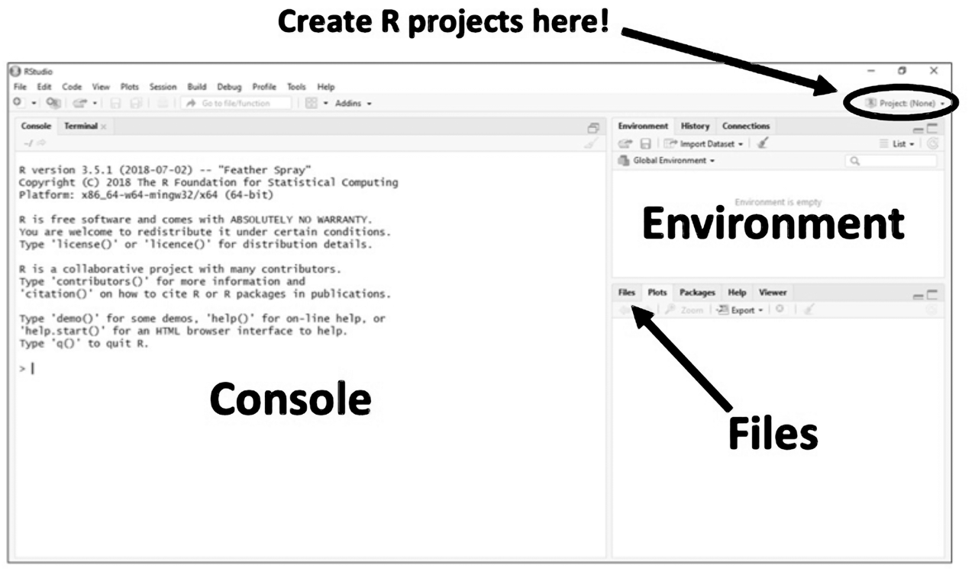

**Creating and Using R Projects**

Whenever you use RStudio in BIO 180, you will be using **R projects**. This option of RStudio is really useful because it allows you to keep all your data and analysis in a single place so that you can’t forget where you saved your data.

To create an R project:

* First, save all the files you need for your analysis (data files and R script files) in a single folder on the lab computer.
* Next, open RStudio and find the “Project (None)” button at the top-right of the screen (see Figure 1).
  + Click on this button and then select “New Project…” from the dropdown menu.
  + Then select “Existing Directory”. Then **instead of** typing in a “Project working directory,” click “Browse…” When the computer Finder (called File Explorer on Windows) opens up, navigate to the folder where your files are saved.

Once you are inside that folder (you won’t be able to see your files and that is OK!)

* Click “Open”. RStudio will restart and then you will be working inside your new R project – check the top-right of your screen and instead of “Project (None)” it will now show the name of the folder where your files are.
* Now that you are inside your R project, go to the bottom-right panel of the RStudio interface and click on the “Files” tab (see Figure 1). You should then see a list of the files you need for your analysis.
* To begin your analysis, click on the R script file in this list that you want to use (the R script files you will use will have **“.Rmd”** at the end of their name). The R script file you clicked on will open in the top-left panel of your RStudio interface.

**Layout of R Script Files and How to Run Code**

When you open an R script file, you will notice that most of the text is on a white background, but some is on a gray background (see Figure 2). The text that is on the white background is your instructions and some notes explaining what the code is doing. The text on the gray background is the code that you will want to run to complete your analysis. To run all the code in a gray section, simply click the green triangle at the top-right of the code (see Figure Y). If the code creates something, like a graph or a table, it will appear right below the code you ran.

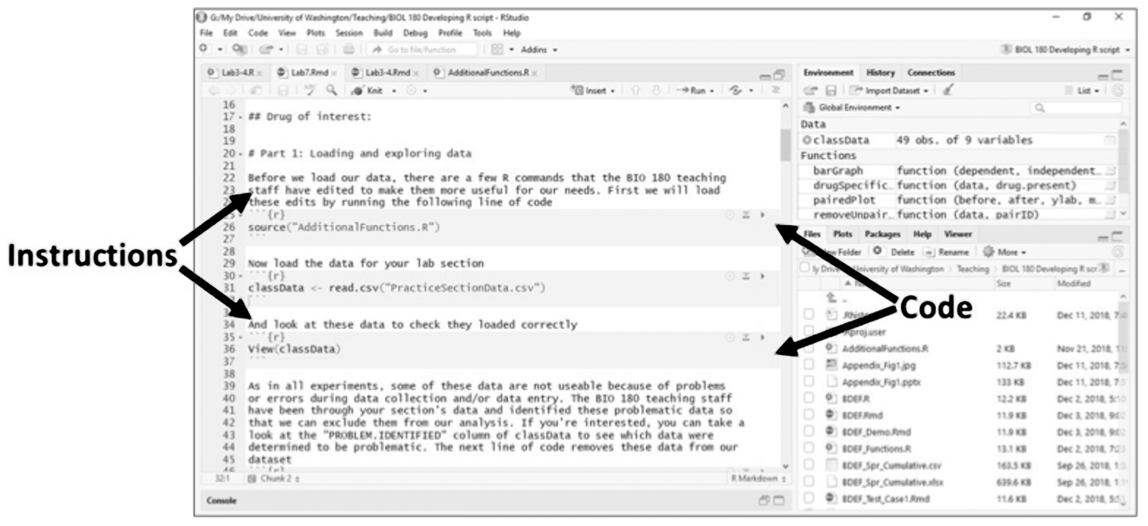

**Figure 2. Layout of R Script files: white background = instructions, gray background = code**

**Viewing Data Tables**

To figure out how to analyze your data, it is **absolutely critical** that you know what your data table looks like! The notes in your R script will often prompt you to look at your data, but you may also want to see it at times when you aren’t prompted. Fortunately, looking at your data is super easy in RStudio.

The data you will use in RStudio will be stored in data tables (called data frames in R jargon). These data tables will have names associated with them and your script will tell you what the names of your data tables are. The data tables that are currently defined in your RStudio session will be listed in the top-right panel of the RStudio interface under the “Environment” tab (see Figure 1). To view a data table, simply click on the name for that data table in your Environment (**click on the name, not the blue circle** with a white triangle in it).

The data table will then open on the left panel of the RStudio interface, right where your R script was. You can scroll around the data to look at it and then use the tabs at the top of the left panel of the RStudio interface to move between your R script and the data table. What is really cool about this feature is that if you make changes to the data table by running more code (e.g. adding a new column), you don’t need to reopen the data table, it will automatically update here.

**Knitting an R Script File**

Once you have finished going through your R script file and have made any changes to the code that you need to, you will want to run the entire script file to create a fancy looking summary of your analysis. This process is called “knitting”. To do this, simply click on the word “Knit” at the top of your R script file (has a blue ball of yarn next to it). RStudio will then take a few seconds to produce an html file of your script, which will pop-up in a new window.

If you want to print your html file, click “Open in Browser” at the top of the html file. After the file is opened in Safari, you can then press Command + P and the printing options will appear. Decide which pages you want to print and then hit print to send it to the printer in your lab room. BONUS: if you are really proud of your html file, you can also email it to yourself! The html file will automatically be saved in the same folder as your analysis files, so you can attach it to an email from there.

**Troubleshooting RStudio**

This section contains a brief explanation of some of the most common problems that you are likely to encounter when running your code.

1. Removing hash tags (pound signs)

When looking through the R script files, you will probably notice hash tags (#) at the beginning of many lines of code. This is a useful symbol in the R programming language, because it tells RStudio not to run any code that appears after the hash tag. This comes in handy when you are knitting an R script file that contains code you didn’t use (e.g. if you did a *t*-test, you might not have used the code for linear regression). However, if you want to run a line of code, but forget to remove the hash tag, it will not work. If some of your code isn’t working, be sure to check that you remembered to remove any pesky hash tags!

1. Inverted commas

In the code sections of your R script, you will notice many words that are printed in green text and surrounded by inverted commas (e.g. “RIF”). You will often be asked to change the word that is inside the inverted commas. If you do this, **you must not delete the inverted commas!** If you delete the commas, RStudio will no longer read the word, because it will think it is a name you have given to some data. RStudio will try to find the data associated with that name, not find anything, and then give you an error message saying something like “could not find object RIF”. You can think of this as RStudio saying “I’m sorry; I don’t know what a RIF is”!

### Appendix III: Guide on How to Analyze Sequence Trace Files (a.k.a, Chromatograms)

When you receive raw data from a sequencing facility, the first thing to do is check the quality of your sequencing reaction. The most important step is to look closely at the trace file (or chromatogram) of the results you receive. When it comes to DNA sequencing, the chromatogram is your visual representation of the DNA samples produced by the sequencing. It will help you determine the confidence-level of the sequencing lab’s data regarding the identity of the nucleotide base at each position in your sequence. The sequencing facility has software that is configured to automatically report a nucleotide for each position (often referred to as making a “base-call”). If the software’s criteria for making a decisive base-call are not met, then it reports an “N” at that position – where “N” represents any, non-specific nucleotide. The examples below can guide you in assessing the quality of your results.

Characteristics of a chromatogram **º 1)** include:

* 4 colors to represent the four bases
  + (guanine, cytosine, thymine, adenine)
* Well-formed, distinct single-colored peaks
  + *(if* reliable sequence data: see below)
* Absence of background signals
  + (or very small background peaks, in relationship to the taller single peaks that match the color of the decisive base-calls).

**An example of reliable sequence data:**

If your chromatogram has individual, sharp and evenly spaced peaks (as shown below), you can be quite confident about the identity of the nucleotide at each position in your sequence. Notice how each peak lines up directly with the nucleotide letter above it, each peak is about 1-letter’s-width across (not wider), and the second-tallest peak of a different color at each position is much shorter than the tallest peak. (Here, we almost cannot see the shorter peaks, because they are flat along the axis at the bottom of the chromatogram.

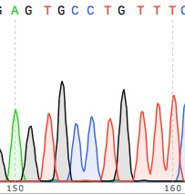Also, by convention, the tallest peak and the nucleotide-letter abbreviation above it will be depicted in the same color -- the color of the called base.. Peaks like those shown here suggest that you had optimal primer design and purity of DNA and template. Typically, a well set-up sequencing reaction like this will yield ~500-800 bases of clean, reliable DNA sequence.

1 Adapted from:<http://bitesizebio.com/10709/how-to-analyze-dna-sequencing-results-properly/>

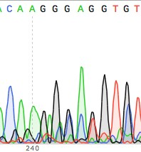**An example of UNreliable sequence data:**

In contrast to the chromatogram above, the chromatogram at the right has overlapping peaks; this suggests the sequencing results are not as clean as you would like. Small peaks seen in this chromatogram are referred to as “noise”. A good quality DNA sequence should not have much noise. In fact, the image to the right is so ambiguous that the DNA sequencing reaction should be repeated.

**Advice for analyzing your sequence trace files:**

As you analyze your own sequence chromatograms, check for nucleotides labeled “N”. When you see a miscalled peak, look at the peak to decide whether you can determine whether or not to edit the nucleotide, based on the peak. The “N” below can confidently be called as “A”, so you could manually edit the N in the raw, base-called sequence to read “A” in your working sequence (the lower of the 2 rows of sequence in your SeqTrace trace-viewing window).

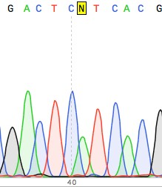

# APPENDIX 2: Student In-Class Worksheets

## BIO1 | CURE Lab 1 Worksheet

Group #/name: ___________________________ Lab Section: _____________________

Members: _______________________________ _______________________________

_______________________________ _______________________________

1. Think about the design of the experiment you just did. The goal is to isolate drug-resistant and drug-sensitive forms of *E. coli*. **(2pts)**

Compare: to: Compare: to:



What factor is being manipulated here?

**3c).5pt** ***Density of E. coli at start of growth*.**

What factor is being held constant?

**3d).5pt**  ***Absence of antibiotic***

What factor is being manipulated here?

**3a).5pt**  ***Presence of antibiotic***

What factor is being held constant?

**3b).5pt**  ***Density of E. coli at start of growth.***

1. After 24 hours of growth, do you expect to see *a lot* of growth on the dishes containing an antibiotic? Why or why not? **(.5pt)**

***No—only a few or possibly even no bacterial cells will have mutations that confer resistance and allow them to grow.***

1. Why did the research team have you spread bacteria on *two* dishes containing the same drug? **(.5pt)**

***To increase the probability of finding at least some cells that are resistant.***

1. Do you expect to see the same number of colonies on dishes containing different drugs? Why or why not? **(.5pt)**

***No—it may be easier for resistance mutations to arise for some antibiotics versus others.***

a) What is the purpose of having the two dishes without drug? **(.5pt)**

***One represents high population density; one represents low population density so you can isolate a single colony.***

b) If your LB Petri dish (without drug) had no colonies after incubation, would that concern you? Why or why not? **(.5pt)**

***Yes—it means that something is wrong with the LB plates or with the original population.***

1. Why are we interested in better understand the evolution of antibiotic resistance? **(.5pt)**

***Antibiotics are used to treat infections. Microbes evolve resistance to antibiotics with alarming speed. Understanding this process may help health officials to better-manage the evolution of antibiotic resistance.***

## BIO1 | CURE Lab 2 Worksheet

1. In every lab section of this course, each group of students will isolate a cell that is resistant to RIF and a cell that is resistant to STR. **(1pt)**
2. **.5pt**Did everyone pick the same mutant? Stated another way, do all of the resistant cells being studied this quarter have the same genotype? Explain.

**No—there are likely to be many different mutations that confer resistance.**

1. **.5pt**Will all of the cells being studied this quarter have the same level of resistance to RIF or STR? That is, do they all have the same phenotype with respect to drug resistance? Explain.

**No—there is likely to be a wide range in degree of resistance, from low to very high.**

1. What does it mean to say that there is a fitness cost to resistance? **(.5pt)**

**Resistant cells don’t grow as well as sensitive cells when the drug is absent.**

1. Why will it be interesting to see what happens to your resistant cells when they evolve in an environment that *lacks* an antibiotic? **(.5pt)**

**If there is a fitness cost to resistance, then the cells should “re-evolve” to be sensitive, over time. But if compensatory mutations occur, the cells could have a reduced fitness cost and maintain resistance.**

1. Think about the results of the “giant petri dish experiment.” What does that experiment have to say about the hypothesis that drug resistance is all-or-none? Explain your reasoning. **(1pt)**

**The experiment does not support the all-or-none claim, because the cells evolved to become more resistant over time. There were probably a large series of mutations involved in conferring extremely high resistance.**

1. Why is the Kerr lab interested in studying how drug-resistant cells evolve when they are in an environment that lacks the drug? Specifically, how will your transfers mimic what might be happening in a clinical setting, with patients who have been treated with RIF or STR? **(1pt)**

**They are interested in the phenomenon known as compensatory mutations, which allow resistant cells to grow better in the absence of the drug. In a clinical setting, the experiment mimics what might happen if a patient is given a drug until resistant forms of the disease-causing bacteria evolve, then taken off the drug. How do the resistant cells change over time? Do they retain resistance, or lose it and become sensitive to the drug again?**

1. After you have propagated your RIF mutant for many generations through serial transfer, you will investigate your progenitor and descendant further. Specifically, you be measuring the growth rates of both isolates in an environment that lacks RIF. Suppose you find that the growth rate of the descendant is greater than the growth rate of the progenitor. **(5pt)**
2. State **two** hypotheses about how RIF resistance may or may not have changed from the progenitor to the descendant. Include your rationale for each hypothesis, and refer to whether you expect growth rate to increase, decrease, or stay the same. **(2pt,** 1pt each**)**

**Hypothesis 1: The level of resistance does not change. Mutations that occurred during experimental evolution affected growth rate but not resistance.**

**Hypothesis 2: The level of resistance decreases. Mutations that cause resistance usually reduce growth rate, so experimental evolution in the absence of the drug favored mutations that reduced resistance and increased growth rate.**

**Hypothesis 3: The level of resistance increases because mutations occurred that both increase growth rate and increase resistance.**

1. Propose an experiment to distinguish between your hypotheses. Be explicit about what you are manipulating and what are measuring. **(1pt)**

**Grow the progenitor and descendant in their own microtiter wells (without RIF). After the strains have grown, place some cells of each strain on each of the following petri dishes:**

**Dish A: Just growth medium, no antibiotic**

**Dish B: Growth medium plus a “normal” level of antibiotic**

**Dish C: Growth medium plus a high level of antibiotic**

**Check each of these dishes for bacterial growth after 24 hours incubation. The things being manipulated are the strain being placed (progenitor vs. descendant) and the medium on the plates (no antibiotic vs. normal concentration vs. high concentration). The response being measured is growth of each strain across the dishes.**

1. Given your experiment above, clearly state what you would predict under each hypothesis. **(2pt,** 1pt each**)**

**Prediction under Hypothesis 1: The progenitor should grow on the dish without antibiotic and the dish with a normal concentration of RIF, but not on a dish with a high concentration. The descendant should grow on the dish without antibiotic and the dish with a normal concentration of RIF, but not on a dish with a high concentration.**

**Prediction under Hypothesis 2: The progenitor should grow on the dish without antibiotic and the dish with a normal concentration of RIF, but not on a dish with a high concentration. The descendant should grow on the dish without antibiotic, but not on the dish with a normal concentration of RIF or the dish with a high concentration.**

**Prediction under Hypothesis 3: The progenitor should grow on the dish without antibiotic and the dish with a normal concentration of RIF, but not on a dish with a high concentration. The descendant should grow on the dish without antibiotic, the dish with a normal concentration of RIF, and the dish with a high concentration.**

## BIO1 | CURE Lab 3 Daily Transfers Worksheet

**Bacteria Daily Transfers: Reminders or Discussion Questions**

1. When you come into lab, you will need some supplies to do your daily transfer.

You will have:

* a P20 and P200 pipette
* kimwipes
* ethanol
* A tip waste bin
* A non-tip waste bin
* Transfer tracking sheet
* Pens

There are 5 things you will need to complete your transfer. What are they?

* **Your microtiter plate containing your experiment/bacteria**
* **Eppi of LB**
* **Eppi of saline**
* **Gloves**
* **Sterile pipette tips**

1. After getting your microtiter plate, what should you check?

* **Is your media control well clear?**
* **Are your wells containing bacteria cloudy?**

1. After putting gloves on, sterilize your bench space, wipe down your pipettes, and set your pipettes to the appropriate volume. What are the steps of your daily transfer?
   1. **With a sterile pipette tip, fill the next two empty wells with 180 saline**
   2. **With a new sterile tip, fill the next 3 empty wells with 180 LB**
   3. **With a different tip for each strain, transfer 10uL of the fully grown bacteria into the saline, mix, and then into the LB**
2. Why do you do each step (you described above)?

* **Sterile pipette tip to keep things sterile, bacteria are everywhere!**
* **Saline is for a dilution (thin the # of cells so there can be cell divisions)**
* **LB is another dilution but also gives the bacteria food to grow**
* **Change tips between strains so that there is cross-contamination of your experiment**

1. If you didn’t do the daily transfers, how would your experimental questions change?

**Would not be able to look over time comparing the progenitors to their descendants to see if fitness or resistance levels changed in the absence of drug.**

## BIO1 | CURE Lab 3 Worksheet

**Part 1: Loading and exploring data**

1. How do you run (or execute) a line of code in RStudio? **.5 pt**

**When you are using Markdown, press the green triangle. (In general you can place the cursor on the line (or highlight several lines, if relevant), and press CTRL+ENTER).**

1. Why is it helpful to look at the data you’ll be analyzing? **.5 pt**

**You can see how the data are organized. This will help you figure out how to tell R what you want to do with the data. You can also inspect individual datapoints to check for weird or missing values.**

1. Generate one or two ideas on why cell might contain a 1 in “PROBLEM.IDENTIFIED”. **.5pt**

**Data could be missing entirely or entered incorrectly, or there could’ve been problems with the experimental protocol—for example if the petri dishes had too many colonies to count or no colonies at all.**

**Part 2: (Initial) *t*-test**

This *t*-test will tell you whether fitness in a drug-free environment is different for RIF-resistant versus RIF-sensitive strains of *E. coli* (the ancestors, in this case).

1. What is your hypothesis? **.5 pt**

**RIF-resistant strains pay a cost of resistance.**

1. What is the corresponding null hypothesis? **.5 pt**

**RIF-resistant strains do not pay a cost of resistance.**

1. Graph the data you expect to see (include standard error bars) **1 pt (.5 pt each)**

If your hypothesis is correct: If the null hypothesis is correct:

Fitness

Fitness

RIF sensitive RIF resistant

RIF sensitive RIF resistant

1. In the results, which mean is higher? **SEN (“none”, no drug at isolation)**  Is the difference statistically significant? Based on the *p*-value, yes.

**.5 pts**

1. In the script that plots a bargraph: **.5 pts**

* What does the dollar sign ($) indicate?

**Which column (variable) to use for the dependent or independent variable**

* What do the “ylab,” “xlab,” and “main” specifications do?

**Let you specify what the axis labels and the main label will read.**

**Part 3: Paired *t*-test**

The paired *t*-test will tell you whether fitness in a drug-free environment is different for RIF-resistant progenitors versus descendants.

1. What is your hypothesis and corresponding prediction? **.5 pts**

**For most mutations, there is a cost to resistance. Prediction: In a drug-free environment, descendants have higher fitness than RIF-resistant progenitor strains.**

1. What is the corresponding null hypothesis, and the prediction that follows from the null? **.5 pts**

**For most mutations, there is no cost to resistance. Prediction: In a drug-free environment, there is no change in fitness over time.**

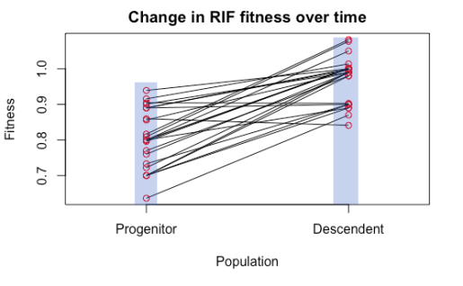

1. Graph the data you expect to see (include standard error bars) **1 pt (.5 pt each)**

**Here we are making bar graphs. In R it will be plotted so you can see the scatter of points. Similar to the image to the right.…**

If your hypothesis is correct: If the null hypothesis is correct:

Fitness

Fitness

RIF progenitor RIF descendant

RIF progenitor RIF descendant

1. Write an English sentence that “translates” the line of code that reads “RIFStrains <- subset(classData, ClassData$DRUG.AT.ISOLATION == “RIF”) **.5 pts**

**I’m making a new dataset called RIFStrains from the file called classDATA, by picking out the subset of data where cells in the DRUG.AT.ISOLATION column say RIF.**

1. Which hypothesis did your analysis support? Explain how you made this decision. **.5 pts**

**The hypothesis that there is a fitness cost to resistance. Fitness in descendants was higher, on average, than fitness in the progenitors, *p*-value = 3.871e-09**

1. Inspect the plot for these data. Comment on what you see. **.5 pts**

**Look at the R code, we see a range of fitness values for the progenitors. There is a LOT of variation that might be interesting. Many lines show no difference, but some show strong increases in fitness over time (compensatory mutations?). It doesn’t appear that all of the initial mutations have the same cost.**

**Total: 8 pts**

## BIO1 | CURE Lab 4 Worksheet

1. How many MIC datapoints will you collect? **(0.5pt)** _____

**12 (6 strains x two MIC plates [RIF and STR])**

* Which strains will you assay? **(0.5pt)**

**Progenitors and descendants from sensitive, RIF-resistant, and STR-resistant.**

* Which drugs will you assay for each strain? **(0.5pt)**

**RIF and STR**

1. When you set up your MIC assays in Lab 5, you will be doing replicates for each strain and drug.

* How many replicates in each case? **(0.5pt)** ___________

**2**

* Replicates cost time, energy, and money. Why are you doing them? **(0.5pt)**

**Replicates help catch errors or unusual results. Consistency among replicates gives you more confidence that the results are correct.**

* When you analyze the replicates in Lab 6, which one will you use to estimate MIC? **(0.5pt)**

**The lowest, as we’re quantifying the *minimum* inhibitory concentration.**

1. Look over the results of your FitVsMICModel <-lm(FITNESS ~ MIC1, data = FitVsMIC) command.

* Write 1-2 English sentences summarizing what each name or symbol means and what this command tells R to do. **(0.5pt)**

**We named the analysis “FitVsMICModel” and are using the dataset we named “FitVsMIC.” The actual linear model (“lm”) analyzes the relationship between FITNESS as an outcome or dependent variable and MIC1 as a predictor or independent variable.**

* What is the estimated slope of the line? **(0.5pt)** ______

**-2.147 e -05**

* What is the *p*-value of this slope**? (0.5pt)** ______

**0.1507**

* What is the R2 value? **(0.5pt)** __**____**

**0.09**

* Is the scatterplot and line of best fit consistent with the slope, *p*-value, and R-squared reported by the analysis? Explain why or why not. **(0.75pt)**

**Yes—the slope is slightly negative but close to flat, and there is a LOT of scatter in the points.**

* When you examine the scatterplot, is there anything noteworthy about the data? Explain. **(0.75pt)**

**There are not many datapoints with MICs between about 1100 and 3300. It looks like the relationship might be negative.**

* Based on this dataset, what is the relationship between MIC and Fitness? **(0.75pt)**

**There is none. But it would be good to get a lot more data, to sample in mid-range MICs and find out if certain highly-resistant cells actually do have lower fitness or not.**

* Does this result surprise you? Explain why or why not. **(0.75pt)**

**Any well-reasoned answer is acceptable; many possible good answers. When in doubt, collect more data!**

## BIO1 | CURE Lab 5 Worksheet

1. (**2 pts, .33 each**) Predict how the MIC of your RIF-resistant strain in STR will compare to the MIC of the RIF-sensitive strain in STR, if the resistant strain has:

* Collateral sensitivity higher same lower
* Collateral resistance higher same lower
* No collateral effect higher same lower

In each case, explain your logic in one sentence.

* Collateral sensitivity:

**If resistance to RIF makes cells more sensitive to STR, the resistant strain should have lower MIC for STR than the sensitive strain.**

* Collateral resistance:

**If resistance to RIF makes cells more resistant to STR, the resistant strain should have higher MIC for STR than the sensitive strain.**

* No collateral effect:

**If resistance to RIF has no impact on resistance to STR, the resistant strain should have the same MIC for STR as the sensitive strain.**

1. (**2 pts**) Suppose you observe that your RIF-resistant descendant shows a lower cost of resistance than your RIF-resistant progenitor. Suggest an explanation for the observation and explain your reasoning.

**Either a “back-mutation” occurred that made the original resistant mutation revert back to the original sensitive mutation, or new compensatory mutations occurred that lower the cost of resistance but the strain maintains resistance.**

1. (**2 pts**) In the clinical setting, MICs are used to determine the proper dose of antibiotic for treating an infection in particular patients. Explain the logic.

**For the drug to be effective against a particular strain, dosage needs to be adjusted to be above the strain’s MIC. (Note that physicians don’t prescribe extremely high dosages in all cases because they tend to lead to more extreme side effects like nausea, indigestion, and abdominal pain.) That is why we might be surprised to see growth in the wells containing a low level of antibiotic, if that level is sub-MIC.**

1. (**2pts**) Explain the logic of using a common competitor to assess fitness in your competition assays. In particular, explain why researchers use the term “relative fitness.” In this case, your fitness measurements are relative to what?

**The common competitor creates a common “yardstick.” We are measuring fitness as growth relative to a common competitor, so results are comparable across all of the strains we are analyzing.**

## BIO1 | CURE Lab 6 Worksheet

**PART 1. MIC**

Fig 1.

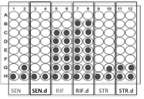

**A)** Look at figures 1-4, what does each figure suggest about how the RIF resistant strain’s antibiotic resistance level has changed?

Fig 1.

Fig 2.

Fig 3.

Fig 4.

**B)**

i. In your own words, what information does a MIC assay give you?

ii. How might this information be useful?

Fig 2.

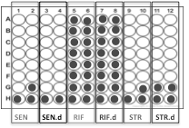

Fig 3.

.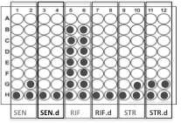

Fig 4.

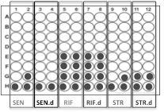

**MIC DATA**

Instructions: From your MIC microtiter plates, enter the MIC values for each strain in the table below.

PRO (P) = progenitor;

DES (D) = descendant;

DRUG.AT.ISOLATION = antibiotic in the Petri dishes used to isolate the colony in lab 1.

MIC1 = the microtiter plate containing the drug gradient of rifampicin;

MIC2 = the microtiter plate containing the drug gradient of streptomycin.

|  |  |  |  |  |  |  |
| --- | --- | --- | --- | --- | --- | --- |
| GROUP | PRO.OR.DES | DRUG.AT.ISOLATION | DRUG.FOR.MIC1 | MIC1 | DRUG.FOR.MIC2 | MIC2 |
|  | P | NONE | RIF |  | STR |  |
| D | NONE | RIF |  | STR |  |
| P | RIF | RIF |  | STR |  |
| D | RIF | RIF |  | STR |  |
| P | STR | RIF |  | STR |  |
| D | STR | RIF |  | STR |  |

**PART 2. RELATIVE FITNESS**

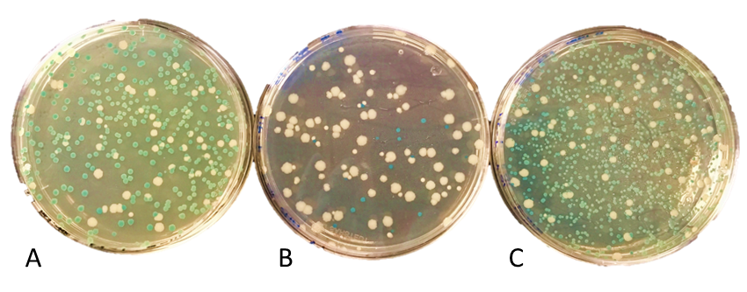

Figure 5 shows bacteria colonies from the end of the competitions between a focal strain (blue colonies) and the common competitor (white colonies) Focal strains shown are: A) SEN, B) STR, and C) STR.d.

Compare the number of colonies on Petri dish A to colonies on Petri dish B in Figure 5. What general pattern do you see?

Compare the number of colonies on Petri dish B to colonies on Petri dish C in Figure 5. What general pattern do you see?

**Competition Data**

Instructions: Count colonies from the beginning of the competition (T = 0) and the end (T = 1) and enter them in the table below. See the sample row.

|  |  |  |  |  |  |  |  |  |  |  |  |  |
| --- | --- | --- | --- | --- | --- | --- | --- | --- | --- | --- | --- | --- |
| **Focal Strain** | T = 0 | | | | | | T = 1 | | | | | |
| Focal (blue) | | | Competitor (white) | | | Focal (blue) | | | Competitor (white) | | |
| # of colonies | dilution | | # of colonies | dilution | | # of colonies | dilution | | # of colonies | dilution | |
| **sample** | **81** | | **7** | **59** | | **7** | **138** | | **8** | **95** | | **8** |
| RIF |  | |  |  | |  |  | |  |  | |  |
| RIF.d |  | |  |  | |  |  | |  |  | |  |
| STR |  | |  |  | |  |  | |  |  | |  |
| STR.d |  | |  |  | |  |  | |  |  | |  |

## BIO1 | CURE Lab 7 Worksheet

1. From your relative fitness data on your progenitor, do you detect an initial cost to rifampicin resistance or to streptomycin resistance? If so, is the difference statistically significant?

**Answer should refer to fitness data in progenitors and compare levels in sensitive versus resistant strains. (1pts for correct reference to data and interpretation of *p*-value).**

2. Do data from the rest of your lab section suggest that the fitness cost is the same for all the RIF and STR progenitors? Or does the cost seem to vary across replicates? If the latter, does this provide evidence for variation in the mutations that cause resistance?

**In many or more cases, there will be variation within sections. If so, it suggests that the mutations that cause resistance vary in terms of their fitness consequences. (1pts for correct reference to data)**

3. From the relative fitness data, do you observe a change in mean fitness over time? If so, does fitness tend to increase or decrease?

**This will vary from group to group. (1pts for correct reference to data)**

4. If you wanted to look for evidence supporting compensation, what data would you need to look at? Recall that compensation is said to occur when a strain does not lose the original resistance mutation, but further mutations lower the cost of resistance.

**Compare MIC values of progenitors and descendants (should stay the same) and compare fitness of progenitors and descendants (should, in theory increase). (1pts for correct reference to data)**

5. What data would you need to assess whether reversion occurred? Recall that reversion is said to occur when a sensitive strain is regenerated by back mutation.

**Compare MIC values of progenitors and descendants—descendant should be much lower. (1pts for correct reference to data)**

6. Do the data provide any evidence for collateral effects? If so, describe the data and pattern.

**This requires a comparison of MIC values in sensitive and resistant progenitors, for both antibiotics. (1pts for correct reference to data)**

7. In a few sentences, what questions did your experiment investigate?

* **Is there a fitness cost of resistance?**
* **Do fitness costs change over time, when cells evolve in an environment that lacks drugs? (e.g. Does compensation occur?)**
* **Is there variation in the level of drug resistance? If so, does it change over time when cells evolve in an environment that lacks drugs? (e.g. Does reversion occur?)**
* **Is there evidence for collateral effects in RIF and STR resistance?**

**(1pts for 2 or more legitimate entries in list)**

8. Based on the results from your group and other groups in your lab section, suggest a future experiment.

**Many possible answers; (1pts for thoughtful entry)**

9. What is the most interesting or useful thing you have learned doing this research?

**Many possible answers**

## BIO2 | CURE Lab 8 Worksheet

**PART 1**

|  |  |
| --- | --- |
|  |  |

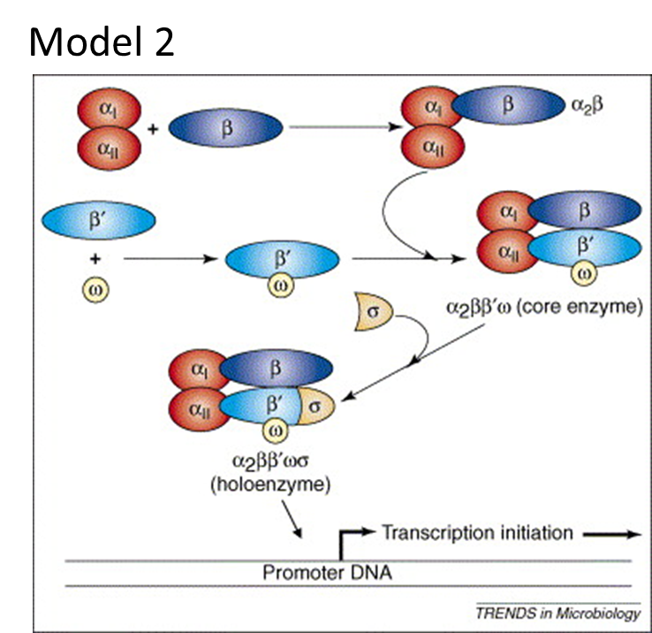

**Use Model 1 and 2 to answer the following questions:**

|  |  |
| --- | --- |
| 1. If a new RNA polymerase begins to assemble in a bacterial cell, what happens first? | 3. What is the role of σ (pronounced sigma)? |
| 2. What would happen if a bacterial cell only produced 1 α subunit? | 4. Once assembled, the finished protein is called a holoenzyme, why? |

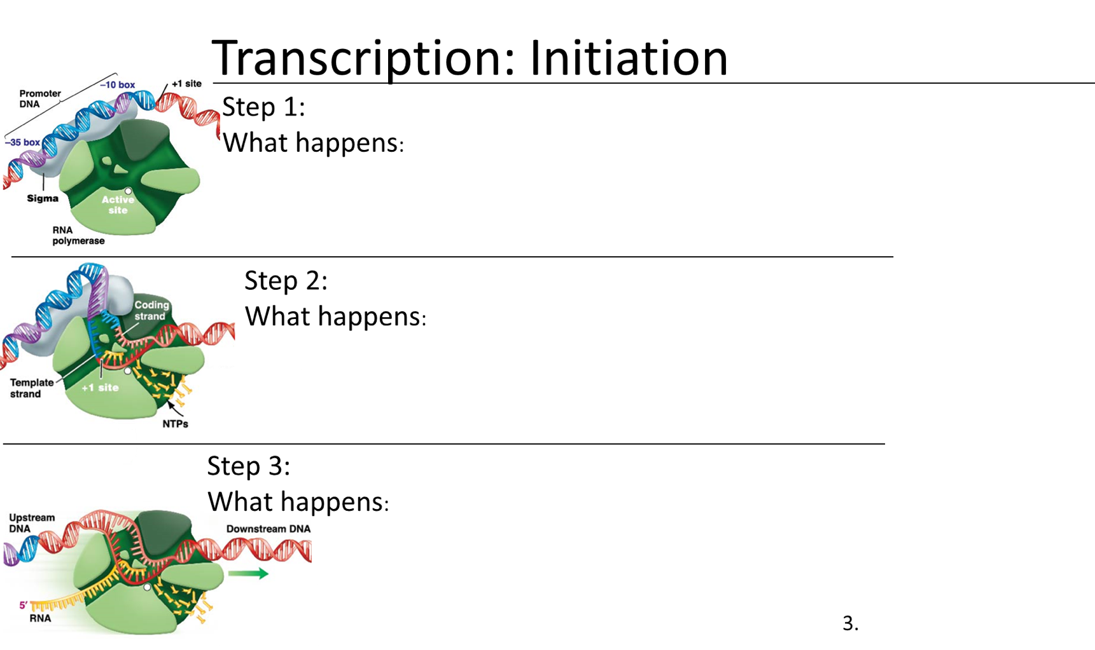

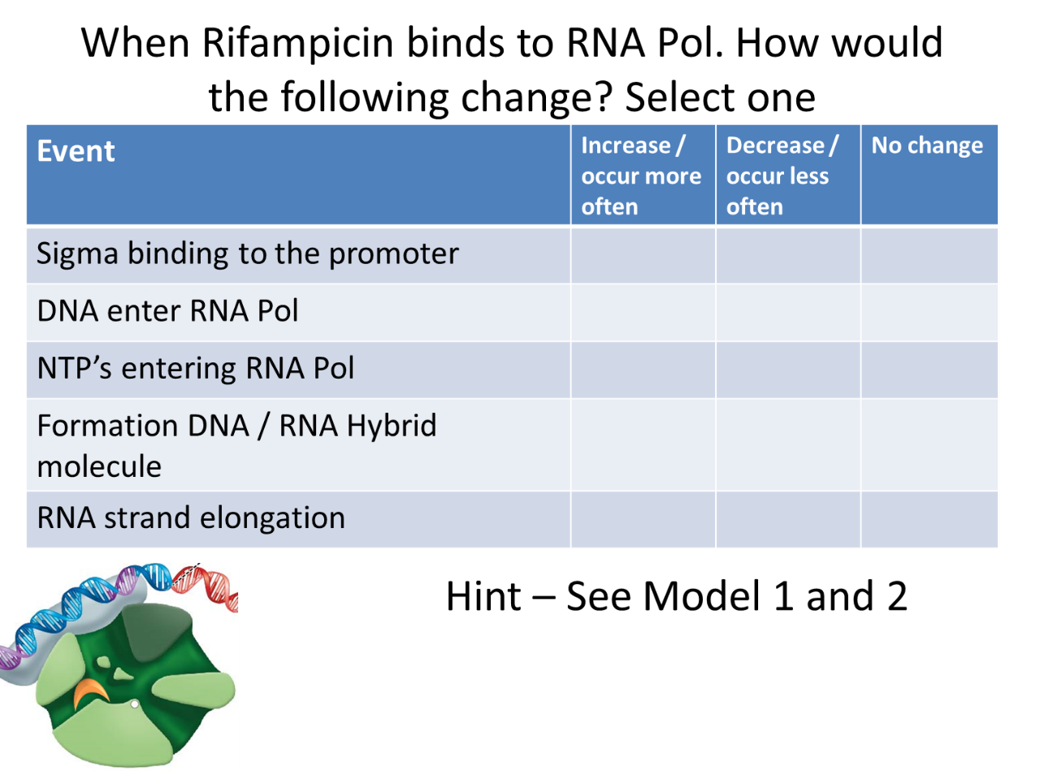

**PART 2**

Mutation occurred in (card 1): __________________________________________________

Mutation event (card 2): _______________________________________________________

Based on your specific mutation and location, please predict the following:

|  |  |  |
| --- | --- | --- |
| **Event** | **Yes** | **No** |
| Is your gene expressed? (made into a protein) |  |  |
| Will the protein be similar in primary structure? |  |  |
| Will the CORE enzyme assemble? |  |  |
| Can Sigma bind to the Core enzyme? |  |  |
| Can Sigma bind to promoter? |  |  |
| Can DNA bind to the Holoenzyme? |  |  |
| Can RNA /DNA Hybrid molecule form? |  |  |
| Can RNA be transcribed in your cell? |  |  |

Imagine that your bacterial cell survived the mutation and you move it to a petri dish with nutrients.

|  |  |  |
| --- | --- | --- |
| Question | Yes | No |
| Will the cell be able to make new proteins? |  |  |
| Will the cell be able to metabolize nutrients and grow? |  |  |
| Will the cell be able to replicate its DNA? |  |  |
| Will the cell be able to divide (reproduce)? |  |  |

Note: If you selected “No” as an answer to any of these questions, the mutation is fatal. If you have time, you may draw a new set of mutations and try again.

This term we are learning about rifampicin-resistant bacteria

1. Bacteria that are resistant to rifampicin will most likely have mutations in what large structure / machine?
2. Which genes are associated with this structure / machine?
3. Of all of the possible genes, which specific gene is most likely responsible for containing a mutation associated with rifampicin resistance?

## BIO2 | CURE Lab 9 Worksheet

Please complete this discussion **before** looking at your DNA sequence data.

Start by locating your strain.

What is the strain number that you will be working with for the rest of the quarter? _________

The next questions are about either your specific strain or the sensitive ancestor (“SEN”).

|  |  |  |  |
| --- | --- | --- | --- |
|  | Relative Fitness | Rifampicin MIC | Streptomycin MIC |
| SEN: Sensitive Progenitor |  |  |  |
| SEN: Sensitive descendent |  |  |  |
| RIF: Progenitor |  |  |  |
| RIF: Descendant |  |  |  |

Which of the four strains had highest fitness in an environment lacking antibiotics? (*Circle one)*

|  |  |  |  |
| --- | --- | --- | --- |
| SEN Progenitor | SEN Descendant | RIF Progenitor | RIF Descendant |

If you were to repeat the fitness assay for each of the above strains in an environment containing rifampicin, would you expect the fitness values to change? Please explain.

* SEN Progenitor:
* SEN Descendant:
* RIF Resistant Progenitor:
* RIF Descendant:

Remember that your progenitor was exposed to the antibiotic rifampicin. Your descendant has not been grown in rifampicin. Is your descendant still resistant? What data support this claim?

Does your group expect to find a mutation in the SEN strain descendants? Explain the logic or data behind your prediction.

Does your group expect to find a mutation in the Rif-resistant progenitor strain? Explain the logic or data behind your prediction.

Does your group expect to find a mutation in the Rif-resistant descendant strain? Explain the logic or data behind your prediction.

Next use Benchling to align your sequences, trim your sequences, and translate your sequence with help from your TA. Use the web browser to zoom in on any mutations. Press and hold the “command”, “shift”, and “4” key. This will cause a crosshair icon to appear. Scroll over the image of your mutation. This will cause a PNG image file of the highlighted area. This image will be essential for your future assignments in lab and your poster. Please rename the file and save it in a location where you can retrieve it in the future.

## BIO2 | CURE Lab 10 Worksheet

**Scientific posters**

Posters must include these titled sections:

Background: describes the question being asked and why scientists care about it

Overview: What was done in 180 and 200

Methods: How the work was done, including what assays were performed

Data: Use creativity to communicate your results

Discussion: consider data on the cost of resistance, collateral effects, and other interesting issues

Next Steps: What would you do next, and why?

Tips:

* Use images, whenever possible, to communicate information.
  + Try to use minimal text. Using bulleted points can help reduce word counts. Aim for 300–800 words total.

**Formatting:**

To ensure that the posters print neatly and efficiently, we are requiring the following:

Use this template (see below) as a starting point.

Use only the following fonts and sizes: Headings: Cambria (Headings), size: 50; body text, labels: Cambria (headings), size: 26-32.

Minimum image dimensions: 1,000 pixels (width or height)

Once finished, save as a .PDF file and email to

Tips:

* Use font 24 or larger (should be readable from 3 feet or more away).
* White background reduces the appearance of clutter and might make your poster easier to view.

### Sample Poster template



# 

## BIO2 | CURE Lab 11 Worksheet

See student lab manual

## BIO2 | CURE Lab 12 Worksheet

Please mingle with your fellow scientists, read their posters, and ask questions.  As you do this,***please make notes on the following questions for 2 posters***from groups who presented during the half of the class when your group was not presenting*.*

**POSTER, GROUP# ______**

**DATA INTERPRETATION:**

1A. Paraphrase the team’s interpretation of their results / main conclusions.

1B. Do you agree with their interpretations? Why or why not?

**FUTURE EXPERIMENTS:**

2A. What did the presenters propose as future/follow-up experiment(s)?

2B. What modifications would you suggest (if any) to strengthen the proposed experiment(s)?

**GENERAL FEEDBACK:**

3A. What constructive feedback would you like to offer on the poster and presentation?

3B. What did you learn?

3C. What would you like to hear more about?

1. β-galactosidase is naturally occurring *E. coli* protein. It is responsible for cleaving the sugar lactose into glucose and galactose. Cells that can produce β-galactosidase will also cleave a chemical called X-gal. The research team added X-gal to the LB in the indicator petri plates. When X-gal is cleaved, one of the products is blue. But our common competitor strain has a mutation in the gene for β-galactosidase that prevents the protein from being assembled properly. As a result, the common competitor cells cannot cleave lactose. This is why colonies from the common competitor are white (their β-galactosidase cannot cleave X-gal and turn blue) while your focal strains are blue (their β-galactosidase can cleave X-gal and turn blue).
2. The PCR will take some time to complete. Due to the limited time in lab, the samples that you prepped for the PCR will be verified, using gel electrophoresis, *by the next lab group* and you will be running the gel electrophoresis on the samples PCR-amplified by the lab group before you.